Ventspils, Kurzeme, Latvia
Don't let the industrial port fool you — Ventspils is one of the Baltic's most charming surprises: immaculate streets, a living medieval castle, award-winning beaches, and a city that decorates itself with giant flower sculptures and fiberglass cows.
⚓ Docked (deep-water pier) · 🕒 Typical call: 6–8 hrs · 💶 Euro (€) · 🗣️ Latvian / English widely spoken · 🌊 Blue Flag beach
✍️ MY DAY IN PORT (FILL IN)
Ship / Date
In port | arrive ______ · all aboard ______
Booked excursion
Notes / meeting point
GETTING ASHORE
- Docking: Deep-water pier — no tender. Smaller ships berth at the riverside promenade; larger ships at the northern cargo quay with a shuttle to town.
- Walk to center: Promenade dock: 5 min. Northern quay: shuttle (~10 min). Old Town and castle within 10 min of either.
- Best For: Easy walkers, culture lovers, families — flat, clean, pedestrian-friendly
- Don't Miss: Livonian Order Castle + the Cow Sculpture Trail + the Southern Breakwater lighthouse walk
GETTING AROUND
- 🚕 Taxi: €5–€8 — Local taxis (taxi-ventspils.lv) charge a €3 boarding fee plus €0.85/km with a €5–6 minimum. The short hop to center typi
- 📱 Rideshare: ✅ Bolt
TOP THINGS TO DO
- Livonian Order Castle & Museum — Latvia's best-preserved medieval castle (c.
- Cow Sculpture Trail — Over 25 giant, whimsically painted fiberglass cows are scattered across the city — a legacy of the international CowParade art…
- Blue Flag Beach & Seaside Park — Wide, powdery white sand backed by 9-meter dunes — one of the finest beaches in the Baltics.
- Seaside Open-Air Museum — Authentic historic fishermen's huts, wooden windmills, and traditional boats set in the Seaside Park.
- Southern Breakwater Walk — Stroll out along the Dienvidu Mols breakwater where the Venta River meets the Baltic Sea.
BEST WALKS
- Old Town & Riverside Promenade Loop: 2–3 km · 45–60 min · Easy — From the pier, walk the Ostas iela riverfront promenade past historic pilot boats and public art…
- Southern Breakwater to the Lighthouse: 2.5 km one-way · 45 min · Easy — Follow the riverbank south and out along the breakwater (Dienvidu Mols) to the lighthouse where the…
WEATHER · DAYLIGHT · MONEY
Month | High °F | Low °F | Rainy days
May | 58 | 45 | 8
Jul | 69 | 60 | 13
Sep | 62 | 53 | 11
Daylight: May 5:13AM–9:48PM · Jul 4:59AM–10:18PM · Sep 7:04AM–7:51PM
cruiseports.org/ventspils · Confirm terminal & all-aboard time with your ship

Ventspils, Kurzeme, Latvia — Port Map
Red = walkable sights · Amber = excursions farther out · P = cruise terminal
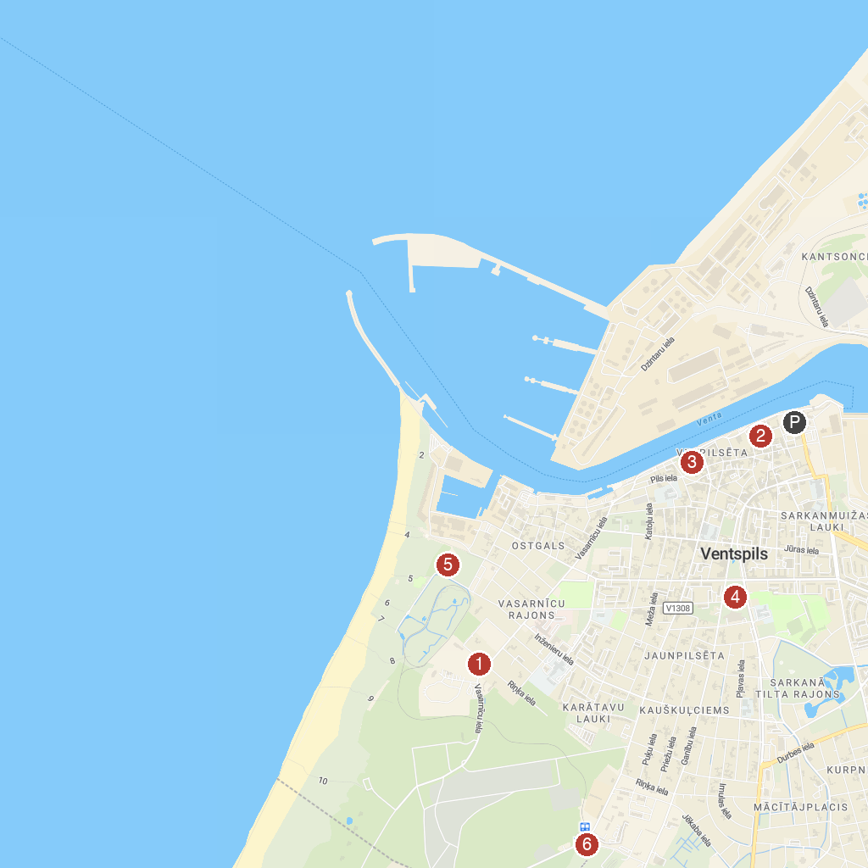
MAP KEY
1. Seaside Open-Air Museum | 4. Fregate whale fountain
2. Crafts house | 5. Ventspils Water Park
3. Ventspils muzejs / Ventspils Museum | 6. Ventspils Piedzīvojumu parks
P. Cruise port / terminal
Map © MapTiler © OpenStreetMap contributors · cruiseports.org

