Venlo, Limburg, Netherlands
Venlo sits where the Meuse bends toward Germany — a compact trading city with a Renaissance town hall, a lively market square, and the most Burgundian food culture in the Netherlands. Ships dock right on the Maasboulevard, putting the historic center three minutes on foot.
⚓ Pier (no tender) · 🕒 Typical call: 6-8 hrs · 💶 Euro — cards widely accepted · 🗣️ Dutch (English & German spoken) · 🌿 River cruise — Meuse/Maas
✍️ MY DAY IN PORT (FILL IN)
Ship / Date
In port | arrive ______ · all aboard ______
Booked excursion
Notes / meeting point
GETTING ASHORE
- Docking: Pier at Maasboulevard — no tender required
- Walk to center: 3–5 min to Market Square (Markt)
- Best For: History walks, local pastries, castle garden day-trip
- Don't Miss: Limburgse vlaai tart + Castle Gardens Arcen excursion
GETTING AROUND
- 🚕 Taxi: €5–€10 — Taxis are available near the dock. Starting rate is around €3.19 plus ~€2.35/km — the compact city means most rides are
- 📱 Rideshare: ✅ Uber
TOP THINGS TO DO
- Historic City Center Walk — Circle the Markt to admire the 1597 Renaissance Town Hall, duck into Sint-Martinuskerk for its 53-bell carillon and medieval…
- Castle Gardens Arcen (Kasteeltuinen Arcen) — One of Europe's finest landscape parks, 15 km north of Venlo.
- Limburgs Museum — Interactive museum tracing Limburg province from Roman times through WWII and the modern era.
- Limburg Food & Vlaai Tasting — Seek out Limburgse vlaai (yeast-dough fruit tart), zuurvlees (sweet-sour beef stew), and a Hertog Jan or Brand beer at a local…
- De Meinweg National Park Hike — A national park of heath, forest, and wetlands straddling the Dutch-German border, about 20 km from Venlo.
BEST WALKS
- Maasboulevard to Markt Loop: 1.5 km · 30–45 min · Easy — From the dock, walk north along the Maasboulevard waterfront promenade, then turn left into the…
- Julianapark & City Fortifications: 2 km · 40 min · Easy — From the Markt, head north to Julianapark to see the surviving remnants of Venlo's old city walls…
WEATHER · DAYLIGHT · MONEY
Month | High °F | Low °F | Rainy days
May | 65 | 49 | 11
Jul | 75 | 59 | 12
Sep | 69 | 54 | 10
Daylight: May 5:44AM–9:20PM · Jul 5:36AM–9:45PM · Sep 7:10AM–7:49PM
cruiseports.org/venlo · Confirm terminal & all-aboard time with your ship

Venlo, Limburg, Netherlands — Port Map
Red = walkable sights · Amber = excursions farther out · P = cruise terminal
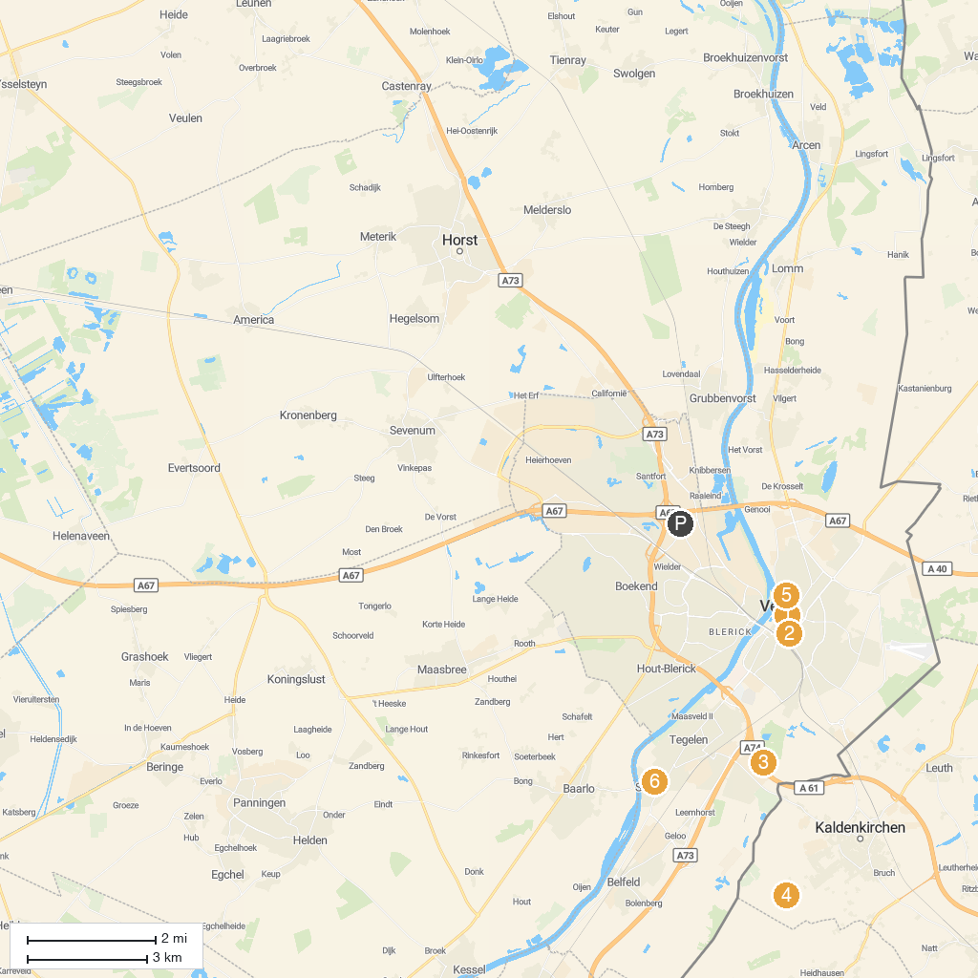
MAP KEY
1. Grote of Sint-Martinuskerk, Venlo | 5. Kaldenkirchen Sequoia Farm
2. Limburgs Museum | 6. Wilhelminapark
3. Speelpark Klein Zwitserland | 7. Limburgs Schutterij Museum
4. Niederrheinisches Freilichtmuseum
P. Cruise port / terminal
Map © MapTiler © OpenStreetMap contributors · cruiseports.org

