Vega de Terrón, Salamanca, Spain
A tiny Douro River village straddling Spain and Portugal, Vega de Terrón punches well above its size — it's your jumping-off point for golden Salamanca and the dramatic Arribes del Duero gorge.
⚓ Docked (river pier) · 🕒 Typical call: 8-10 hrs · 💶 Currency: Euro (€) · 🗣️ Language: Spanish · 🏰 UNESCO excursion port
✍️ MY DAY IN PORT (FILL IN)
Ship / Date
In port | arrive ______ · all aboard ______
Booked excursion
Notes / meeting point
GETTING ASHORE
- Docking: River pier — ships dock directly, no tender required
- Walk to village: ~5 min to village centre; very small, limited services
- Best For: Salamanca day trip, border scenery, Arribes del Duero nature
- Don't Miss: Salamanca's Plaza Mayor and University — a UNESCO WHS highlight
GETTING AROUND
- 🚕 Taxi: ~€100–€150 one-way (estimated, long-distance rate) — Taxis can be arranged at the port but supply is limited in this small village. Confirm a fixed fare before departing; th
TOP THINGS TO DO
- Salamanca — Golden City Day Trip — Spain's most photogenic university city glows in warm sandstone.
- Arribes del Duero Natural Park — The Douro carves a dramatic gorge — up to 400m deep — along the Spanish-Portuguese border.
- Castelo Rodrigo, Portugal — Cross the border into Portugal to reach this perfectly preserved medieval walled village perched on a hilltop.
- Arribes del Duero Wine & Bodega Visit — The Arribes del Duero DO produces characterful reds from Rufete and Juan García grapes, rarely found outside the region.
- Miranda do Douro, Portugal — A charming border town with a ruined cathedral, a medieval castle, and the unique Mirandese language — one of only two…
BEST WALKS
- Village & Border Bridge Stroll: ~1 km · 20 min · Easy · Flat riverbank — A quick amble through the village to the international bridge that connects Spain and Portugal.
- Douro Gorge Viewpoint Walk: ~2 km · 40 min · Easy–Moderate · Riverside path — Follow the Douro upstream from the quay along a riverside path to reach a viewpoint overlooking the…
WEATHER · DAYLIGHT · MONEY
Month | High °F | Low °F | Rainy days
May | 73 | 51 | 7
Jul | 88 | 62 | 2
Sep | 79 | 57 | 5
Daylight: May 7:09AM–9:38PM · Jul 7:08AM–9:57PM · Sep 8:08AM–8:36PM
cruiseports.org/vega-de-terron-salamanca · Confirm terminal & all-aboard time with your ship

Vega de Terrón, Salamanca, Spain — Port Map
Red = walkable sights · Amber = excursions farther out · P = cruise terminal
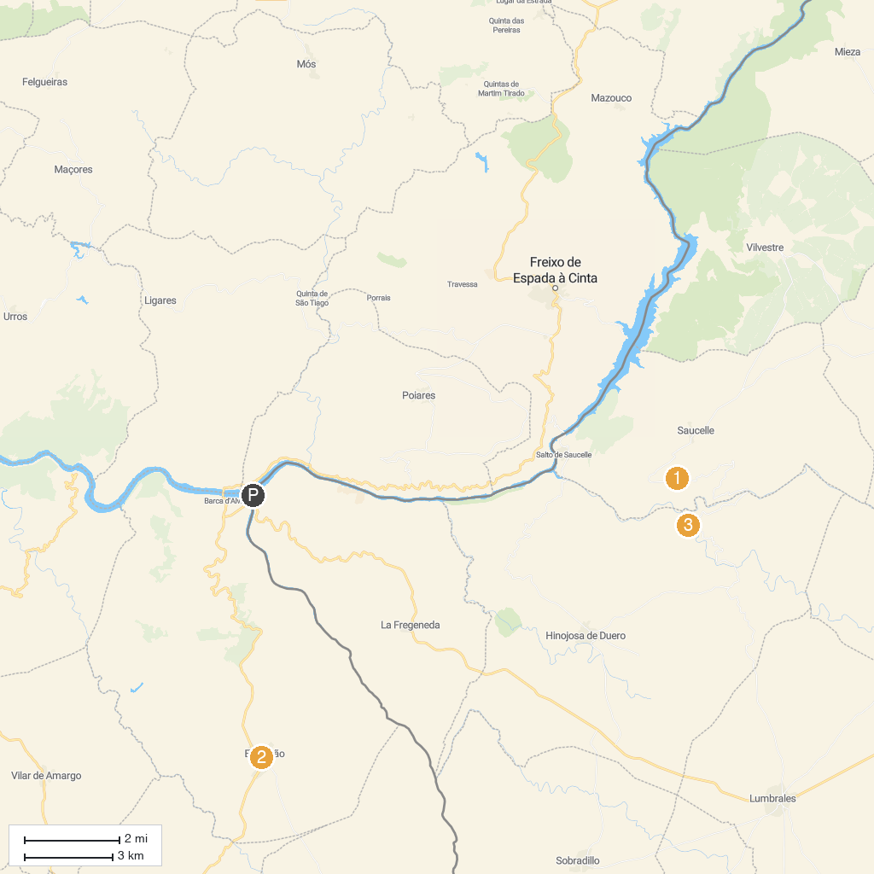
MAP KEY
1. Arribes del Duero Natural Park | 4. Igreja Matriz de Escalhao
2. Las Janas Viewpoint | 5. Cachón del Camaces Waterfall
3. Figueira de Castelo Rodrigo Garden
P. Cruise port / terminal
Map © MapTiler © OpenStreetMap contributors · cruiseports.org

