Västervik, Kalmar County, Sweden
Sweden's self-styled 'summer city' packs a 5,000-island archipelago, a medieval castle ruin, a Björn Ulvaeus–revived waterfront, and a narrow-gauge steam railway into one compact, very walkable Baltic port.
⚓ Pier (Lucernahamnen, ~1 km from center) · 🕒 Typical call: 7–10 hrs · 💳 Cashless — cards only (SEK) · 🗣️ Swedish (English widely spoken)
✍️ MY DAY IN PORT (FILL IN)
Ship / Date
In port | arrive ______ · all aboard ______
Booked excursion
Notes / meeting point
GETTING ASHORE
- Docking: Pier at Lucernahamnen, ~1 km walk or short taxi to the old town
- Walk to Center: ~15 min on foot along the waterfront promenade
- Best For: Archipelago boat trips, scenic walks, Swedish history, families
- Don't Miss: Stegeholm Castle ruins on Slottsholmen & a fika in the old town
GETTING AROUND
- 🚕 Taxi: ~100–200 SEK — Västerviks Taxi (tel: 0490-373 00) serves the port area. The short ride to the town center typically costs around 100–20
- 📱 Rideshare: ❌ not available
TOP THINGS TO DO
- Tjust Archipelago Boat Trip — Explore the nearly 5,000 islands of the Tjust archipelago on a guided cruise.
- Stegeholm Castle Ruins & Slottsholmen — Walk the short causeway to Slottsholmen island to see the 14th-century castle ruins, the ABBA-connected Slottsholmen Hotel…
- Narrow-Gauge Railway to Hultsfred — Board Sweden's longest narrow-gauge railway for a scenic ride through the Småland countryside in vintage yellow-and-orange…
- Astrid Lindgren's World (Vimmerby) — Pippi Longstocking's creator was born in Vimmerby, ~55 min from Västervik.
- Eagle & Seal Safari — A 30-minute boat ride from central Västervik reaches the outer archipelago, home to white-tailed sea eagles and gray seals.
BEST WALKS
- Old Town & Slottsholmen Loop: ~3 km · 60–75 min · Easy, flat — From the pier, walk the promenade into the old town, browse the cobbled Storgatan, visit St.
- Museum & Uno's Tower: ~1 km · 30 min + museum time · Easy — Västervik Museum covers local maritime and cultural history.
WEATHER · DAYLIGHT · MONEY
Month | High °F | Low °F | Rainy days
May | 60 | 41 | None
Jul | 72 | 55 | None
Sep | 64 | 48 | None
Daylight: May 4:30AM–9:10PM · Jul 4:16AM–9:41PM · Sep 6:24AM–7:11PM
cruiseports.org/vastervik · Confirm terminal & all-aboard time with your ship

Västervik, Kalmar County, Sweden — Port Map
Red = walkable sights · Amber = excursions farther out · P = cruise terminal
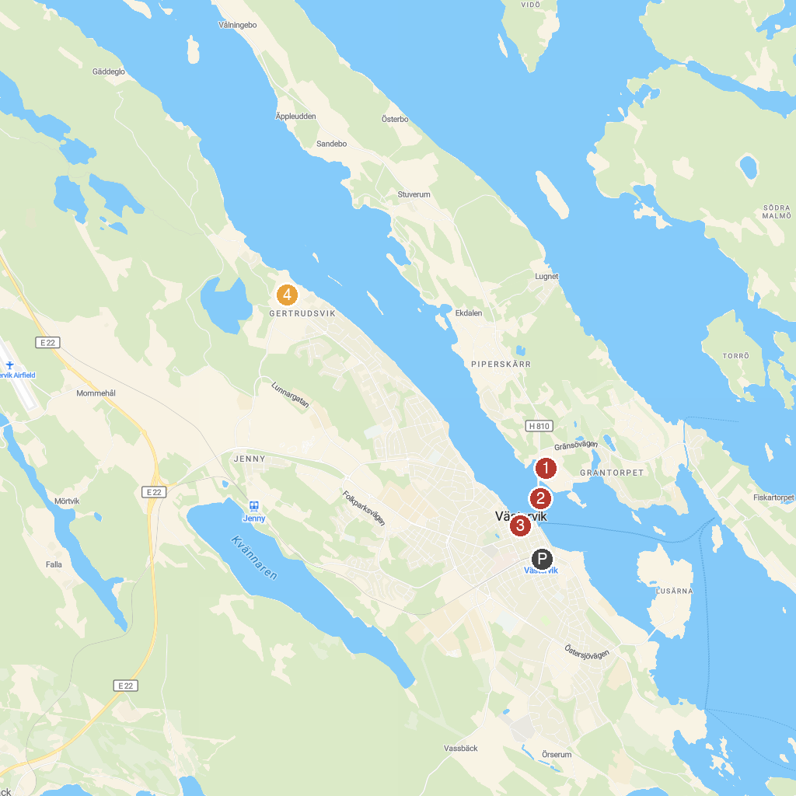
MAP KEY
1. Stiftelsen Västerviks Museum | 4. Psykiatriska museet, Västervik
2. Stegeholm Castle Ruin | 5. Gladhammars Kyrka
3. Fiskaretorget | 6. Almviks Tegelbruks Museum
P. Cruise port / terminal
Map © MapTiler © OpenStreetMap contributors · cruiseports.org

