Varna, Black Sea Coast, Bulgaria
The 'Pearl of the Black Sea' packs 6,000 years of history — from Thracian gold that predates the pyramids to golden-sand beaches — all within easy reach of a docking berth a short stroll from the Sea Garden.
⚓ Docked (pier) · 🕒 Typical call: 8-10 hrs · 💵 Bulgarian Lev (BGN) · 🗣️ Bulgarian (Cyrillic); English widely spoken · 🏖️ Black Sea beaches
✍️ MY DAY IN PORT (FILL IN)
Ship / Date
In port | arrive ______ · all aboard ______
Booked excursion
Notes / meeting point
GETTING ASHORE
- Docking: Varna East Passenger Terminal; most ships dock, NCL occasionally tenders
- Walk to center: 15-20 min on foot; Sea Garden starts 2-3 min from pier
- Best For: History buffs, beach days, affordable local dining
- Don't Miss: Gold of Varna at the Archaeological Museum — oldest gold treasure on Earth (4600 BC)
GETTING AROUND
- 🚕 Taxi: €2–4 — Metered taxis are plentiful at the port. The short ride to the city center costs roughly €2–4 (BGN 4–8). Use apps like T
- 📱 Rideshare: ❌ not available
- 🚌 Hop-on hop-off: ✅
TOP THINGS TO DO
- Gold of Varna & Archaeological Museum — The Varna Necropolis treasure (4600-4200 BC) is the oldest worked gold ever found — predating the Egyptian pyramids by 1,500 years.
- Roman Thermae — The 4th-largest surviving Roman baths in Europe, built in the late 2nd century AD.
- Aladzha Rock Monastery — A medieval cave monastery carved into 40-metre limestone cliffs, about 15 km north of the port.
- Golden Sands Beach Resort — Bulgaria's famous resort strip 17 km north — 3.5 km of fine golden sand with beach bars, water sports, and sunbed rentals.
- Balchik Palace & Botanical Garden — Queen Marie of Romania's whimsical summer residence perched on white chalk cliffs, 45 km north of Varna, surrounded by one of…
BEST WALKS
- Sea Garden to Cathedral: 2.5 km | ~30-35 min | Flat to gentle uphill — Exit the terminal into the Sea Garden (Morska Gradina), Bulgaria's grandest coastal park.
- Roman Thermae Loop: 1.5 km | ~20 min | Easy — A short walk from the pier through the old town to the Roman Thermae — the largest ancient building…
WEATHER · DAYLIGHT · MONEY
Month | High °F | Low °F | Rainy days
May | 70 | 55 | 0
Jul | 84 | 67 | 0
Sep | 78 | 62 | 0
Daylight: May 5:44AM–8:25PM · Jul 5:42AM–8:45PM · Sep 6:48AM–7:18PM
cruiseports.org/varna · Confirm terminal & all-aboard time with your ship

Varna, Black Sea Coast, Bulgaria — Port Map
Red = walkable sights · Amber = excursions farther out · P = cruise terminal
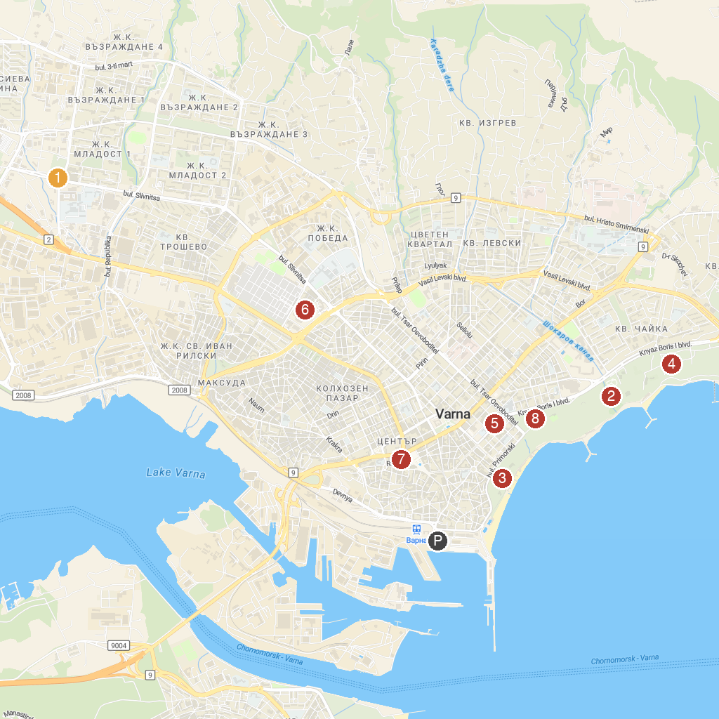
MAP KEY
1. Park Museum „Vladislav Varnenchik“ | 5. Graffit Gallery
2. Varna Zoo | 6. Retro Museum
3. Public Astronomical Observatory & Planetarium Nicolaus Copernicus | 7. Clock Tower of Varna
4. Dolphinarium Varna | 8. DETSKI KAT VARNA
P. Cruise port / terminal
Map © MapTiler © OpenStreetMap contributors · cruiseports.org

