Vardø, Finnmark, Norway
Perched on a treeless island in the Barents Sea, Vardø is Norway's easternmost outpost — a place of stark Arctic beauty, a sobering witch-trial memorial, and one of Europe's greatest seabird cliffs.
⚓ Pier (dock) · 🕒 Typical call: 6-8 hrs · 💵 Norwegian Krone (NOK) — cards accepted everywhere · 🗣️ Norwegian (English widely spoken) · ☀️ Midnight sun mid-May to late July
✍️ MY DAY IN PORT (FILL IN)
Ship / Date
In port | arrive ______ · all aboard ______
Booked excursion
Notes / meeting point
GETTING ASHORE
- Docking: Pier — ships berth at Vardø Havn, steps from the town centre
- Walk to Centre: 2 min to main street; 5 min to fortress; 15 min to Steilneset
- Best For: History, birdwatching, stark Arctic landscapes, street art
- Don't Miss: Steilneset Memorial — one of the world's most powerful public monuments
GETTING AROUND
- 🚕 Taxi: NOK 100–175 (short trips) — Local taxis are available but Norwegian taxi rates are among Europe's highest. For the short hop into town they're rarel
- 📱 Rideshare: ❌ not available
TOP THINGS TO DO
- Steilneset Memorial — Designed by architect Peter Zumthor and artist Louise Bourgeois, this 125-metre silk cocoon honours the 91 victims executed for…
- Vardøhus Fortress — The world's northernmost star fortress, first established around 1307 and rebuilt in its current octagonal form in 1734.
- Hornøya Island Birdwatching — Norway's easternmost point and one of Europe's premier seabird colonies.
- Street Art & Town Walk — In 2012, artist Pøbel's Komafest project brought international muralists to paint Vardø's abandoned wooden buildings and…
- Drakkar Sculpture & Coastal Walk — A massive driftwood sculpture on the island's north shore — part Viking longship, part sea monster — built by Russian artists in…
BEST WALKS
- Pier to Fortress to Steilneset Loop: 3 km · 45-60 min · Easy · Paved paths — From the harbour pier, walk north-west to Vardøhus Fortress (5 min), then loop south through the…
- North Shore to Drakkar Sculpture: 2.5 km one-way · 25-30 min · Easy · Coastal path — Head north from the pier along the island's perimeter to reach the striking Drakkar wooden…
WEATHER · DAYLIGHT · MONEY
Month | High °F | Low °F | Rainy days
May | 44 | 36 | 0
Jul | 56 | 47 | 1
Sep | 50 | 43 | 1
Daylight: Sep 5:07AM–6:31PM
cruiseports.org/vardo · Confirm terminal & all-aboard time with your ship

Vardø, Finnmark, Norway — Port Map
Red = walkable sights · Amber = excursions farther out · P = cruise terminal
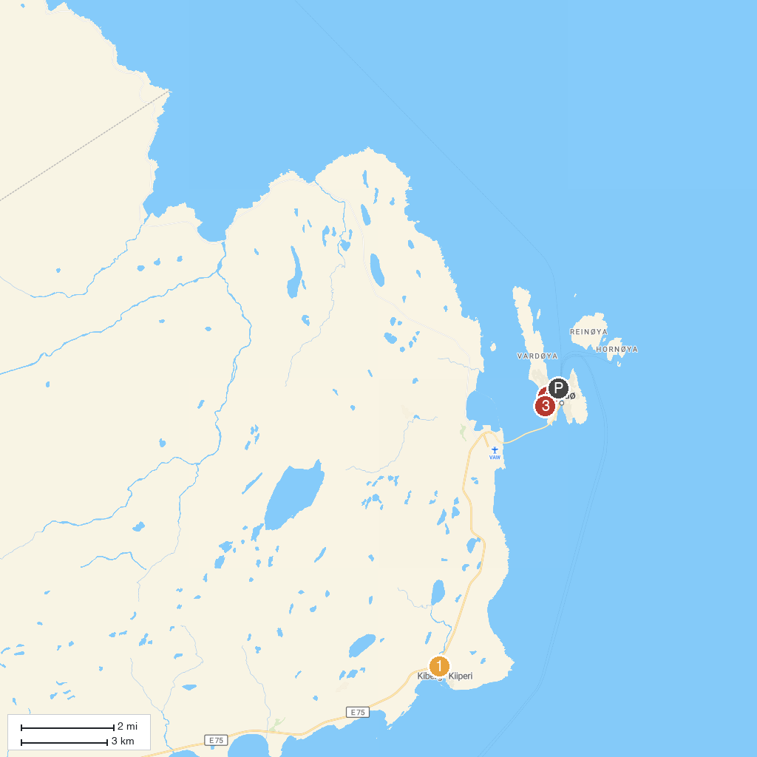
MAP KEY
1. Partisanmuseet | 3. Steilneset Memorial Site
2. Vardøhus Fortress
P. Cruise port / terminal
Map © MapTiler © OpenStreetMap contributors · cruiseports.org

