Vannes, Brittany, France
One of Brittany's most perfectly preserved medieval cities, Vannes wraps you in 15th-century ramparts, cobbled lanes, and the serene beauty of the Gulf of Morbihan — all within easy reach of the marina.
⚓ Small ships: tender to marina; large ships dock at Lorient (transfer) · 🕒 Typical call: 7–9 hrs · 💶 Currency: Euro (€) · 🗣️ Language: French (some English in tourist areas)
✍️ MY DAY IN PORT (FILL IN)
Ship / Date
In port | arrive ______ · all aboard ______
Booked excursion
Notes / meeting point
GETTING ASHORE
- Docking: Small/expedition ships tender to Port de Plaisance (marina); larger ships dock at Lorient ~45 min away with shuttle transfer
- Walk to centre: 5–10 min from marina to the historic Porte Saint-Vincent gateway
- Best For: Medieval history, Breton food, Gulf of Morbihan island cruises
- Don't Miss: The ramparts gardens, galettes at a creperie, and the whimsical 'Vannes et sa Femme' carving
GETTING AROUND
- 🚕 Taxi: €6–€10 — Taxis are readily available at the port and reach the city center or train station in 3-5 minutes. Good for groups or th
- 📱 Rideshare: ✅ Uber, Bolt
TOP THINGS TO DO
- Vannes Old Town & Ramparts Walk — Wander the intact medieval walls and their spectacular flower gardens, duck into Saint-Pierre Cathedral, and find the famous…
- Gulf of Morbihan Island Cruise — Board a boat at the Gare Maritime and cruise the Gulf of Morbihan's 300+ islands.
- Carnac Megaliths Day Trip — About 30 km west, Carnac hosts the world's largest concentration of prehistoric standing stones — over 3,000 menhirs stretching…
- Musée de la Cohue & Gaillard Castle — La Cohue, the 13th-century market hall, now houses the city's Fine Arts Museum with Breton-inspired paintings.
- Conleau Peninsula & Beach — A 4.5 km hop south on Bus #2 brings you to the Conleau Peninsula — a pine-shaded haven with a small sandy beach, seawater pool…
BEST WALKS
- Marina to Ramparts Garden Loop: 3 km | 45–60 min | Easy | Free — From the Port de Plaisance marina, follow the quayside north to Porte Saint-Vincent, then circuit…
- Old Town Highlights Walk: 1.5 km | 30–40 min | Easy | Free — Start at the cathedral, explore Place Henri IV for half-timbered facades, find the 'Vannes et sa…
WEATHER · DAYLIGHT · MONEY
Month | High °F | Low °F | Rainy days
May | 66 | 47 | 1
Jul | 74 | 55 | 1
Sep | 71 | 53 | 1
Daylight: May 6:33AM–9:41PM · Jul 6:29AM–10:04PM · Sep 7:48AM–8:22PM
cruiseports.org/vannes · Confirm terminal & all-aboard time with your ship

Vannes, Brittany, France — Port Map
Red = walkable sights · Amber = excursions farther out · P = cruise terminal
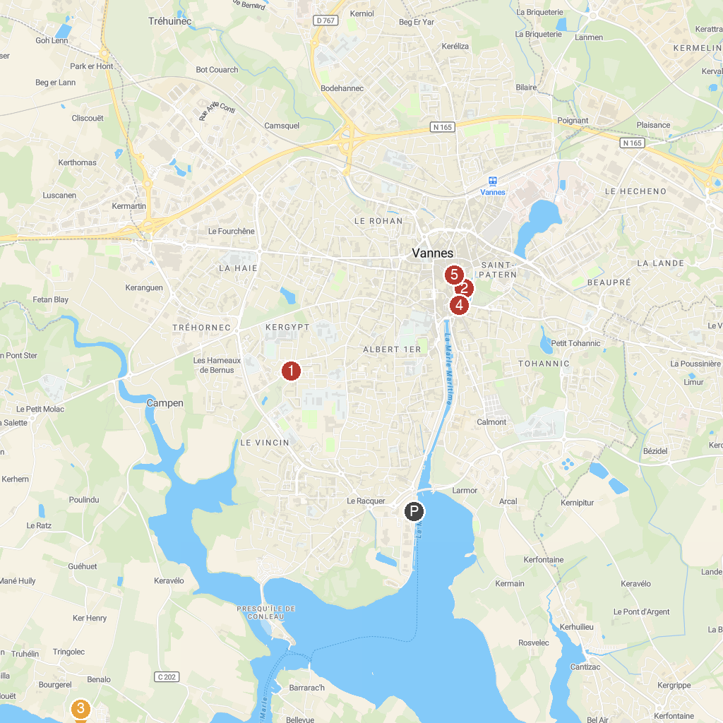
MAP KEY
1. Église Saint Vincent Ferrier | 5. Château de l'Hermine
2. Remparts de Vannes | 6. Cathédrale Saint-Pierre de Vannes
3. CIPM Marins & Capitaines | 7. Château du Plessis Josso
4. Largoet Castle
P. Cruise port / terminal
Map © MapTiler © OpenStreetMap contributors · cruiseports.org

