Valletta, Malta
Baroque palaces crowd honey-stone streets above one of the world's great natural harbours. Malta's capital packs more UNESCO heritage per square metre than almost anywhere on earth — and it's almost all walkable from the ship.
⚓ Docked (Valletta Waterfront) · 🕒 Typical call: 8-10 hrs · 💶 Currency: Euro (€) · 🗣️ Language: Maltese & English · 🌡️ Best months: Apr–Jun, Sep–Oct
✍️ MY DAY IN PORT (FILL IN)
Ship / Date
In port | arrive ______ · all aboard ______
Booked excursion
Notes / meeting point
GETTING ASHORE
- Docking: Valletta Cruise Port (Pinto Wharf), Floriana — docked, no tender
- Walk to centre: 15 min on foot or 5 min by free shuttle bus to City Gate
- Best For: Baroque architecture, WWII history, Knights of St John heritage
- Don't Miss: St John's Co-Cathedral (Caravaggio inside), Upper Barrakka Gardens views
GETTING AROUND
- 🚕 Taxi: €8–15 — Authorized taxi booths operate at the port with fixed rates to destinations. Fares are per taxi (up to 4 passengers), no
- 📱 Rideshare: ✅ Bolt, Uber, eCabs
- 🚌 Hop-on hop-off: ✅ City Sightseeing Malta
TOP THINGS TO DO
- Valletta Old City Walk — Stroll the fortified Baroque capital: City Gate, Republic Street, St John's Co-Cathedral (two Caravaggio masterpieces), the Grand…
- Three Cities (Vittoriosa, Senglea, Cospicua) — Take a water taxi across the Grand Harbour to the fortified Three Cities — older than Valletta itself, packed with Knights'…
- Mdina — the Silent City — Malta's ancient walled hilltop capital is 30 minutes by bus or taxi.
- Malta's Megalithic Temples — The Ħaġar Qim and Mnajdra temples (3600–3200 BC) predate Stonehenge and the pyramids.
- Blue Grotto Boat Trip — Motorboat trips run from Wied iż-Żurrieq on Malta's south coast into the Blue Grotto sea cave system — brilliant turquoise water…
BEST WALKS
- Republic Street Spine Walk: 2.5 km round trip · 1-2 hrs · Easy–Moderate — The classic Valletta route: enter through City Gate, walk Republic Street past the Grand Master's…
- Barrakka Gardens & Waterfront Loop: 1.5 km · 45 min · Easy — From City Gate, descend to Upper Barrakka Gardens for Grand Harbour panoramas (and the noon cannon…
WEATHER · DAYLIGHT · MONEY
Month | High °F | Low °F | Rainy days
May | 71 | 63 | 3
Jul | 85 | 75 | 0
Sep | 81 | 74 | 4
Daylight: May 5:56AM–8:00PM · Jul 5:57AM–8:18PM · Sep 6:44AM–7:08PM
cruiseports.org/valletta · Confirm terminal & all-aboard time with your ship

Valletta, Malta — Port Map
Red = walkable sights · Amber = excursions farther out · P = cruise terminal
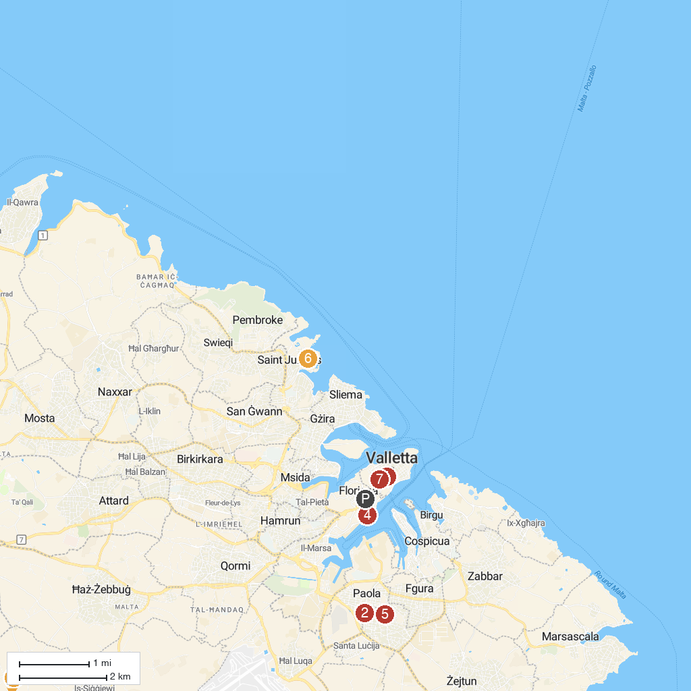
MAP KEY
1. St. John's Co-Cathedral | 5. Ħal-Tarxien Prehistoric Complex
2. Ħal Saflieni Hypogeum | 6. Portomaso Casino
3. Laferla Cross | 7. Ras id-Dawwara
4. The Valletta Waterfront | 8. Knisja ta' Santa Barbara
P. Cruise port / terminal
Map © MapTiler © OpenStreetMap contributors · cruiseports.org

