Vallejo, California, USA
Once home to the U.S. Navy's first Pacific shipyard, Vallejo blends industrial history with waterfront craft breweries, walkable promenade access, and an easy hop to Napa Valley wine country.
⚓ Docked (pier) · 🕒 Typical call: 4-8 hrs · 💵 US Dollar · 🗣️ English · 🍷 Napa Valley gateway
✍️ MY DAY IN PORT (FILL IN)
Ship / Date
In port | arrive ______ · all aboard ______
Booked excursion
Notes / meeting point
GETTING ASHORE
- Docking: Small ships dock at Vallejo Waterfront/Municipal Marina — no tender required
- Walk to center: 5–10 min to downtown; waterfront promenade is steps away
- Best For: Navy history, craft beverages, Napa day trips, SF ferry excursions
- Don't Miss: Mare Island's historic shipyard, St. Peter's Chapel Tiffany windows, Mare Island Brewing Co.
GETTING AROUND
- 🚕 Taxi: $4–$10 — Taxis are available outside the terminal for short hops around downtown Vallejo. Fares are low given the terminal's cent
- 📱 Rideshare: ✅ Uber, Lyft
TOP THINGS TO DO
- Mare Island Naval Shipyard — Explore the first U.S.
- St. Peter's Chapel — Tiffany Windows — The oldest naval chapel in the U.S.
- Mare Island Craft Beverages Trail — Hit the Mare Island Brewing Co.
- San Francisco by Ferry — The Vallejo–San Francisco Bay Ferry departs steps from the ship and delivers you to the SF Ferry Building in about an hour…
- Napa Valley Day Trip — Vallejo is the closest Bay Area port to Napa Valley.
BEST WALKS
- Waterfront Promenade Walk: 1–2 miles · Easy · 30–60 min — Head out from the marina along the waterfront promenade, enjoying views of Mare Island Strait…
- Downtown Vallejo Heritage Walk: 1 mile · Easy · 45 min — From the marina, walk east on Georgia Street into downtown.
WEATHER · DAYLIGHT · MONEY
Month | High °F | Low °F | Rainy days
May | 72 | 49 | 0
Jul | 78 | 55 | 0
Sep | 80 | 53 | 0
Daylight: May 5:58AM–8:13PM · Jul 5:58AM–8:30PM · Sep 6:51AM–7:16PM
cruiseports.org/vallejo-ca · Confirm terminal & all-aboard time with your ship

Vallejo, California, USA — Port Map
Red = walkable sights · Amber = excursions farther out · P = cruise terminal
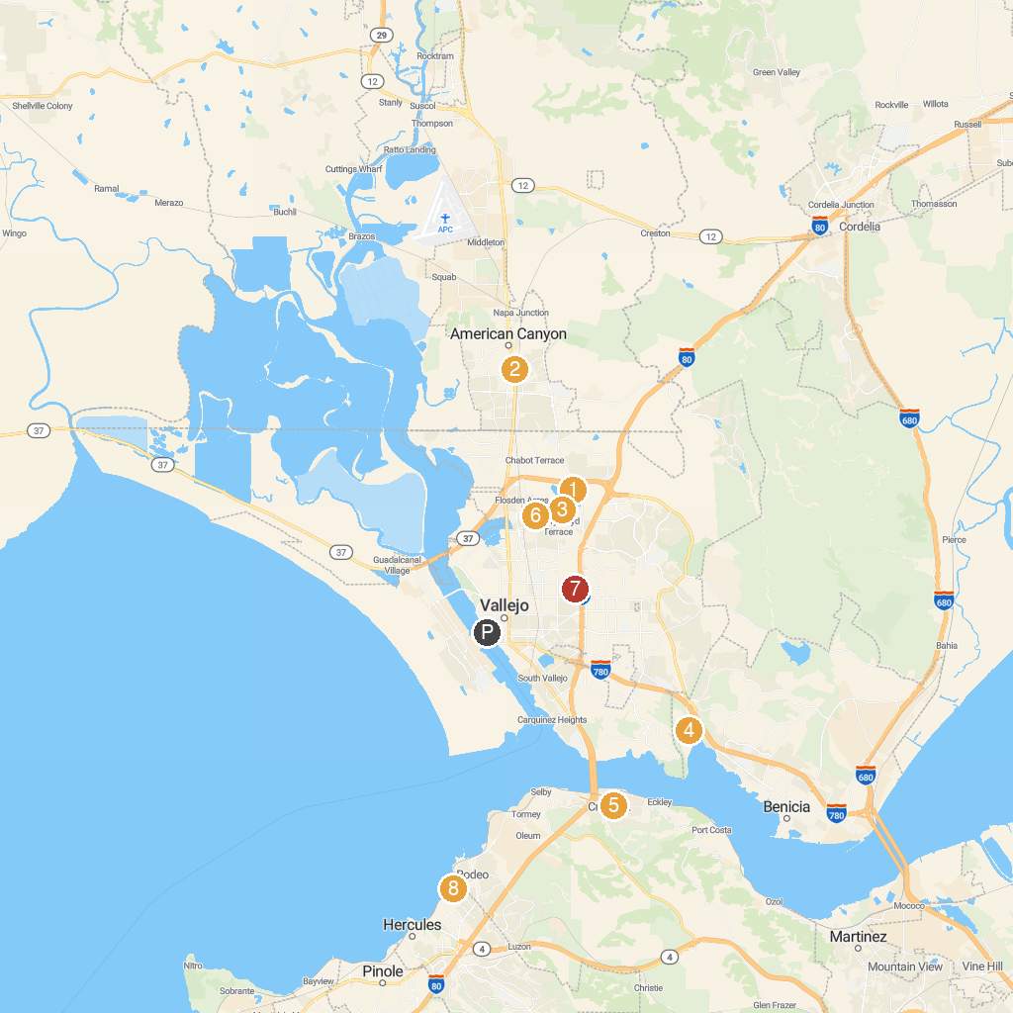
MAP KEY
1. Six Flags Discovery Kingdom | 5. Alexander Park
2. Napa Valley Casino | 6. Richardson Park
3. Dan Foley Park | 7. Grant Mahony Park
4. Benicia State Recreation Area | 8. Shoreline Park Area Picnic
P. Cruise port / terminal
Map © MapTiler © OpenStreetMap contributors · cruiseports.org

