Valencia, Valencian Community, Spain
Spain's third city fires on all cylinders — the birthplace of paella, home to one of Europe's most spectacular science museums, and graced with a long sandy beach just minutes from the Gothic old town.
⚓ Docked (Muelle de Poniente cruise terminal) · 🕒 Typical call: 8–10 hrs · 💶 Euro (EUR) · 🗣️ Spanish & Valencian · Good English in tourist areas
✍️ MY DAY IN PORT (FILL IN)
Ship / Date
In port | arrive ______ · all aboard ______
Booked excursion
Notes / meeting point
GETTING ASHORE
- Docking: Muelle de Poniente, Valencia Port Authority
- To city center: ~6 km — cruise-line/Cruise Card shuttle or taxi (15–20 min)
- Best For: Paella · Old Town · City of Arts & Sciences
- Don't Miss: Mercado Central & La Lonja de la Seda (Silk Exchange)
GETTING AROUND
- 🚕 Taxi: €15–€20 — Regulated taxis queue outside the terminal. Journey to city center takes 12–15 minutes; a port surcharge of ~€2.95 appli
- 📱 Rideshare: ✅ Uber, Bolt
- 🚌 Hop-on hop-off: ✅ · from €21
TOP THINGS TO DO
- City of Arts & Sciences — Santiago Calatrava's futuristic complex houses the Hemisfèric IMAX, the Museu de les Ciències Príncipe Felipe, the Oceanogràfic…
- Old Town: Cathedral, Silk Exchange & Mercado Central — Valencia's historic core packs three UNESCO-worthy landmarks into a walkable triangle: the Gothic Cathedral (claimed home of the…
- Paella Cooking Class or Paella Lunch — Valencia is the birthplace of paella — the real thing, made with rabbit and chicken over orange wood.
- Albufera Natural Park & Rice Fields — Just 10 km south of the city, the Albufera lagoon and its surrounding rice paddies are the cradle of Valencian paella.
- Playa de la Malvarrosa & El Cabanyal — Valencia's main city beach is wide, clean, and lined with seafood restaurants.
BEST WALKS
- Turia Riverbed Gardens Walk: 3 km · Flat · 45–60 min — The old Turia riverbed was converted into a 9 km linear park after the 1957 floods.
- Old Town Circuit: 2 km · Easy · 1 hr — Link Valencia's top historic sights on foot: start at the Mercado Central, cross to La Lonja de la…
WEATHER · DAYLIGHT · MONEY
Month | High °F | Low °F | Rainy days
May | 75 | 59 | 4
Jul | 87 | 71 | 2
Sep | 82 | 67 | 8
Daylight: May 6:47AM–9:08PM · Jul 6:47AM–9:27PM · Sep 7:43AM–8:09PM
cruiseports.org/valencia · Confirm terminal & all-aboard time with your ship

Valencia, Valencian Community, Spain — Port Map
Red = walkable sights · Amber = excursions farther out · P = cruise terminal
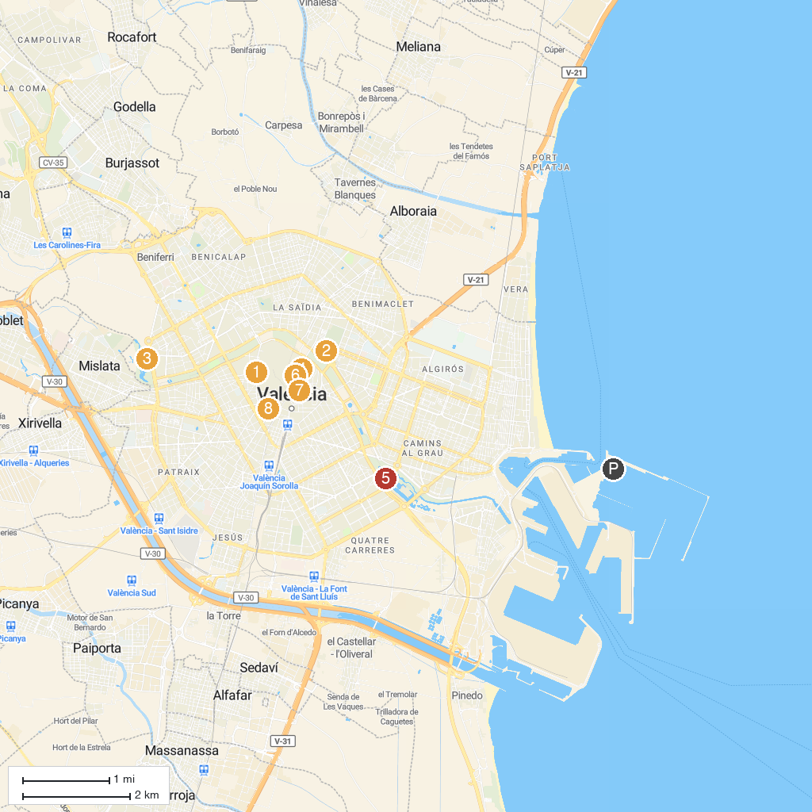
MAP KEY
1. Quart Towers | 5. Palau de Les Arts Reina Sofía
2. Natural Science Museum of Valencia | 6. Valencia Cathedral
3. Bioparc Valencia | 7. Museo Nacional de Cerámica y Artes Suntuarias "González Martí
4. La Almoina Archaeological Museum | 8. Museo Valenciano de la Ilustración y la Modernidad
P. Cruise port / terminal
Map © MapTiler © OpenStreetMap contributors · cruiseports.org

