Valence, Drôme, France
La Porte du Midi — the Gateway to the South. Valence straddles the line between northern Dauphiné and sun-drenched Provence, delivering Roman history, world-class cuisine, and a riverside park that's worth the visit on its own.
⚓ Docked (Quai Frédéric Mistral) · 🕒 Typical call: 6-8 hrs · 💶 Euro (€) · 🗣️ French · 🍷 River Cruise Port
✍️ MY DAY IN PORT (FILL IN)
Ship / Date
In port | arrive ______ · all aboard ______
Booked excursion
Notes / meeting point
GETTING ASHORE
- Docking: Pier — Quai Frédéric Mistral or Port de l'Épervière
- Walk to center: 15–20 min from Quai Frédéric Mistral (uphill through Parc Jouvet)
- Best For: Gastronomy, history, Rhône wine tasting, cycling the ViaRhône
- Don't Miss: Le Kiosque Peynet, Maison des Têtes facade, and a Suisse biscuit from Pâtisserie Nivon
GETTING AROUND
- 🚕 Taxi: €5–€10 — Taxis are available near the port; the short distance to the city center means fares are minimal. Rank at Place de la Ré
- 📱 Rideshare: ✅ Uber, Bolt
TOP THINGS TO DO
- Château de Crussol Ruins — A 12th-century limestone castle perched dramatically on a cliff across the Rhône in Saint-Péray.
- Ardèche Gorges Day Trip — Often called the 'Grand Canyon of Europe,' the Ardèche Gorges offer kayaking, hiking, and jaw-dropping limestone canyon scenery…
- Tain l'Hermitage Wine & Chocolate — Just 20 minutes north, Tain l'Hermitage produces some of the Northern Rhône's most prestigious wines — Crozes-Hermitage…
- Old Town Valence Walking Tour — Explore the medieval quartier: the Romanesque Cathedral of Saint-Apollinaire with its monument to Pope Pius VI (who died here in…
- Musée de Valence — Art & Archaeology — Housed in the former Episcopal Palace beside the cathedral, this museum spans regional prehistory to contemporary art.
BEST WALKS
- Riverside to Old Town via Parc Jouvet: 2.5 km · 30–40 min · Moderate (uphill) — The classic cruise-day walk.
- Canal Walk — La Robine & Les Balmes: 2 km loop · 25 min · Easy — Valence has over 10 km of open-air canals dating to Roman times.
WEATHER · DAYLIGHT · MONEY
Month | High °F | Low °F | Rainy days
May | 72 | 51 | None
Jul | 87 | 62 | None
Sep | 79 | 55 | None
Daylight: May 6:11AM–9:02PM · Jul 6:08AM–9:23PM · Sep 7:19AM–7:50PM
cruiseports.org/valence · Confirm terminal & all-aboard time with your ship

Valence, Drôme, France — Port Map
Red = walkable sights · Amber = excursions farther out · P = cruise terminal
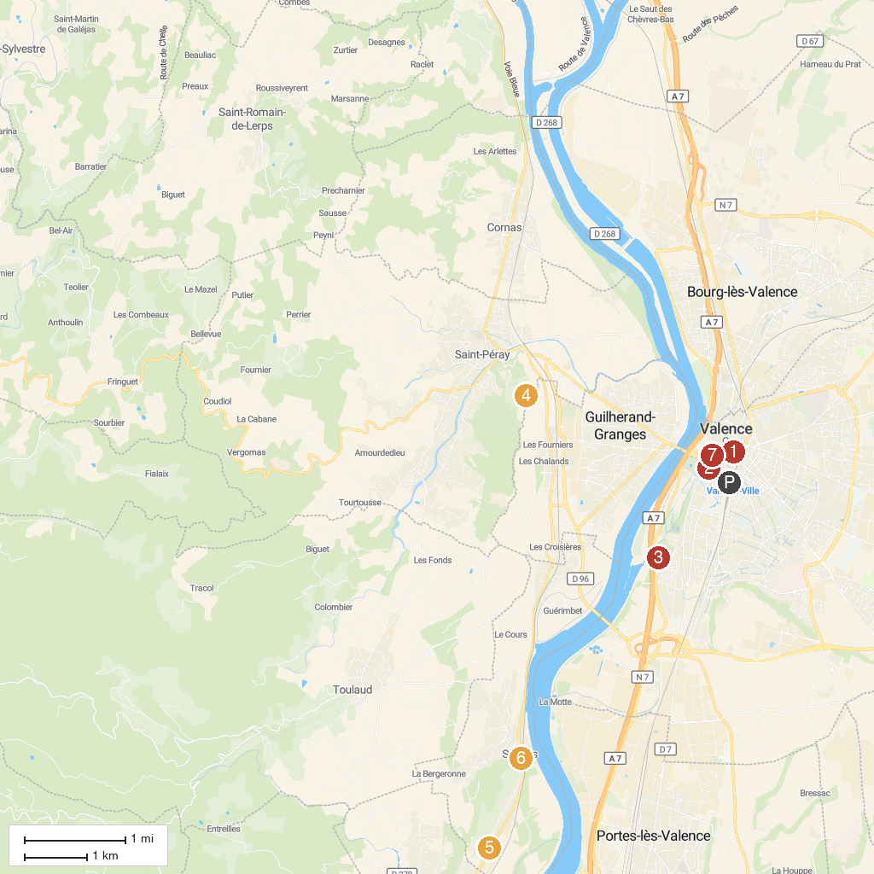
MAP KEY
1. Armenian Heritage Center | 5. Jardin des Trains Ardéchois
2. Kiosque Peynet | 6. Site archéologique: Grottes et Musée
3. Marcel Paul Park | 7. Musée de Valence, art et archéologie
4. Château de Crussol
P. Cruise port / terminal
Map © MapTiler © OpenStreetMap contributors · cruiseports.org

