Vairao, Tahiti Iti, French Polynesia
The wild side of Tahiti. Vairao anchors ships in a deep bay on Tahiti Iti, steps from the world's most fearsome wave and a roadless wilderness most tourists never reach.
⚓ Tender port · 🕒 Typical call: 6-8 hrs · 💵 French Pacific Franc (XPF) · 🗣️ French / Tahitian · 🏄 Home of Teahupo'o
✍️ MY DAY IN PORT (FILL IN)
Ship / Date
In port | arrive ______ · all aboard ______
Booked excursion
Notes / meeting point
GETTING ASHORE
- Docking: Tender — ships anchor in Vairao Bay; tender to Vairao quay (inaugurated 2018)
- Walk to center: Village shops within 5-10 min on foot; major sights require transport
- Best For: Boat tours to Teahupo'o, Fenua Aihere wilderness, Maui Beach, authentic Polynesian village life
- Don't Miss: A boat tour to the Teahupo'o reef — one of the world's most spectacular waves, safely viewed from the lagoon
GETTING AROUND
- 🚕 Taxi: 2,500–3,500 XPF (~$25–35 USD) — Regulated taxis available at the port. Fares to nearby villages are modest; a ride to Papeete (~45 km north) runs consid
- 📱 Rideshare: ❌ not available
TOP THINGS TO DO
- Teahupo'o Reef Boat Tour — The must-do at Vairao.
- Fenua Aihere Wilderness Boat Trip — The roadless far end of Tahiti Iti — accessible only by boat.
- Maui Beach Day — One of the rare white-sand beaches on Tahiti, about 10 minutes by car from the pier.
- Taravao Plateau Lookout — Drive up to the Belvedere de Taravao for sweeping views over the isthmus connecting Tahiti's two peninsulas — rolling green…
- Vaipahi Water Garden — About 20 minutes along the south coast of Tahiti Nui, this botanical garden features lush walking paths through tropical flora…
BEST WALKS
- Vairao Village Stroll: ~30-45 min · Easy · Flat — A gentle walk through this quiet Polynesian village: local homes with colorful gardens, the…
cruiseports.org/vairao · Confirm terminal & all-aboard time with your ship

Vairao, Tahiti Iti, French Polynesia — Port Map
Red = walkable sights · Amber = excursions farther out · P = cruise terminal
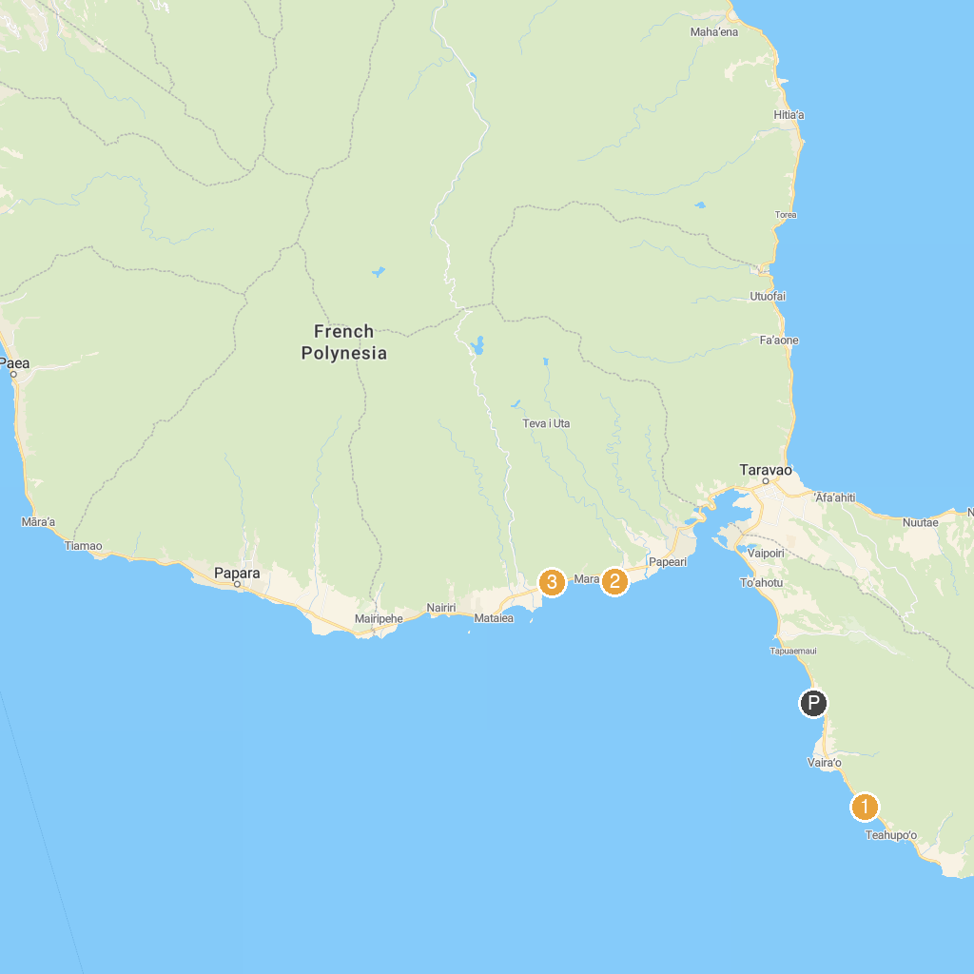
MAP KEY
1. Tahiti iti pearl farm | 3. Water Gardens Vaipahi
2. Harrison Smith Botanical Garden | 4. Vaihi Waterfalls
P. Cruise port / terminal
Map © MapTiler © OpenStreetMap contributors · cruiseports.org

