Vaasa, Ostrobothnia, Finland
Gateway to Finland's only UNESCO Natural World Heritage Site, Vaasa pairs a compact, walkable city center with striking modern art, bilingual culture, and the otherworldly Kvarken Archipelago rising from the sea.
⚓ Pier (Vaskiluoto harbor) · 🕒 Typical call: 8-10 hrs · 💶 Currency: Euro (€) · 🗣️ Languages: Finnish & Swedish
✍️ MY DAY IN PORT (FILL IN)
Ship / Date
In port | arrive ______ · all aboard ______
Booked excursion
Notes / meeting point
GETTING ASHORE
- Docking: Pier at Vaskiluoto harbor, ~2.5 km west of city center
- Walk to Center: ~30 min on foot; shuttle or bus Line 13 recommended
- Best For: UNESCO nature, modern art, Nordic town exploring
- Don't Miss: Kvarken Archipelago boat tour; Kuntsi Museum of Modern Art
GETTING AROUND
- 🚕 Taxi: €15–€38 — Taxis are available at the port; Taksi Vaasa is the local operator. The 2.5–3 km ride to the city center takes about 10
- 📱 Rideshare: ✅ Uber, Bolt
TOP THINGS TO DO
- Kvarken Archipelago Boat Tour — Finland's only UNESCO Natural World Heritage Site, the Kvarken Archipelago showcases the world's fastest-rising land — the…
- Old Vaasa Ruins — Seven kilometres southeast of the modern city lie the haunting ruins of the original Vaasa, destroyed by a great fire in 1852.
- Kuntsi Museum of Modern Art — Housed in a handsome 19th-century customs warehouse right on the inner harbor, Kuntsi holds one of Finland's finest modern and…
- Ostrobothnian Museum & Art Museum — The region's main museum complex occupies a grand building in the city center, covering Ostrobothnian cultural history, natural…
- Stundars Open Air Museum — About 15 km south in the village of Solf, Stundars is a living museum of nearly 60 traditional Ostrobothnian buildings…
BEST WALKS
- City Center Stroll: Market Square to Inner Harbor: 2 km · 30-40 min · Easy — Start at Kauppatori (Market Square), the city's lively social hub.
- Vaskiluoto Island Walk: 3 km loop · 45 min · Easy — If you have time before re-embarking, explore Vaskiluoto island itself — there's a small beach, a…
WEATHER · DAYLIGHT · MONEY
Month | High °F | Low °F | Rainy days
May | 54 | 39 | 1
Jul | 70 | 55 | 1
Sep | 58 | 46 | 1
Daylight: Sep 6:58AM–7:57PM
cruiseports.org/vaasa · Confirm terminal & all-aboard time with your ship

Vaasa, Ostrobothnia, Finland — Port Map
Red = walkable sights · Amber = excursions farther out · P = cruise terminal
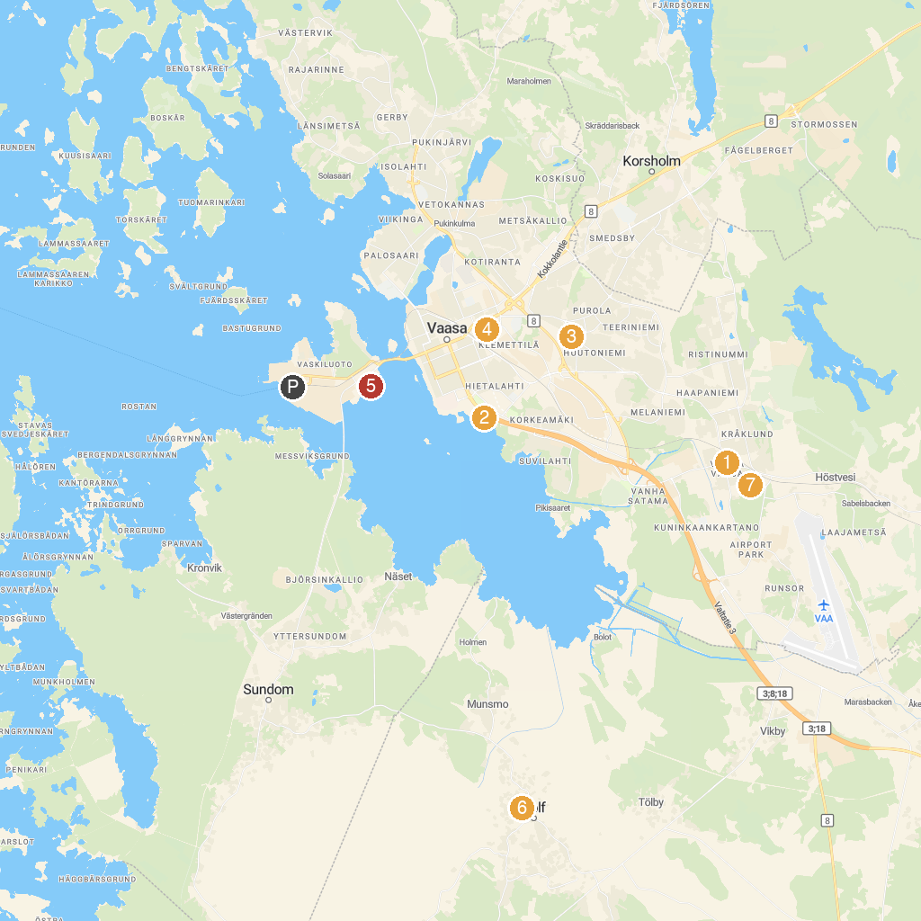
MAP KEY
1. Ruins of Old Vaasa | 5. Tropiclandia
2. Brage Open Air Museum | 6. Åminne Folkpark
3. Huutoniemi Church | 7. Stundars Agricultural Handicraft Museum
4. Vaasa Automobile and Motor Museum | 8. Korsholm Church
P. Cruise port / terminal
Map © MapTiler © OpenStreetMap contributors · cruiseports.org

