Uwajima, Ehime, Japan
A quietly compelling Shikoku port where a 400-year-old castle watches over pearl farms, ancient shrines, and one of Japan's last surviving bullfighting traditions.
⚓ Pier (Sakashizu Wharf) · 🕒 Typical call: 8-10 hrs · 💴 Japanese Yen (JPY) · 🗣️ Japanese
✍️ MY DAY IN PORT (FILL IN)
Ship / Date
In port | arrive ______ · all aboard ______
Booked excursion
Notes / meeting point
GETTING ASHORE
- Docking: Pier — Sakashizu No.2 Wharf, ~2 km from city center
- Walk to center: 20-25 min on foot or 5 min by taxi
- Best For: Castle history, pearl shopping, cultural surprises
- Don't Miss: Uwajima Castle (one of only 12 originals in Japan)
GETTING AROUND
- 🚕 Taxi: ¥800–¥1,200 — Taxis are available at the Sakashizu No. 2 Wharf and will take you to Uwajima Station / city center (approx. 3 km) in ab
TOP THINGS TO DO
- Uwajima Castle — One of only 12 original (unrestored) castles remaining in Japan, built in 1596 by Todo Takatora.
- Traditional Bullfighting (Togyu) — Uwajima is one of a handful of places in Japan where bull sumo (bull-vs-bull, no matador) has been practiced for 400 years.
- Pearl Farms & Shopping — The nutrient-rich Uwa Sea makes Uwajima one of Japan's premier pearl-cultivation regions.
- Date Museum & Tensha-en Garden — The Date Museum, near the castle, displays 13 generations of samurai swords, armor, and clan relics from the ruling Date family.
- Warei Shrine — Uwajima's principal Shinto shrine sits at the mouth of the Seki River, guarded by dramatic Otafuku and Hanadaka masks at the…
BEST WALKS
- Castle & Shrine Loop: 2.5 km · ~1.5 hrs · Mostly flat with one hill climb — From the pier, walk or taxi to Uwajima Castle park entrance, climb to the keep, then descend and…
- Pearl & Date Culture Walk: 1.5 km · ~1 hr · Flat — A shorter cultural loop from city center: browse pearl shops on the main shopping arcade, visit the…
WEATHER · DAYLIGHT · MONEY
Month | High °F | Low °F | Rainy days
May | 76 | 60 | 2
Jul | 88 | 76 | 3
Sep | 85 | 73 | 2
Daylight: May 5:10AM–7:02PM · Jul 5:11AM–7:19PM · Sep 5:53AM–6:16PM
cruiseports.org/uwajima · Confirm terminal & all-aboard time with your ship

Uwajima, Ehime, Japan — Port Map
Red = walkable sights · Amber = excursions farther out · P = cruise terminal
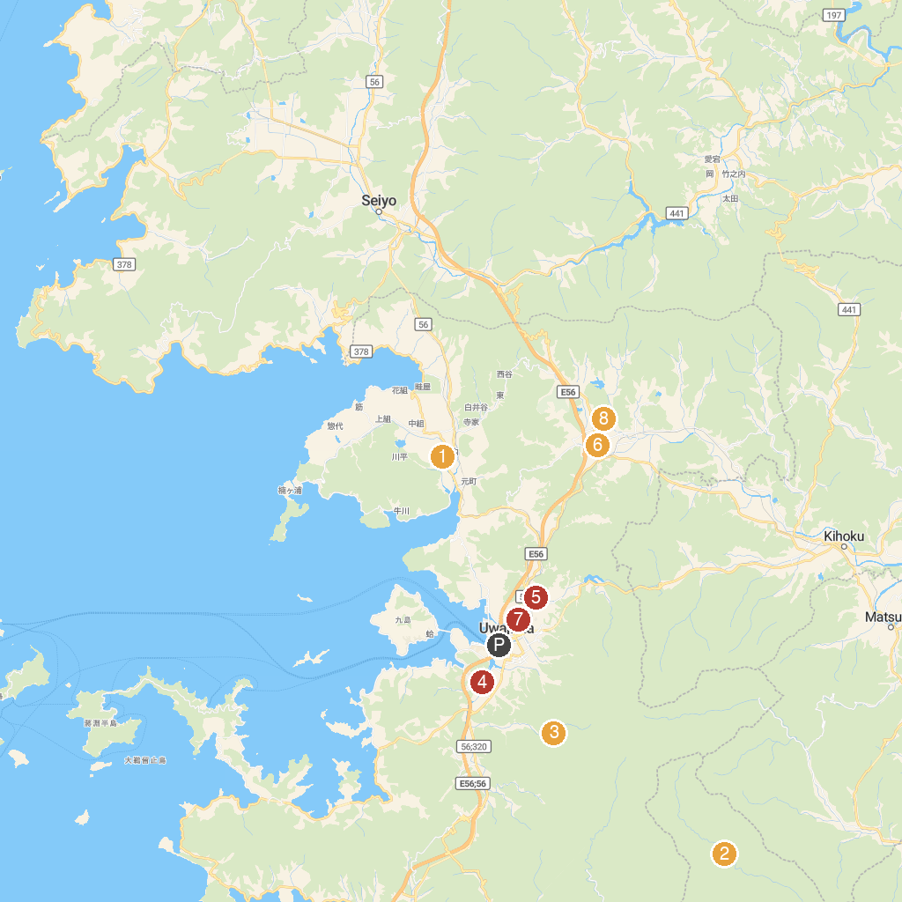
MAP KEY
1. Yoshida Park | 5. Ibukihachiman Shrine
2. Kuroson Gorge | 6. Azechi Umetaro Memorial Museum
3. Yakushidani Ravine | 7. Warei Shrine
4. Mishima Shrine | 8. Ryuukouji Temple
P. Cruise port / terminal
Map © MapTiler © OpenStreetMap contributors · cruiseports.org

