Utrecht, Utrecht Province, Netherlands
The Netherlands' best-kept city secret — Utrecht pairs a soaring Gothic tower with one-of-a-kind two-level canal wharves, a booming café culture, and almost zero tourist crowds.
⚓ Docked (river quay) · 🕒 Typical call: 8-10 hrs · 💶 Currency: Euro (€) · 🗣️ Language: Dutch (English widely spoken) · 🚲 Extremely cycle-friendly city
✍️ MY DAY IN PORT (FILL IN)
Ship / Date
In port | arrive ______ · all aboard ______
Booked excursion
Notes / meeting point
GETTING ASHORE
- Docking: Alongside river quay (Amsterdam-Rhine Canal area) — no tender
- Walk to center: ~1.5–2.5 km (20–30 min flat walk) or short taxi/bus
- Best For: Medieval history, canal-side dining, architecture, day-trippers
- Don't Miss: Climbing the Dom Tower & exploring DOMunder beneath Dom Square
GETTING AROUND
- 🚕 Taxi: €15–€22 — Metered taxis available but not staged at the industrial canal berth. Pre-book with UTC or Staxi for a fixed fare to the
- 📱 Rideshare: ✅ Uber, Bolt
TOP THINGS TO DO
- Climb the Dom Tower — At 112 m, the Dom Tower is the tallest church tower in the Netherlands.
- DOMunder Archaeological Tour — Armed with a flashlight, descend beneath Dom Square to explore two millennia of Utrecht's history — Roman fortress, medieval…
- Oudegracht Canal Walk & Wharf Cellars — Utrecht's medieval canals are unique: the wharves sit a full level below street, and the arched cellar doors now house…
- Museum Speelklok — A medieval church packed with self-playing musical instruments — from ornate 18th-century music boxes to enormous fairground…
- City Cycling Tour — Utrecht is one of the world's great cycling cities — over 300 km of bike lanes and a culture built on two wheels.
BEST WALKS
- Dom Square to the Old Canal: 1.5 km · 30–40 min · flat — Start at the iconic Dom Tower and Domkerk, duck into the peaceful Pandhof cloister garden, then…
- Miffy Walk: 1 km · 20 min · flat — Pay tribute to Utrecht's most famous resident: find the Miffy traffic light at Lange Vliestraat…
WEATHER · DAYLIGHT · MONEY
Month | High °F | Low °F | Rainy days
May | 65 | 46 | 1
Jul | 74 | 55 | 1
Sep | 69 | 50 | 1
Daylight: May 5:45AM–9:27PM · Jul 5:37AM–9:52PM · Sep 7:14AM–7:53PM
cruiseports.org/utrecht · Confirm terminal & all-aboard time with your ship

Utrecht, Utrecht Province, Netherlands — Port Map
Red = walkable sights · Amber = excursions farther out · P = cruise terminal
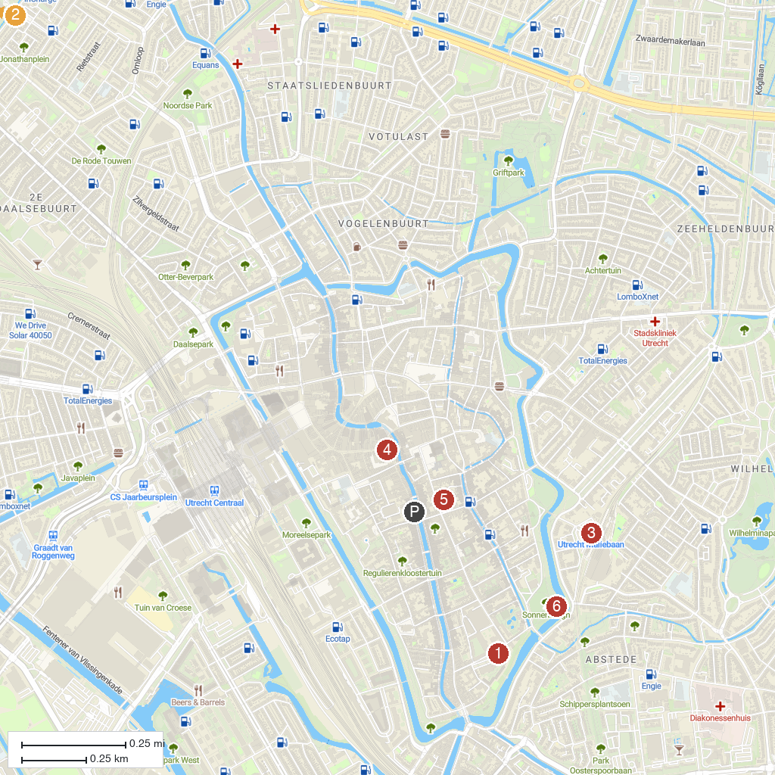
MAP KEY
1. Centraal Museum | 5. Het Utrechts Archief - Expo
2. De Haar Castle | 6. De Stulp
3. The Railway Museum | 7. Sonnenborgh Observatory
4. Museum Speelklok
P. Cruise port / terminal
Map © MapTiler © OpenStreetMap contributors · cruiseports.org

