Ushuaia, Argentina
The southernmost city on Earth — gateway to Antarctica, framed by the snow-capped Martial Mountains and the legendary Beagle Channel. The literal end of the world.
⚓ Docked (city-center pier) · 🕒 Typical call: 8–10 hrs · 💵 Argentine Peso (ARS) · USD widely used · 🗣️ Spanish · English in tourism
✍️ MY DAY IN PORT (FILL IN)
Ship / Date
In port | arrive ______ · all aboard ______
Booked excursion
Notes / meeting point
GETTING ASHORE
- Docking: Pier in town
- Walk to center: 5 min
- Best For: Nature · Wildlife · Hiking
- Don't Miss: Beagle Channel cruise
GETTING AROUND
- 🚕 Taxi: ~$3–5 USD — Taxis are plentiful at the pier. The short hop to the city center runs roughly $3–5 USD. Drivers prefer Argentine Pesos
- 📱 Rideshare: ✅ Uber
- 🚌 Hop-on hop-off: ✅
TOP THINGS TO DO
- Beagle Channel Catamaran Cruise — Sail the channel Darwin charted, past sea lion colonies, cormorant rookeries, and the iconic Les Éclaireurs Lighthouse (the…
- Tierra del Fuego National Park — Sub-Antarctic forest, peat bogs, Lapataia Bay, and the marker where the Pan-American Highway ends.
- End of the World Train (Tren del Fin del Mundo) — A narrow-gauge heritage steam railway that retraces the route prisoners once rode to fell timber.
- Catamaran to Gable Island & Penguin Colony — A longer channel trip out to a Magellanic (and sometimes Gentoo) penguin rookery, often with a walk on Gable Island and an…
BEST WALKS
- San Martín street & the waterfront: ~2 km · 1 hr · easy — Stroll the main drag for outdoor gear, chocolate, and king-crab restaurants, then loop back along…
- Glaciar Martial trail: ~5 km round-trip · 2.5–3 hrs · moderate–strenuous — A steep climb above town to the Martial Glacier cirque, with sweeping views over the city, channel…
- Museo Marítimo & ex-Presidio: ~1 km · 1.5 hrs · easy — The former end-of-the-world prison, now a museum of Antarctic exploration, maritime history, and…
WEATHER · DAYLIGHT · MONEY
Month | High °F | Low °F | Rainy days
May | 42 | 33 | 16
Jul | 36 | 27 | 15
Sep | 41 | 31 | 16
Daylight: May 9:19AM–5:38PM · Jul 9:47AM–5:31PM · Sep 7:39AM–7:18PM
cruiseports.org/ushuaia · Confirm terminal & all-aboard time with your ship

Ushuaia, Argentina — Port Map
Red = walkable sights · Amber = excursions farther out · P = cruise terminal
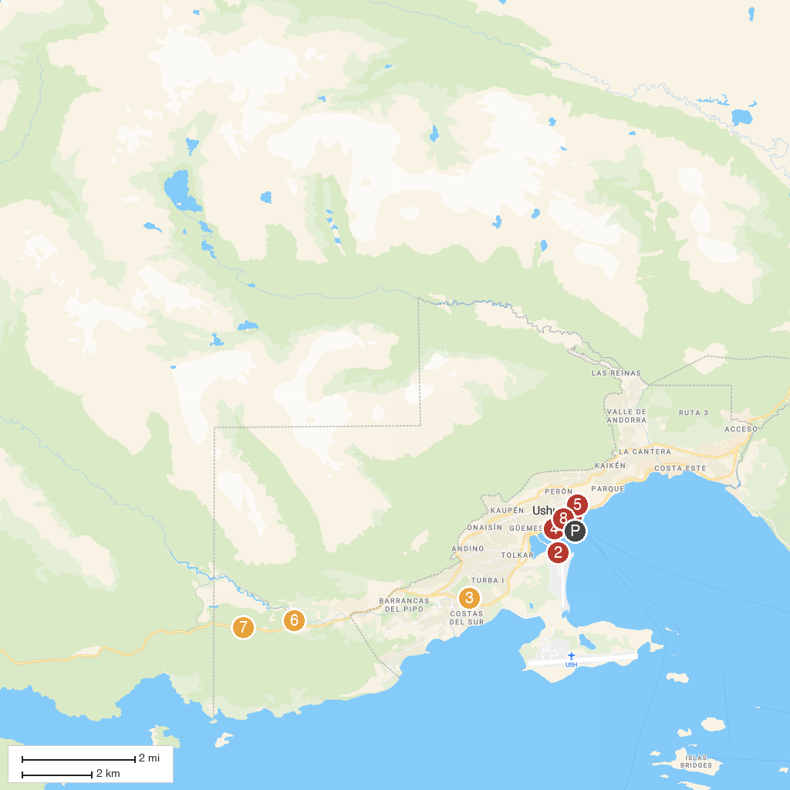
MAP KEY
1. Museo del Fin del Mundo | 5. Museo Marítimo y del Presidio de Ushuaia
2. Ushuaia Aeroclub | 6. Southern Fuegian Railway
3. Gumo on the Way | 7. Parque Nacional Tierra del Fuego
4. Saint Christopher | 8. Museo del Fin del Mundo - Antigua Casa de Gobierno
P. Cruise port / terminal
Map © MapTiler © OpenStreetMap contributors · cruiseports.org

