Umeå, Västerbotten, Sweden
Sweden's "City of Birches" surprises cruisers with free world-class museums, a thriving arts scene, and a very un-touristy northern Swedish university city that actually lives its culture.
⚓ Pier port (Holmsund) · 🚌 Shuttle required — 18 km to city · 🕒 Typical call: 8-10 hrs · 💳 Cashless — cards only · 🗣️ Swedish (English universal)
✍️ MY DAY IN PORT (FILL IN)
Ship / Date
In port | arrive ______ · all aboard ______
Booked excursion
Notes / meeting point
GETTING ASHORE
- Docking: Pier at Holmsund port, ~18 km south of city center
- Walk to center: Not walkable — shuttle or taxi required (~20 min drive)
- Best For: Free museums, contemporary art, birch-lined walks, local cuisine
- Don't Miss: Bildmuseet (free contemporary art), Västerbottens Museum & Gammlia
GETTING AROUND
- 🚕 Taxi: ~700–800 SEK (~–75 USD) one way — Taxis are available at the port. The ~18 km journey to city center is estimated at 700–800 SEK based on Umeå taxi base f
- 📱 Rideshare: ✅ Uber
TOP THINGS TO DO
- Västerbottens Museum & Gammlia Open-Air Museum — One of Sweden's best regional museums — free indoor exhibits on Sámi culture and the Kalvträsk ski — among the world's oldest…
- Bildmuseet — Contemporary Art by the River — A striking geometric museum on the Umeå Arts Campus showcasing international contemporary art.
- Guitars — The Museum — One of the world's great private guitar collections — rare Gibsons and Fenders from the 1950s and 60s, amplifiers, and memorabilia.
- Kvarken Archipelago (UNESCO World Heritage) — The only UNESCO World Heritage site shared between Sweden and Finland, where the land rises 9 mm per year due to post-glacial…
- Umedalen Sculpture Park — More than 40 works by international sculptors scattered through a pine forest on the outskirts of the city — free to visit and…
BEST WALKS
- Birch Avenues & Riverfront Walk: 2-3 km | Easy | 45-60 min — Stroll the famous birch-lined streets planted after the 1888 fire, down to the Ume River waterfront…
- City Center Culture Loop: 2 km | Easy | 1-2 hrs — Walk from the town hall square to the Väven Cultural Centre, then to the Guitars Museum and on to…
WEATHER · DAYLIGHT · MONEY
Month | High °F | Low °F | Rainy days
May | 54 | 36 | 0
Jul | 69 | 52 | 0
Sep | 58 | 41 | 1
Daylight: May 3:27AM–9:45PM · Sep 6:02AM–7:03PM
cruiseports.org/umea · Confirm terminal & all-aboard time with your ship

Umeå, Västerbotten, Sweden — Port Map
Red = walkable sights · Amber = excursions farther out · P = cruise terminal
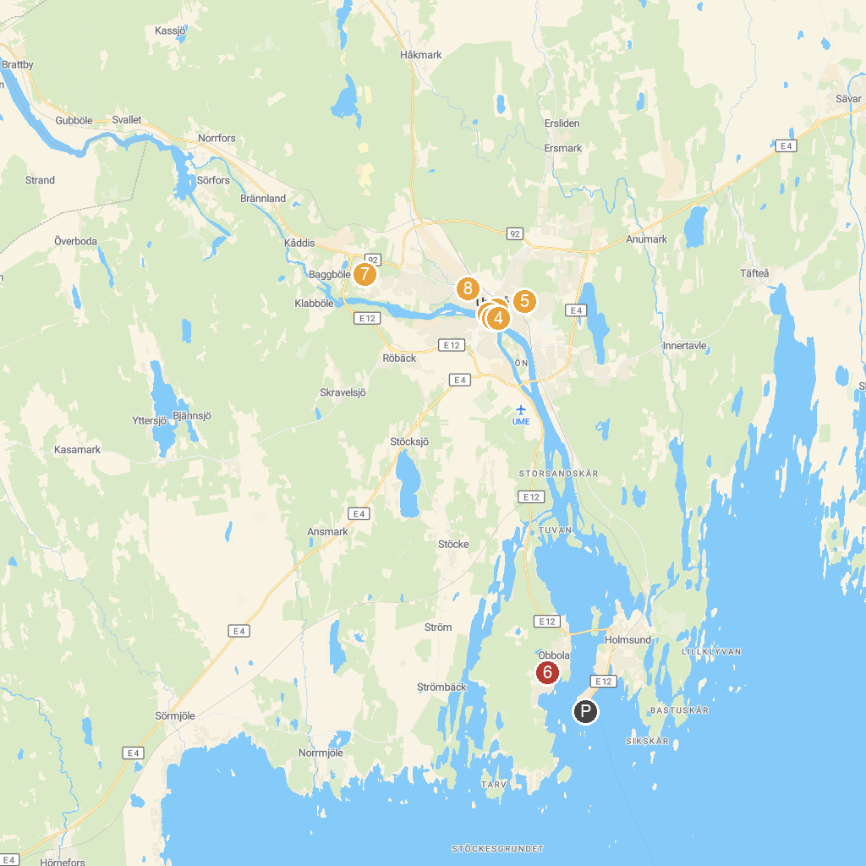
MAP KEY
1. Guitars the Museum | 5. Västerbotten museum
2. Kulturväven | 6. Obbolabadet
3. Årstidernas park | 7. Umedalen skulpturpark
4. Umeå City Church | 8. Nolia huoltohalli
P. Cruise port / terminal
Map © MapTiler © OpenStreetMap contributors · cruiseports.org

