Ulva Island, Southland, New Zealand
One of the world's few open predator-free sanctuaries, Ulva Island dazzles with ancient podocarp forest and birds so fearless they'll hop onto your boots.
⚓ Tender (expedition Zodiacs or water taxi from Oban) · 🕒 Typical call: 5-8 hrs · 💵 NZD · 🗣️ English / Te Reo Māori · 🦜 Wildlife & nature focus
✍️ MY DAY IN PORT (FILL IN)
Ship / Date
In port | arrive ______ · all aboard ______
Booked excursion
Notes / meeting point
GETTING ASHORE
- Docking: Tender only — expedition ships anchor in Paterson Inlet; larger ships tender to Oban then water taxi (~7 min) to island
- Walk to Highlights: Tracks start at the wharf; Sydney Cove 5 min, Boulder Beach 1.5 hrs return
- Best For: Birdwatching, untouched native forest, wildlife photography
- Don't Miss: Kākā parrots in the canopy, fearless robins on the trail, historic Post Office Bay letterbox
GETTING AROUND
- 🚕 Taxi: NZD $32–$35 return (adult) — The only way to reach Ulva Island is by water taxi from Golden Bay Wharf on Stewart Island. Multiple operators run sched
- 📱 Rideshare: ❌ not available
TOP THINGS TO DO
- Guided Birdwatching Walk — Expert local guides (Ulva's Guided Walks, Ruggedy Range) lead 2.5–3-hr walks, identifying bird calls, mimicking them to draw…
- Boulder Beach Loop — The island's signature self-guided circuit through ancient Rimu and Totara podocarp forest to the rugged southern shore.
- Post Office Bay to Sydney Cove Stroll — Short, flat walk from the main landing wharf through forest to a golden-sand beach.
- Sea Kayaking & Snorkelling — The Ulva Island–Te Wharawhara Marine Reserve (est.
BEST WALKS
- Boulder Beach Loop: ~3 km | 1.5 hrs return | Easy — From Post Office Bay wharf, follow the main track south through ancient podocarp forest past West…
- Flagstaff Point Lookout: 20 min return | Easy — Short track from Post Office Bay to a hilltop lookout with panoramic views across Paterson Inlet to…
- Sydney Cove Beach: 5 min from Post Office Bay | Very easy — Flat path from the main wharf to a sheltered golden-sand beach.
cruiseports.org/ulva-island-nz · Confirm terminal & all-aboard time with your ship

Ulva Island, Southland, New Zealand — Port Map
Red = walkable sights · Amber = excursions farther out · P = cruise terminal
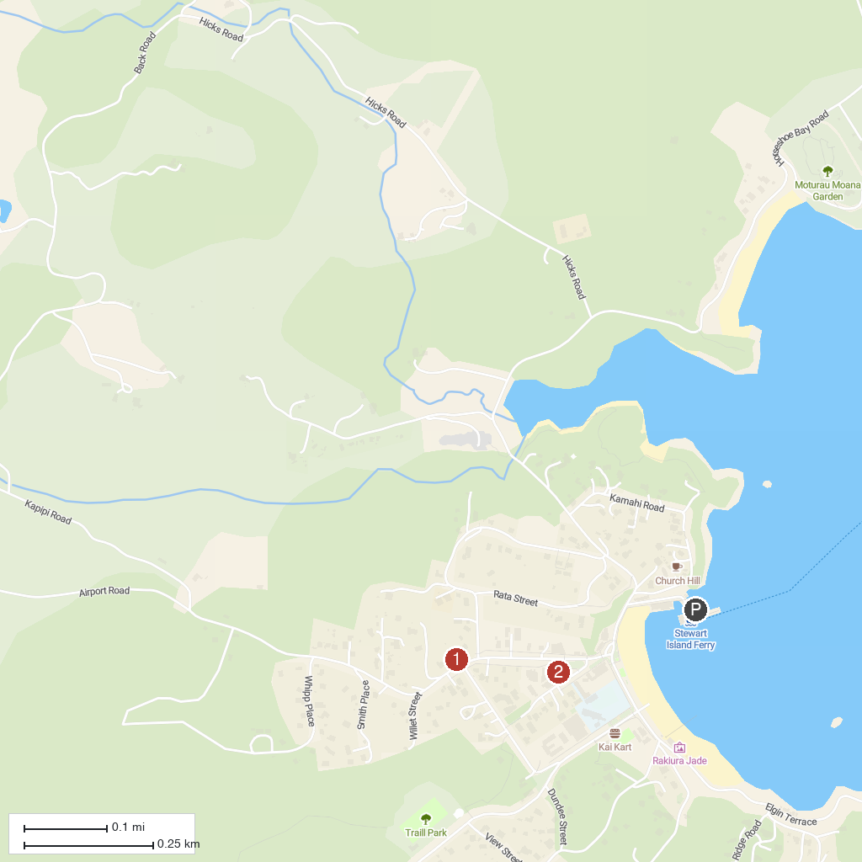
MAP KEY
1. Tequila Fishing and Bird Watching Charters | 2. Rakiura Museum
P. Cruise port / terminal
Map © MapTiler © OpenStreetMap contributors · cruiseports.org

