Ulsteinvik, Møre og Romsdal, Norway
An unspoiled Norwegian maritime hub where futuristic X-BOW ships share the harbour with seabird cliffs and sandy Atlantic beaches — no tourist crowds, just genuine coastal life.
⚓ Pier (alongside) · 🕒 Typical call: 6-8 hrs · 💵 Norwegian Krone (NOK) — cards universal · 🗣️ Norwegian (English widely spoken)
✍️ MY DAY IN PORT (FILL IN)
Ship / Date
In port | arrive ______ · all aboard ______
Booked excursion
Notes / meeting point
GETTING ASHORE
- Docking: Pier alongside (Storkaia/Kvalneset); tender very rare
- Walk to centre: 3–10 min flat walk from gangway
- Best For: Coastal hikes, birdwatching, maritime curiosity
- Don't Miss: Runde Island puffins (May–Jul) or hike Hasundhornet
GETTING AROUND
- 🚕 Taxi: 130–160 kr (~$12–15 USD) — Local taxis are available from the port to the town center (~3 km, ~3 minutes). Advance booking recommended; surcharges
- 📱 Rideshare: ❌ not available
TOP THINGS TO DO
- Runde Bird Island — A 45-minute drive or RIB boat ride to Runde, where over 500,000 seabirds — including Atlantic puffins — nest in dramatic sea…
- RIB Fjord & Ocean Safari — High-speed inflatable boat tours along the island coastline, past seal colonies, sea eagle nesting sites, and dramatic sea stacks.
- Hike Hasundhornet — A rewarding hike straight from the port to the 533 m summit of Hasundhornet, with 360-degree views of the surrounding islands…
- Ulsteinvik Town Walk — Walk the working shipyard waterfront where Ulstein X-BOW vessels are built, visit the octagonal 1849 Ulstein Kyrkje church, and…
- Sunnmørsbadet Water Park — A modern indoor water park and spa in the town centre with wave pool, slides, and thermal hot tubs — a perfect retreat on a rainy…
BEST WALKS
- Waterfront & Town Circuit: 1.5 km · 25 min · Flat · Free — From the pier, walk the working harbour past the X-BOW shipyard hulls to the Sjøborg Cultural…
- Osnesanden Beach Stroll: 2 km · 20 min each way · Flat · Free — A pleasant coastal walk from the pier to Osnesanden, a crescent sandy beach with a playground and…
WEATHER · DAYLIGHT · MONEY
Month | High °F | Low °F | Rainy days
May | 90 | 75 | 1
Jul | 90 | 74 | 1
Sep | 91 | 73 | 1
Daylight: May 4:40AM–10:27PM · Sep 7:02AM–7:59PM
cruiseports.org/ulsteinvik · Confirm terminal & all-aboard time with your ship

Ulsteinvik, Møre og Romsdal, Norway — Port Map
Red = walkable sights · Amber = excursions farther out · P = cruise terminal
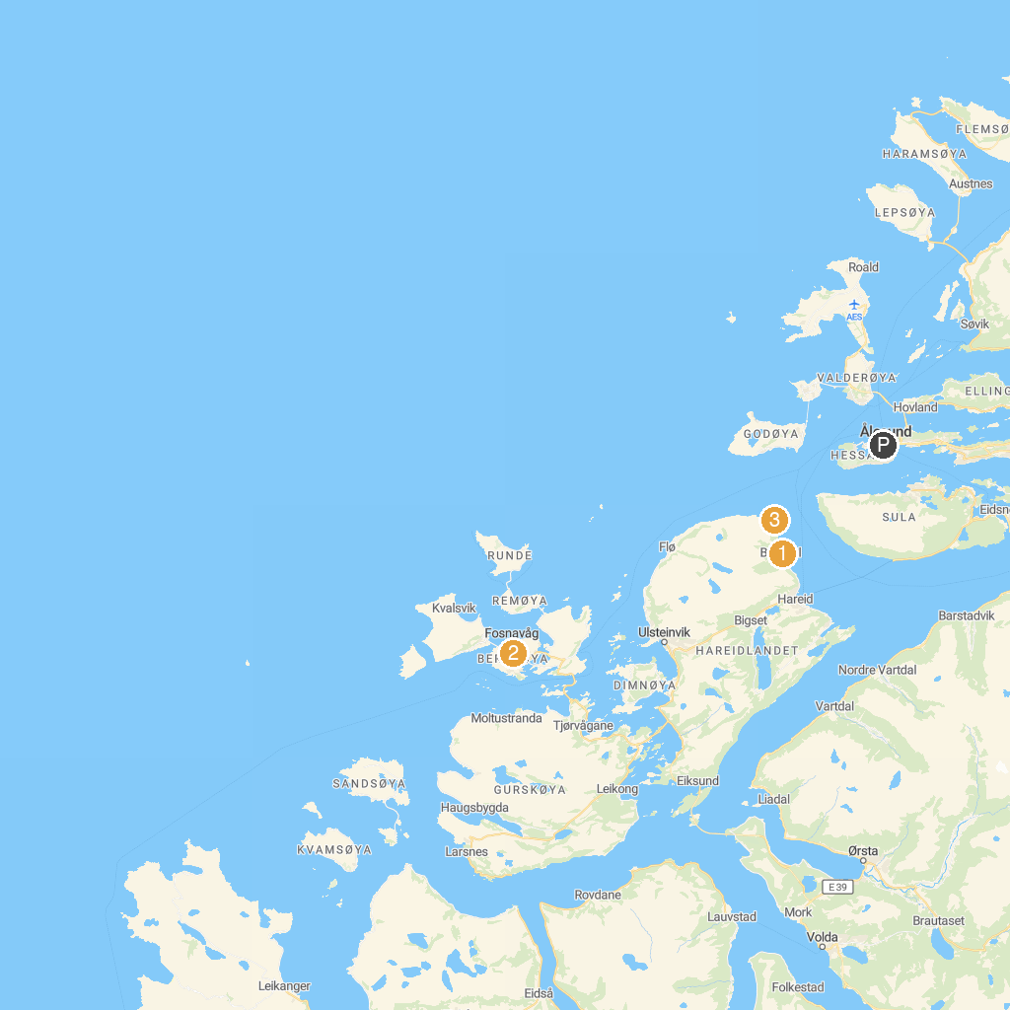
MAP KEY
1. Ishavsmuseet Aarvak | 3. Kvitneset
2. Herøy Church
P. Cruise port / terminal
Map © MapTiler © OpenStreetMap contributors · cruiseports.org

