Ulsan, South Korea
The city that built modern Korea — home to the world's largest car plant and shipyard — surprises cruise visitors with dramatic coastal parks, bamboo forests, and Neolithic whale carvings that predate history.
⚓ Pier (cargo berth) · 🕒 Typical call: 8-10 hrs · 💵 Korean Won (KRW) · 🗣️ Korean (minimal English) · 🐋 Whale heritage
✍️ MY DAY IN PORT (FILL IN)
Ship / Date
In port | arrive ______ · all aboard ______
Booked excursion
Notes / meeting point
GETTING ASHORE
- Docking: Alongside pier at Ulsan Main Port; no tender operations
- Walk to center: Not walkable — taxi or shuttle required (port is industrial/secure)
- Best For: Industrial tourism, coastal parks, Korean culinary experiences
- Don't Miss: Taehwagang National Garden bamboo grove and Daewangam coastal park
GETTING AROUND
- 🚕 Taxi: ₩4,500 base + meter — Metered taxis are readily available in Ulsan. The base fare is ₩4,500 KRW; expect ₩10,000–₩20,000 KRW to central Ulsan d
- 📱 Rideshare: ✅ Kakao T, Uber Taxi
- 🚌 Hop-on hop-off: ✅
TOP THINGS TO DO
- Taehwagang National Garden & Bamboo Grove — Once a polluted river, the Taehwagang was transformed into a vast award-winning ecological park.
- Daewangam Coastal Park — A forest of 15,000 pine trees leads to dramatic rocky coastline.
- Bangudae Petroglyphs — Neolithic and Bronze Age rock carvings depicting whales, deer, and hunters — considered humanity's earliest record of whaling.
- Jangsaengpo Whale Culture Village — Korea banned commercial whaling in 1986 and Ulsan pivoted to whale conservation tourism.
- Hyundai Motor Plant Tour — The largest single automobile factory in the world.
BEST WALKS
- Daewangam Park Coastal Loop: 3 km · 1 hr · Easy · Free — From the park entrance, follow pine-shaded paths to the dramatic rocky shoreline, cross the…
- Taehwagang Bamboo Grove Stroll: 4 km · 1-1.5 hrs · Flat · Free — Walk the length of the Simnidaesup bamboo forest along the Taehwagang riverbank — serene…
WEATHER · DAYLIGHT · MONEY
Month | High °F | Low °F | Rainy days
May | 74 | 57 | 2
Jul | 83 | 72 | 3
Sep | 77 | 66 | 4
Daylight: May 5:18AM–7:20PM · Jul 5:18AM–7:38PM · Sep 6:05AM–6:29PM
cruiseports.org/ulsan · Confirm terminal & all-aboard time with your ship

Ulsan, South Korea — Port Map
Red = walkable sights · Amber = excursions farther out · P = cruise terminal
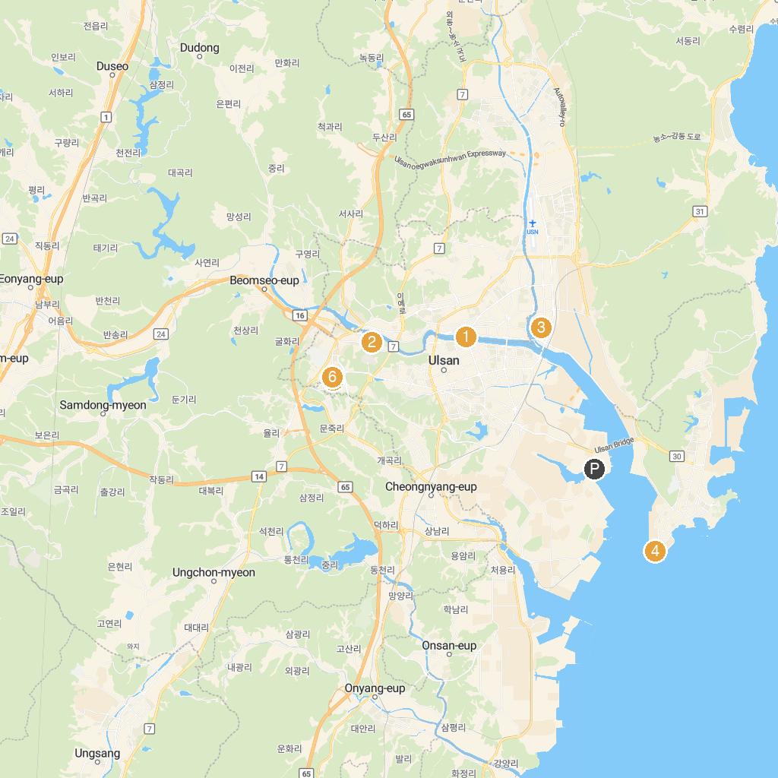
MAP KEY
1. 울산교 장생이다리 | 5. Yong-gul
2. 와와공원 | 6. Seuldo Lighthouse
3. 명촌근린공원 | 7. 문수호반광장
4. 화암추등대 | 8. 문수체육공원
P. Cruise port / terminal
Map © MapTiler © OpenStreetMap contributors · cruiseports.org

