Uelzen, Lower Saxony, Germany
A fairy-tale Hanseatic market town made famous by one of the world's most extraordinary railway stations — Friedensreich Hundertwasser's riot of colour, mosaic, and organic architecture, just steps from a perfectly preserved medieval centre.
⚓ Pier (Elbe Lateral Canal) · 🕒 Typical call: 6–8 hrs · 💶 Euro (€) · 🗣️ German
✍️ MY DAY IN PORT (FILL IN)
Ship / Date
In port | arrive ______ · all aboard ______
Booked excursion
Notes / meeting point
GETTING ASHORE
- Docking: Pier on the Elbe-Seitenkanal (Elbe Lateral Canal); always docked, no tender
- Walk to centre: ~2.5–3 km (30–40 min) or 5-min taxi; many ships offer a shuttle
- Best For: Art lovers, architecture fans, cycling, Hanseatic history
- Don't Miss: Hundertwasserbahnhof — one of the world's most stunning train stations
GETTING AROUND
- 🚕 Taxi: €10–€18 — Taxis are available in Uelzen with a base fare of €4.50 and €2.80/km. Short trips from the river dock to the city center
- 📱 Rideshare: ❌ not available
TOP THINGS TO DO
- Hundertwasserbahnhof Guided Tour — Step inside one of the world's most extraordinary railway stations, redesigned by Austrian artist Friedensreich Hundertwasser for…
- Uelzen Altstadt & Path of Stones — Follow the Weg der Steine — 21 massive painted boulders by German-Swedish artist Dagmar Glemme — from the Hundertwasser Station…
- Uelzen Lock (Schleuse Uelzen) — One of the largest inland locks in Germany, lifting vessels a full 23 metres on the Elbe-Seitenkanal.
- Lüneburg Heath Hike or Cycle — Uelzen sits on the edge of the famous Lüneburger Heide — broad purple heather moorland, juniper scrub, and quiet woodland.
- Museum Schloss Holdenstedt — An elegant 18th-century baroque castle on the edge of Uelzen housing local history collections.
BEST WALKS
- Canal Pier to Hundertwasser Station & Old Town: 3 km | 35–40 min | Easy, flat — Follow the canal-side path west from the ship toward the town, crossing into the Bahnhofstrasse…
- Oldenstädter See (Lake Swim): 3.5 km from pier | 45 min walk | Easy — In summer, locals flock to this sandy-shored former gravel quarry north of the canal.
WEATHER · DAYLIGHT · MONEY
Month | High °F | Low °F | Rainy days
May | 66 | 44 | 1
Jul | 77 | 54 | 1
Sep | 69 | 48 | 1
Daylight: May 5:19AM–9:09PM · Jul 5:11AM–9:35PM · Sep 6:52AM–7:32PM
cruiseports.org/uelzen · Confirm terminal & all-aboard time with your ship

Uelzen, Lower Saxony, Germany — Port Map
Red = walkable sights · Amber = excursions farther out · P = cruise terminal
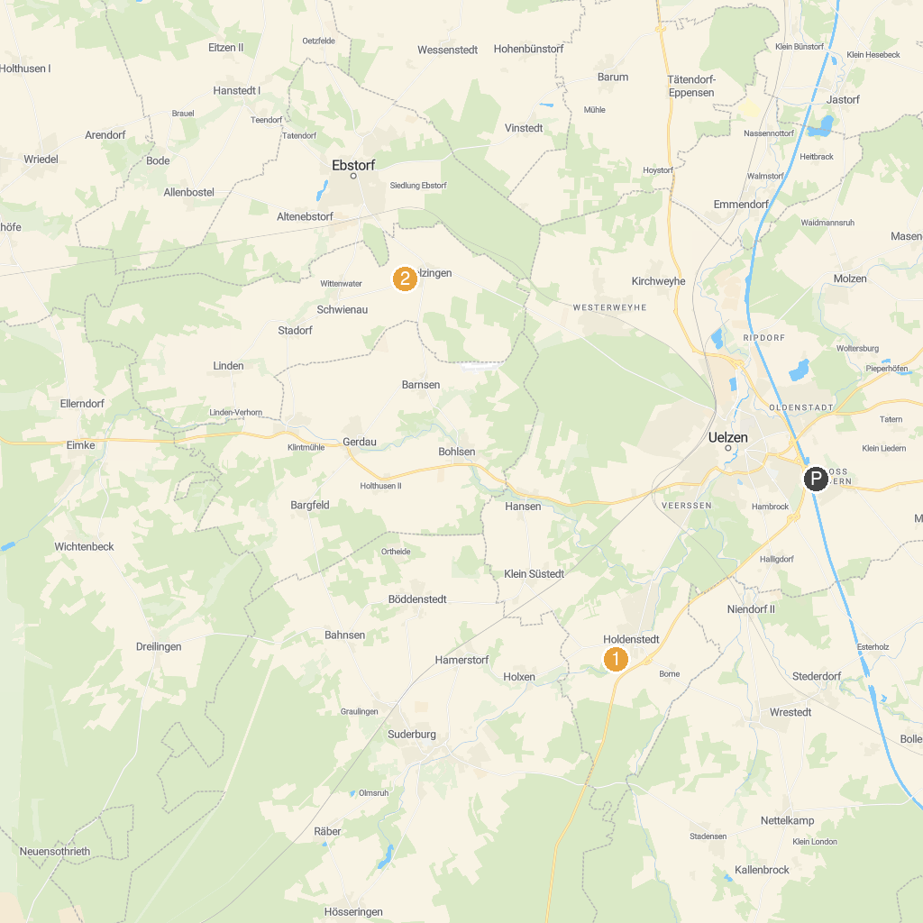
MAP KEY
1. Schloss Holdenstedt | 3. Neptun-Brunnen
2. Arboretum Melzingen | 4. Handwerksmuseum-Suhlendorf
P. Cruise port / terminal
Map © MapTiler © OpenStreetMap contributors · cruiseports.org

