Ube, Yamaguchi, Japan
Japan's underrated 'Sculpture City' on the Seto Inland Sea coast, where 200+ outdoor artworks dot an industrial port town that also hides one of the country's finest zen gardens and a proud pufferfish tradition.
⚓ Pier (Shibanaka Wharf) · 🕒 Typical call: 9–12 hrs · 💴 Currency: Japanese Yen (cash strongly recommended) · 🗣️ Language: Japanese (little English outside tourist desks) · 🎨 Sculpture Biennale city
✍️ MY DAY IN PORT (FILL IN)
Ship / Date
In port | arrive ______ · all aboard ______
Booked excursion
Notes / meeting point
GETTING ASHORE
- Docking: Pier — Shibanaka West No.1 Wharf (270 m berth, 13 m depth)
- Walk to center: ~20–30 min on foot or 10 min by taxi to Tokiwa Park area
- Best For: Outdoor sculpture, zen gardens, off-the-beaten-path Japan, local cuisine
- Don't Miss: Tokiwa Park's 200+ Biennale sculptures and Ryushin Garden at Sourinji Temple
GETTING AROUND
- 🚕 Taxi: ¥500–¥1,500 — Ube Port is about a 5-minute drive from the city center, making taxi the easiest option. Multiple local companies operat
- 📱 Rideshare: ❌ not available
TOP THINGS TO DO
- Tokiwa Park & Ube Biennale Sculptures — Ube's crown jewel: a vast lakeside park scattered with 200+ monumental sculptures from the city's international biennial art…
- Sourinji Temple & Ryushin Garden — Founded in 777 AD, this Zen temple is home to Ryushin Garden — designated a National Scenic Spot and the oldest surviving garden…
- Ube Coal Mining Museum (Sekitan Kinenkan) — Ube built its modern identity on coal mining.
- Fugu (Pufferfish) Lunch — Yamaguchi Prefecture is one of Japan's top fugu regions.
- Ono Tea Plantation (Fujigochi) — Western Japan's largest tea plantation spreads across the hills above Ube, producing the bulk of Yamaguchi Prefecture's tea.
BEST WALKS
- Tokiwa Park Sculpture Walk: 3 km loop | Easy | 1–2 hrs — Meander the lakeside paths of Tokiwa Park, stopping at Biennale sculptures along the way.
- Sourinji Temple & Ryushin Garden: Short walk on temple grounds | Easy | 45 min — A short taxi ride from the park brings you to Sourinji Temple.
WEATHER · DAYLIGHT · MONEY
Month | High °F | Low °F | Rainy days
May | 74 | 59 | 2
Jul | 85 | 75 | 2
Sep | 81 | 70 | 2
Daylight: May 5:14AM–7:09PM · Jul 5:15AM–7:26PM · Sep 5:58AM–6:21PM
cruiseports.org/ube-yamaguchi-city · Confirm terminal & all-aboard time with your ship

Ube, Yamaguchi, Japan — Port Map
Red = walkable sights · Amber = excursions farther out · P = cruise terminal
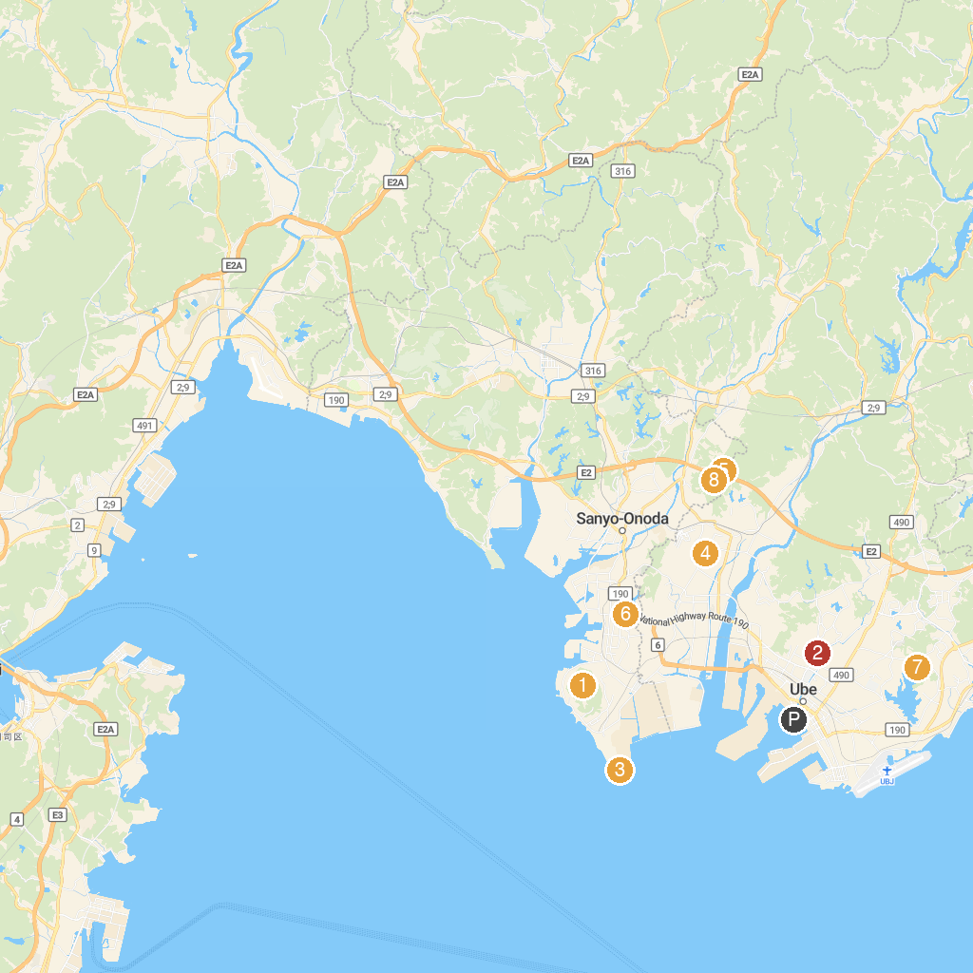
MAP KEY
1. Ryuozan Park | 5. Kumano Shrine
2. Sorinji Temple Garden | 6. Wakayama Park
3. Motoyamamisaki Park | 7. ときわ公園スポーツ広場
4. Renkoji | 8. Ariho Ryokuchi Park
P. Cruise port / terminal
Map © MapTiler © OpenStreetMap contributors · cruiseports.org

