Ubatuba, São Paulo, Brazil
Where the Mata Atlântica tumbles straight into the sea. Ubatuba's emerald mountains, sea-turtle conservation center, and hundred-plus beaches make it one of Brazil's most photogenic — and genuinely wild — cruise stops.
⚓ Tender port (no pier) · 🕒 Typical call: 7-9 hrs · 💵 Brazilian Real (BRL) · 🗣️ Portuguese · 🌧️ Bring a rain layer
✍️ MY DAY IN PORT (FILL IN)
Ship / Date
In port | arrive ______ · all aboard ______
Booked excursion
Notes / meeting point
GETTING ASHORE
- Docking: Tender — ships anchor offshore; ~7 min tender ride to Saco da Ribeira or Praia do Itaguá
- Walk to center: Walkable from Itaguá tender pier; Saco da Ribeira requires a taxi (15 km)
- Best For: Beaches, sea-turtle encounters, Atlantic rainforest hikes, boat trips to Ilha Anchieta
- Don't Miss: Projeto Tamar sea-turtle center and a schooner tour to Ilha Anchieta State Park
GETTING AROUND
- 🚕 Taxi: R$30–50 — Taxis are available from the tender dock. A ride to beaches or town areas within Ubatuba typically costs R$30–50 dependi
- 📱 Rideshare: ✅ Uber, 99
TOP THINGS TO DO
- Projeto Tamar Sea Turtle Center — Walk 10 minutes from the Itaguá pier to this world-renowned conservation project.
- Schooner to Ilha Anchieta State Park — Board a traditional escuna at the Saco da Ribeira marina for the ~30-minute crossing to Ilha Anchieta.
- Beach Day at Praia do Lázaro — Calm, shallow waters shaded by almond trees make Lázaro the best beach for swimmers and families.
- Atlantic Forest Hiking — Serra do Mar State Park covers 80% of Ubatuba with dense jungle mountains rising straight from the coast.
- Historic Center & Craft Market — Stroll from the Itaguá pier to the 1846 Sobradão do Porto colonial mansion and the Igreja Matriz.
BEST WALKS
- Itaguá Pier to Projeto Tamar & Historic Center: 1.5 km loop · ~30 min · Easy — From the tender landing at Praia do Itaguá, walk north along the beachfront promenade to Projeto…
- Aquarium & Town Explore: 1 km · ~20 min · Easy — Head south from the Itaguá pier to the Aquário de Ubatuba (5 min walk).
cruiseports.org/ubatuba · Confirm terminal & all-aboard time with your ship

Ubatuba, São Paulo, Brazil — Port Map
Red = walkable sights · Amber = excursions farther out · P = cruise terminal
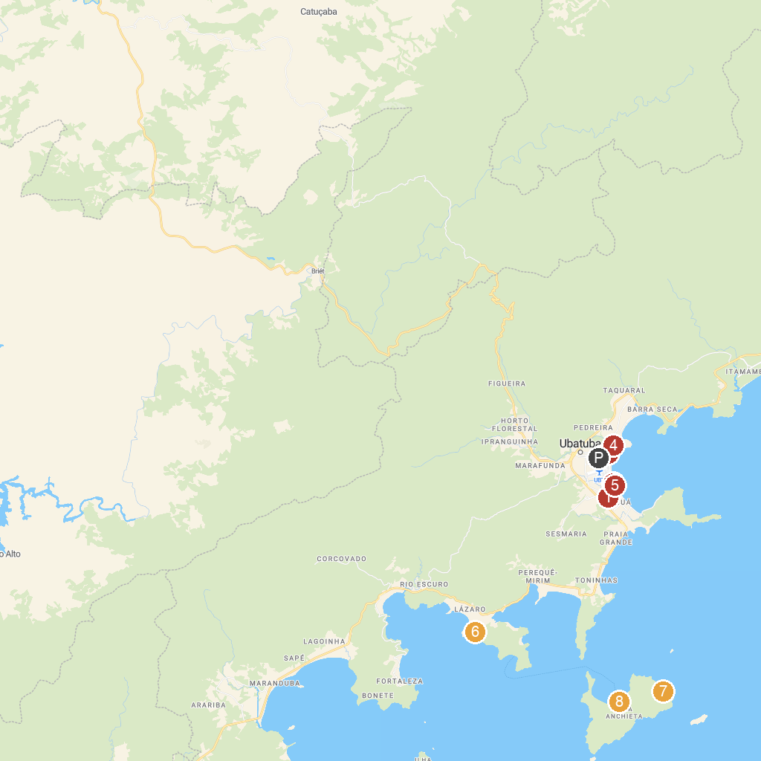
MAP KEY
1. Fundação Projeto Tamar - Ubatuba | 5. Whale Square
2. Ubatuba Aquarium | 6. Gruta Que Chora
3. Obelisco | 7. Praia do Leste
4. Morro da Prainha | 8. Beach Prison
P. Cruise port / terminal
Map © MapTiler © OpenStreetMap contributors · cruiseports.org

