Twillingate, Newfoundland, Canada
Perched on rugged islands in Notre Dame Bay, Twillingate is Newfoundland's iceberg capital — a place of colourful saltbox houses, crashing Atlantic swells, and boat tours that put you face-to-face with 20,000-year-old ice.
⚓ Tender (no pier) · 🕒 Typical call: 6-8 hrs · 💵 Canadian Dollar (CAD) · 🗣️ English (Newfoundland dialect) · 🧊 Iceberg season: May–early July
✍️ MY DAY IN PORT (FILL IN)
Ship / Date
In port | arrive ______ · all aboard ______
Booked excursion
Notes / meeting point
GETTING ASHORE
- Docking: Tender — anchor in harbour, boats to Government Wharf
- Walk to town: 0 min — tender lands in town centre
- Best For: Iceberg & whale watching, coastal hiking, outport culture
- Don't Miss: Long Point Lighthouse views and an iceberg boat tour
GETTING AROUND
- 🚕 Taxi: CAD 10–15 — Local taxis serve short hops around town (e.g. to Durrell ~3 km away). Confirm the fare before you go — no meters are st
TOP THINGS TO DO
- Iceberg & Whale Watching Boat Tour — The signature Twillingate experience.
- Long Point Lighthouse — Newfoundland's most photographed lighthouse sits 300 ft above the Atlantic on Crow Head.
- Prime Berth Fishing Heritage Centre — An award-winning private museum created by a local fisherman near the causeway.
- Auk Island Winery Tasting — One of only two wineries in Newfoundland, producing wine from wild local berries — partridgeberry, bakeapple, blueberry — and…
- Coastal Hiking — Rockcut Trails — A network of trails from French Beach to Lower Little Harbour, hugging sheer cliffs and dramatic sea stacks.
BEST WALKS
- Main Street Stroll: 1 km · 15 min · Easy · Flat — From the Government Wharf, head along Main Street South past craft shops, St.
- Back Harbour Viewpoint Walk: 1.5 km · 20 min · Easy — Loop around to Back Harbour for sheltered, low-elevation views of the anchorage and surrounding…
WEATHER · DAYLIGHT · MONEY
Month | High °F | Low °F | Rainy days
May | 47 | 34 | 1
Jul | 69 | 53 | 1
Sep | 60 | 48 | 1
Daylight: May 5:24AM–8:47PM · Jul 5:18AM–9:10PM · Sep 6:45AM–7:21PM
cruiseports.org/twillingate-nl · Confirm terminal & all-aboard time with your ship

Twillingate, Newfoundland, Canada — Port Map
Red = walkable sights · Amber = excursions farther out · P = cruise terminal
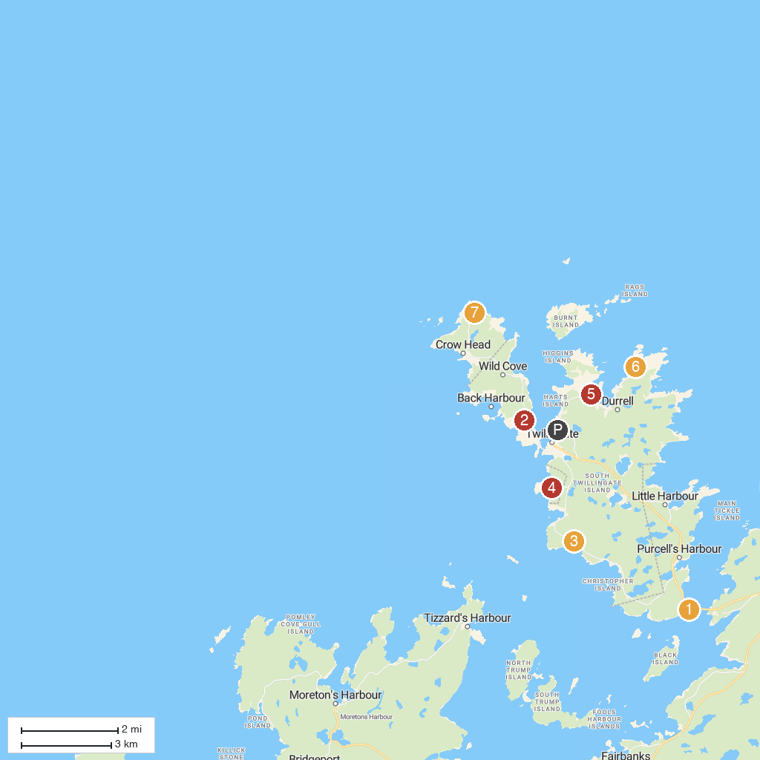
MAP KEY
1. Prime Berth Fishing Museum | 5. Durrell Museum & Brigade Artisan Shoppe
2. Twillingate Museum | 6. French Beach
3. Top of Twillingate | 7. Long Point Lighthouse & Twillingate Lighthouse Heritage Museum
4. Grand Old Shed Party Show | 8. Dildo Run Provincial Park
P. Cruise port / terminal
Map © MapTiler © OpenStreetMap contributors · cruiseports.org

