Tutrakan, Silistra Province, Bulgaria
The self-styled 'romantic capital of the Danube,' Tutrakan is Bulgaria's most authentic river town — a place of cobblestone fishermen's lanes, Roman ruins, and fish soup unchanged for centuries.
⚓ Docked (river pontoon) · 🕒 Typical call: 4–6 hrs · 💵 Bulgarian Lev (BGN) · 🗣️ Bulgarian
✍️ MY DAY IN PORT (FILL IN)
Ship / Date
In port | arrive ______ · all aboard ______
Booked excursion
Notes / meeting point
GETTING ASHORE
- Docking: Direct pontoon berth on the Danube quay — no tender
- Walk to center: 5–10 min (uphill) to main square; Fishermen's Quarter 1–2 min from dock
- Best For: River culture, WWI history, authentic Bulgarian village life
- Don't Miss: Museum of Danube Fishing & Boat Building — only one of its kind in the Balkans
GETTING AROUND
- 🚕 Taxi: 5–10 BGN (~€2.50–5) — Taxis are available near the quay for those who prefer not to climb the hill. Fares for short rides within Tutrakan are
TOP THINGS TO DO
- Fishermen's Quarter Walking Tour — The Ribarska Mahala is the only preserved fishermen's architectural reserve on the entire Danube — narrow cobblestone streets…
- Museum of Danube Fishing & Boat Building — The only museum of its kind in the Balkans.
- Turtucaia WWI Military Memorial — Bulgaria's largest military cemetery, 10 km from town, commemorating the 1916 Battle of Tutrakan.
- Kalimok-Brashlen Wetlands Birdwatching — Just west of town, this protected Danube floodplain hosts Dalmatian pelicans, herons, and ibises.
BEST WALKS
- Fishermen's Quarter & Riverside Park: 1.5 km loop · 30–45 min · Easy — From the pontoon quay, stroll north along the Danube Park past statues and Roman-era ruins, then…
- Upper Town & Roman Fortress: 1 km each way · 20–30 min · Moderate (uphill) — Head uphill from the quay to the main pedestrian street, passing the 1897 Historical Museum building.
cruiseports.org/tutrakan · Confirm terminal & all-aboard time with your ship

Tutrakan, Silistra Province, Bulgaria — Port Map
Red = walkable sights · Amber = excursions farther out · P = cruise terminal
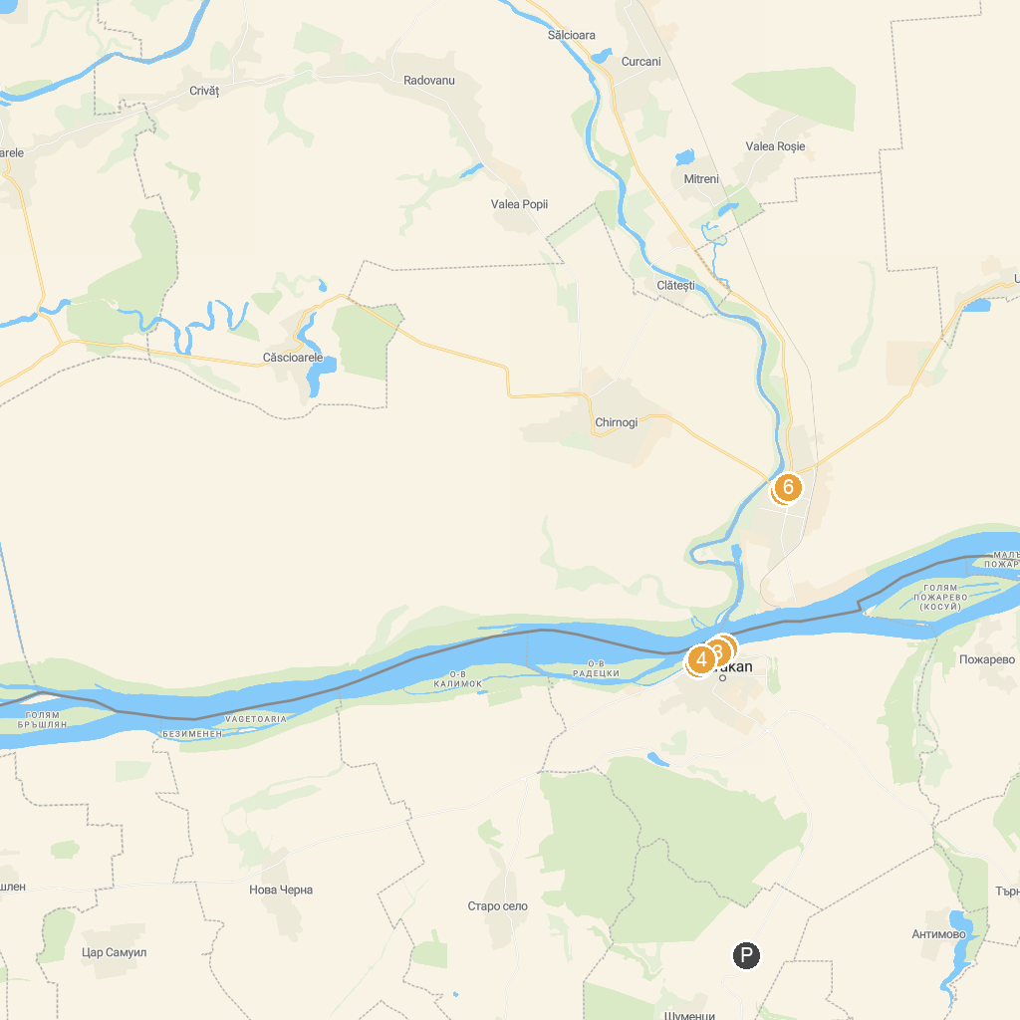
MAP KEY
1. Danube river park | 4. History Museum of Tutrakan
2. Museum Of Danube Fishing & Boatbuilding | 5. Great Park Olteniţa
3. Ribarska mahala - Posetitelski centar | 6. Water tower
P. Cruise port / terminal
Map © MapTiler © OpenStreetMap contributors · cruiseports.org

