Turnu Măgurele, Teleorman, Romania
An unvarnished Danube river town where medieval fortress ruins, a cathedral modeled on Curtea de Argeș, and a waterfront promenade offer a genuine taste of provincial Romania — mostly bypassed by tourists.
⚓ Docked (river pontoon) · 🕒 Typical call: 6-8 hrs · 💵 Romanian Leu (RON) · 🗣️ Romanian · 🏛️ History & Culture
✍️ MY DAY IN PORT (FILL IN)
Ship / Date
In port | arrive ______ · all aboard ______
Booked excursion
Notes / meeting point
GETTING ASHORE
- Docking: River pontoon — ships dock directly, no tender
- Walk to center: ~4 km to town; most take taxi or ship shuttle
- Best For: Danube history, authentic Romanian town life, Bucharest day trips
- Don't Miss: Saint Haralambios Cathedral and the Turnu Fortress ruins
GETTING AROUND
- 🚕 Taxi: $5–$10 — Local taxis are available near the port and can reach the city center quickly. The town is compact — most sights are wit
TOP THINGS TO DO
- Bucharest Day Trip — Romania's capital is about 2-2.5 hours by coach.
- Turnu Fortress Ruins — A 10-15 minute drive from the pier, these are the remnants of a medieval fortress built in the late 14th century under Prince…
- Saint Haralambios Cathedral — The town's architectural centrepiece — an Orthodox cathedral built 1900–1902 under King Carol I, designed by French architect…
- Danube Waterfront Promenade — A tree-lined promenade along the river with benches and views across to Nikopol, Bulgaria on the opposite bank.
- Nikopol & Pleven, Bulgaria (Cross-River) — A short ferry crossing to Nikopol, Bulgaria, opens up excursions to Pleven, home to the impressive Panorama Museum depicting the…
BEST WALKS
- Town Center Circuit: ~2 km | 30-40 min | Flat — From the shuttle drop-off near the central park, walk to the Saint Haralambios Cathedral, then…
WEATHER · DAYLIGHT · MONEY
Month | High °F | Low °F | Rainy days
May | 75 | 53 | 1
Jul | 89 | 64 | 0
Sep | 81 | 56 | 0
Daylight: May 5:55AM–8:39PM · Jul 5:52AM–8:59PM · Sep 7:00AM–7:30PM
cruiseports.org/turnu-magurele · Confirm terminal & all-aboard time with your ship

Turnu Măgurele, Teleorman, Romania — Port Map
Red = walkable sights · Amber = excursions farther out · P = cruise terminal
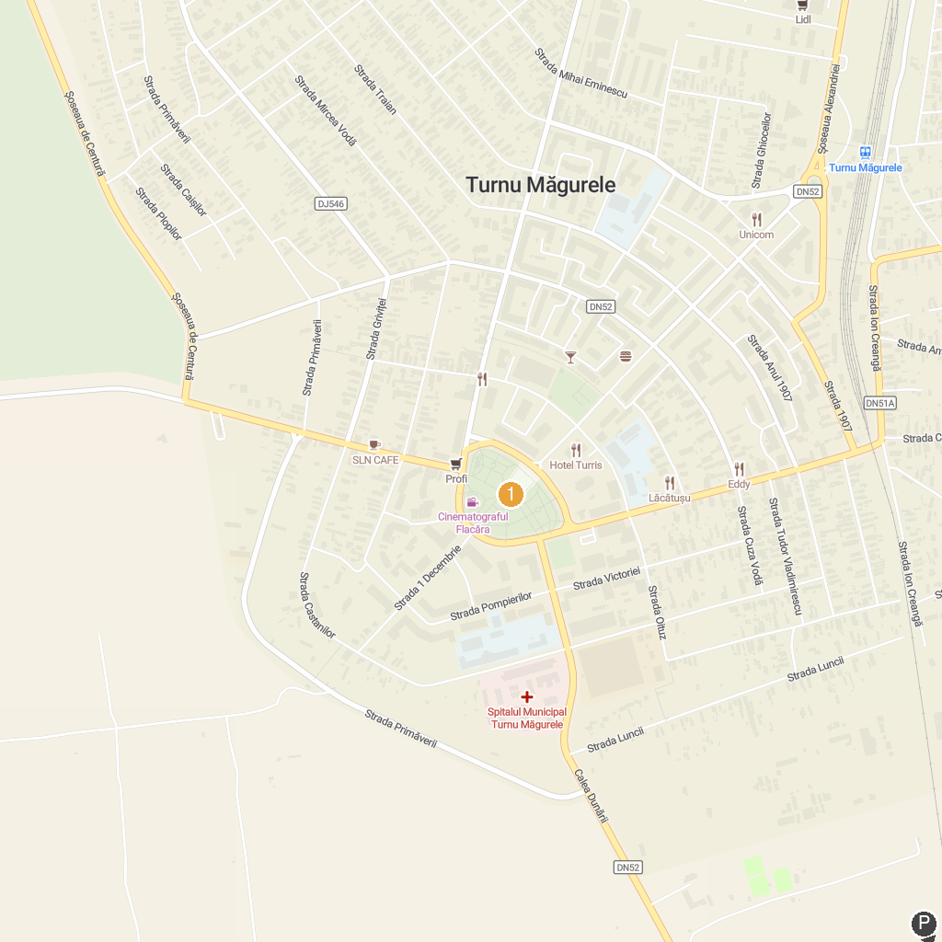
MAP KEY
1. Persina Nature Park | 2. Central Park Turnu Magurele
P. Cruise port / terminal
Map © MapTiler © OpenStreetMap contributors · cruiseports.org

