Turku, Finland
Finland's oldest city greets cruise ships with a medieval fortress at the dock and a walkable riverfront alive with floating restaurants, market halls, and 700 years of history.
⚓ Pier (no tender) · 🕒 Typical call: 7-10 hrs · 💶 Euro (€) — cashless city · 🗣️ Finnish/Swedish; English widely spoken · 🏰 UNESCO-adjacent history
✍️ MY DAY IN PORT (FILL IN)
Ship / Date
In port | arrive ______ · all aboard ______
Booked excursion
Notes / meeting point
GETTING ASHORE
- Docking: Direct pier; no tender required
- Walk to center: 5 min to Turku Castle; 35-45 min to Market Square (3 km)
- Best For: History, food, river walks, archipelago day trips
- Don't Miss: Turku Castle, Market Hall, Aura riverfront & Kakola Hill funicular
GETTING AROUND
- 🚕 Taxi: €10–€20 — Taxis are available at the cruise terminal and take 5–10 minutes to the city center. Meters are standard; expect €10–15
- 📱 Rideshare: ✅ Bolt, Uber, Yango
TOP THINGS TO DO
- Turku Castle — One of Scandinavia's largest medieval fortresses, built in 1280 and just steps from the dock.
- Aboa Vetus Ars Nova Museum — Walk underground into excavated medieval streets beneath a 15th-century palace, then emerge into a striking museum of…
- Ruissalo Island & Saaronniemi Beach — Take Bus Line 8 or the summer water bus to this forested island.
- Market Hall & Riverboat Dining — Turku's 1896 Market Hall is the food capital of Finland in miniature — try archipelago rye bread with smoked salmon, korvapuusti…
- Luostarinmäki Handicrafts Museum — The only wooden quarter to survive Turku's catastrophic 1827 fire.
BEST WALKS
- Aura River Stroll: Castle to Market Square: 3 km | 40-50 min | Flat | One-way — Walk the pedestrianized riverbanks from Turku Castle past the Forum Marinum tall ships, floating…
- Kakola Hill & Funicular: 1 km from city center | 30 min round-trip | Easy — Ride the free glass-walled funicular up to Kakolanmäki — the former maximum-security prison, now a…
WEATHER · DAYLIGHT · MONEY
Month | High °F | Low °F | Rainy days
May | 59 | 42 | 0
Jul | 73 | 56 | 1
Sep | 61 | 47 | 1
Daylight: May 4:50AM–10:06PM · Jul 4:31AM–10:41PM · Sep 6:58AM–7:51PM
cruiseports.org/turku · Confirm terminal & all-aboard time with your ship

Turku, Finland — Port Map
Red = walkable sights · Amber = excursions farther out · P = cruise terminal
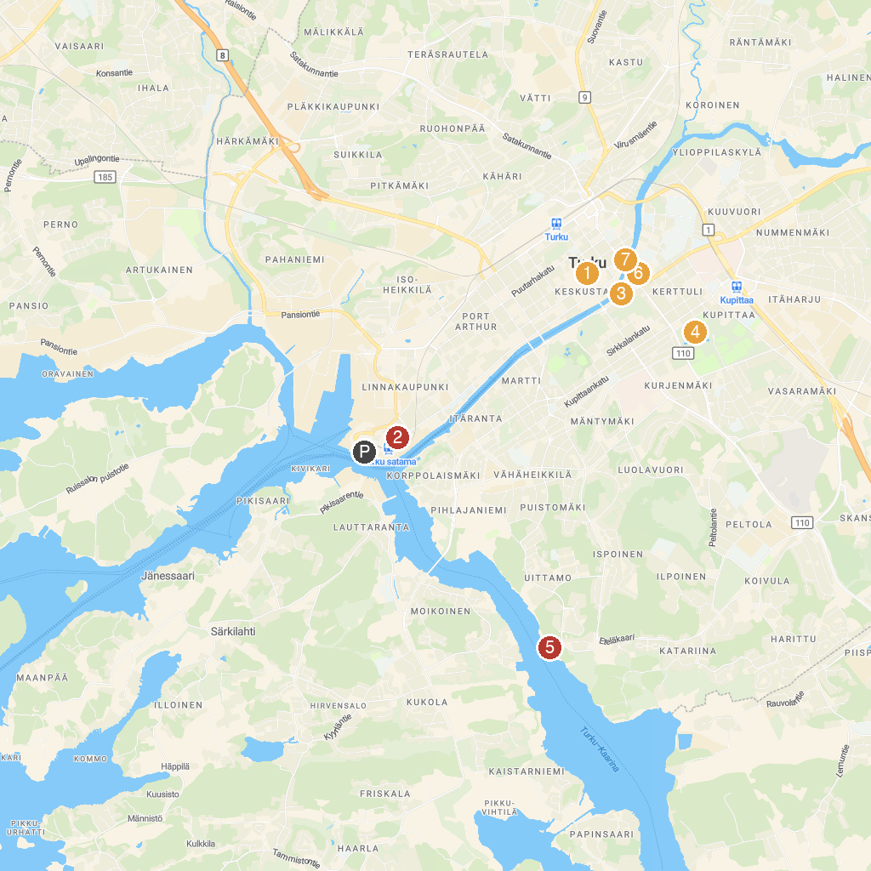
MAP KEY
1. Turku Market Square | 5. Kupittaa Park
2. Turku Castle | 6. Ispoinen Beach
3. Moomin World | 7. Brahe’s Park / Brahenpuisto / Braheskvären
4. Aboa Vetus Ars Nova | 8. Lönnrot’s Park / Lönnrotinpuisto / Lönnrotsskvären
P. Cruise port / terminal
Map © MapTiler © OpenStreetMap contributors · cruiseports.org

