Tsuruga, Fukui Prefecture, Japan
Once the port of refuge for Jewish and Polish refugees fleeing persecution, Tsuruga pairs deep humanitarian history with Sea of Japan seafood, towering wooden torii gates, and sweeping pine-fringed beaches.
⚓ Pier (docked) · 🕒 Typical call: 8-10 hrs · 💴 Japanese Yen (JPY) · 🗣️ Japanese (limited English) · 🦀 Famous for seafood
✍️ MY DAY IN PORT (FILL IN)
Ship / Date
In port | arrive ______ · all aboard ______
Booked excursion
Notes / meeting point
GETTING ASHORE
- Docking: Pier — Kanegasaki Wharf, ~3 km from city center
- Walk to center: ~3 km (30 min); free shuttle usually runs on cruise days
- Best For: History, seafood, shrines, pine grove beaches
- Don't Miss: Port of Humanity Museum & Kehi Jingu Shrine torii gate
GETTING AROUND
- 🚕 Taxi: ¥1,700–¥2,500 to city center — Taxis are usually available at the pier. The port is about 4.5 km from central Tsuruga (walking is not permitted due to
- 📱 Rideshare: ✅ Uber
TOP THINGS TO DO
- Port of Humanity Museum — This deeply moving museum chronicles Tsuruga's role sheltering Polish orphans in the 1920s and Jewish refugees carrying Chiune…
- Kehi Jingu Shrine & Torii Gate — One of Japan's three great wooden torii gates — standing 11 meters tall and rebuilt in 1645 — marks the entrance to this serene…
- Kehi no Matsubara Pine Grove — One of Japan's three most scenic pine groves: 17,000 pines border a crescent white-sand beach on the Sea of Japan.
- Nihonkai Sakana Machi Fish Market — The largest seafood market on the Sea of Japan coast, with 70+ stalls selling fresh catches, grilled mackerel, Echizen crab (in…
- Red Brick Warehouses (Akarenga) — Built in 1905 by Standard Oil and beautifully restored, these warehouses hold restaurants, shops, and a detailed HO-scale diorama…
BEST WALKS
- Pier to Red Brick Warehouses: 5 min · flat · free — Step off the ship and head straight to the restored 1905 warehouses for coffee, local snacks, and a…
- Anime Statue Street & Kehi Jingu: 25 min walk from station · easy · free — From Tsuruga Station, follow the main boulevard lined with 28 bronze anime statues all the way to…
WEATHER · DAYLIGHT · MONEY
Month | High °F | Low °F | Rainy days
May | 74 | 57 | 2
Jul | 88 | 75 | 3
Sep | 82 | 71 | 2
Daylight: May 4:51AM–6:53PM · Jul 4:51AM–7:11PM · Sep 5:38AM–6:03PM
cruiseports.org/tsuruga · Confirm terminal & all-aboard time with your ship

Tsuruga, Fukui Prefecture, Japan — Port Map
Red = walkable sights · Amber = excursions farther out · P = cruise terminal
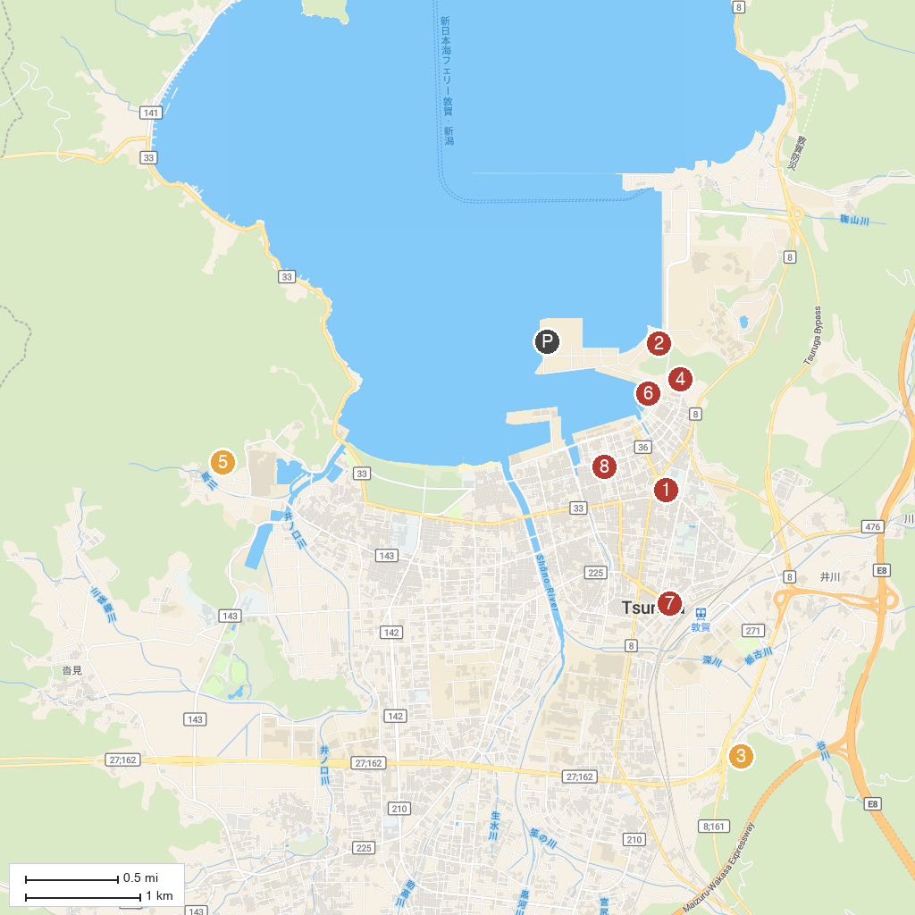
MAP KEY
1. Kehi-jingu Shrine | 5. Saifukuji Temple
2. Kanegasaki Castle Ruins | 6. Kanegasaki Park
3. Atomic Power Museum ATHOME | 7. 敦賀シンボルロード
4. Konzen-ji | 8. Tsuruga Municipal Museum
P. Cruise port / terminal
Map © MapTiler © OpenStreetMap contributors · cruiseports.org

