Troy, New York, USA
The Collar City's perfectly preserved Victorian brownstones and buzzing riverfront make Troy one of the Hudson's most rewarding small-ship stops — and you're steps from it all the moment you step off the gangway.
⚓ Docked (pier) · 🕒 Typical call: 6-8 hrs · 💵 USD · 🗣️ English · 🎬 HBO Gilded Age filming location
✍️ MY DAY IN PORT (FILL IN)
Ship / Date
In port | arrive ______ · all aboard ______
Booked excursion
Notes / meeting point
GETTING ASHORE
- Docking: Pier/bulkhead at Riverfront Park — no tender
- Walk to center: Immediate — Monument Square is 1 block from the dock
- Best For: History, architecture, craft food & beer, walking
- Don't Miss: Brown's Brewing Co. on the river & Famous Lunch mini-dogs
GETTING AROUND
- 🚕 Taxi: $22–$25 — Local taxis (Capitaland Taxi, Black & White Taxi) serve the marina area. Most rides to downtown incur the minimum fare d
- 📱 Rideshare: ✅ Uber, Lyft
TOP THINGS TO DO
- Gilded Age Downtown Walking Tour — Troy's Victorian brownstones and cast-iron facades are so intact that HBO films The Gilded Age here.
- Troy Savings Bank Music Hall — Opened in 1875 and considered one of the finest concert halls in the world for acoustics.
- Collar City Food Trail — From Famous Lunch's legendary Zippy-sauce mini-dogs (since 1932) to Brown's Brewing Company on the river and the Saturday…
- Burden Iron Works Museum — The Romanesque Revival office building of Troy's once-mighty iron empire, home to the world's most powerful water wheel.
- Oakwood Cemetery & Views — This sweeping 19th-century cemetery is the resting place of Samuel Wilson — the real 'Uncle Sam' — and offers panoramic views of…
BEST WALKS
- Riverfront to Monument Square Loop: 1.5 miles · 45-60 min · Easy — From the dock, walk east to Monument Square, then south along 2nd Street past the Victorian…
- Waterfront Brewery Walk: 0.5 miles · 15 min · Easy — A short stroll north along the riverfront path from the dock to Brown's Brewing Company — a…
WEATHER · DAYLIGHT · MONEY
Month | High °F | Low °F | Rainy days
May | 72 | 48 | 1
Jul | 83 | 63 | 2
Sep | 74 | 56 | 1
Daylight: May 5:32AM–8:10PM · Jul 5:30AM–8:30PM · Sep 6:35AM–7:03PM
cruiseports.org/troy-ny · Confirm terminal & all-aboard time with your ship

Troy, New York, USA — Port Map
Red = walkable sights · Amber = excursions farther out · P = cruise terminal
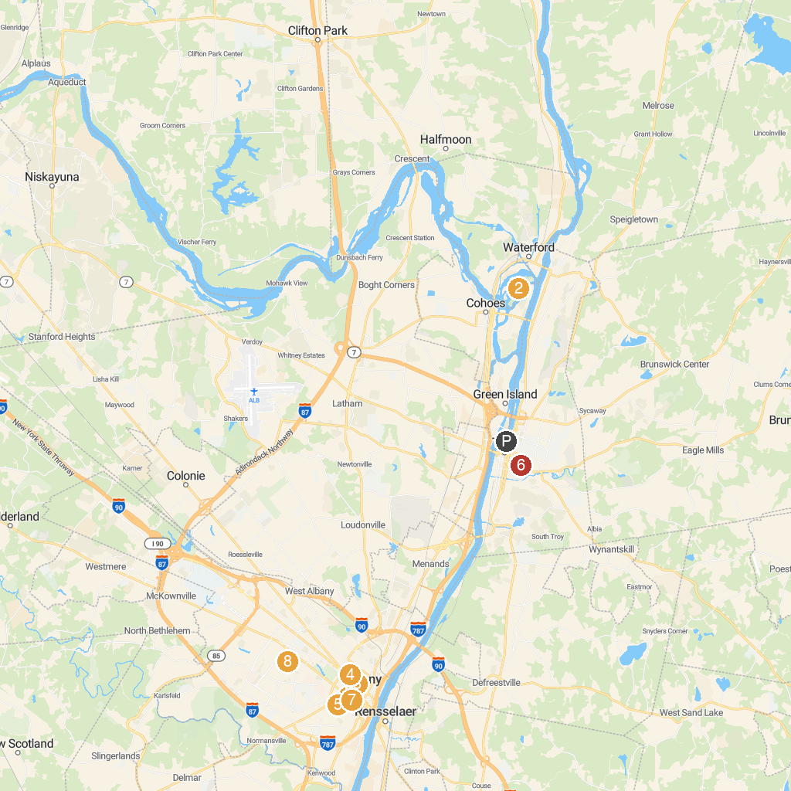
MAP KEY
1. New York State Museum | 5. Lincoln Park
2. Peebles Island State Park | 6. Prospect Park
3. New York State Capitol | 7. Cathedral of the Immaculate Conception
4. Albany Institute of History & Art | 8. Ridgefield Park
P. Cruise port / terminal
Map © MapTiler © OpenStreetMap contributors · cruiseports.org

