Trondheim, Norway
Norway's ancient capital and Viking-age pilgrimage city — home to the magnificent Nidaros Cathedral, colourful Bakklandet wharves, and a lively university town energy on the Trondheim Fjord.
⚓ Docked — central quay walkable to city · 🕒 Typical call: 8–10 hrs · 💵 Norwegian Krone (NOK) · cards widely accepted · 🗣️ Norwegian · English spoken everywhere
✍️ MY DAY IN PORT (FILL IN)
Ship / Date
In port | arrive ______ · all aboard ______
Booked excursion
Notes / meeting point
GETTING ASHORE
- Docking: Turistskipskaia / Ila Quay
- To center: 5–15 min walk
- Best For: History · Architecture
- Don't Miss: Nidaros Cathedral
GETTING AROUND
- 🚕 Taxi: NOK 200–300 (~$20–28) — Taxis queue at the terminal; TrønderTaxi is the main local operator. Ask for a fixed fare upfront — metered rates can va
- 📱 Rideshare: ✅ Uber, Bolt
- 🚌 Hop-on hop-off: ✅ Gray Line / HopOn.no
TOP THINGS TO DO
- Nidaros Cathedral & Archbishop's Palace — The crown jewel of Trondheim and the northernmost medieval cathedral in the world, built over the tomb of St.
- Munkholmen Island — A short 15-minute ferry from Ravnkloa fish market takes you to this small island in the fjord — once a Benedictine monastery…
- Kristiansten Fortress — Built in 1681 after a devastating fire, this hilltop fortress east of the city saved Trondheim from Swedish capture in 1718.
- Ringve Music Museum & Rockheim — Combine two of Norway's finest music museums in one day.
BEST WALKS
- Cathedral Quarter & Gamle Bybro Loop: ~2.5 km · 1.5–2 hrs · easy — From the pier, walk to the magnificent Nidaros Cathedral and explore the Archbishop's Palace, then…
- Bakklandet & the Trampe Bike Lift: ~2 km · 1–1.5 hrs · easy — Stroll the charming cobblestone lanes of Bakklandet, lined with wooden houses turned cafés and…
- Stiftsgården & City Centre Stroll: ~2 km · 1 hr · easy — Explore Torvet (the main square) and visit Stiftsgården, the royal residence and one of…
WEATHER · DAYLIGHT · MONEY
Month | High °F | Low °F | Rainy days
May | 55 | 40 | 16
Jul | 66 | 53 | 17
Sep | 58 | 47 | 16
Daylight: May 4:11AM–10:20PM · Sep 6:43AM–7:42PM
cruiseports.org/trondheim · Confirm terminal & all-aboard time with your ship

Trondheim, Norway — Port Map
Red = walkable sights · Amber = excursions farther out · P = cruise terminal
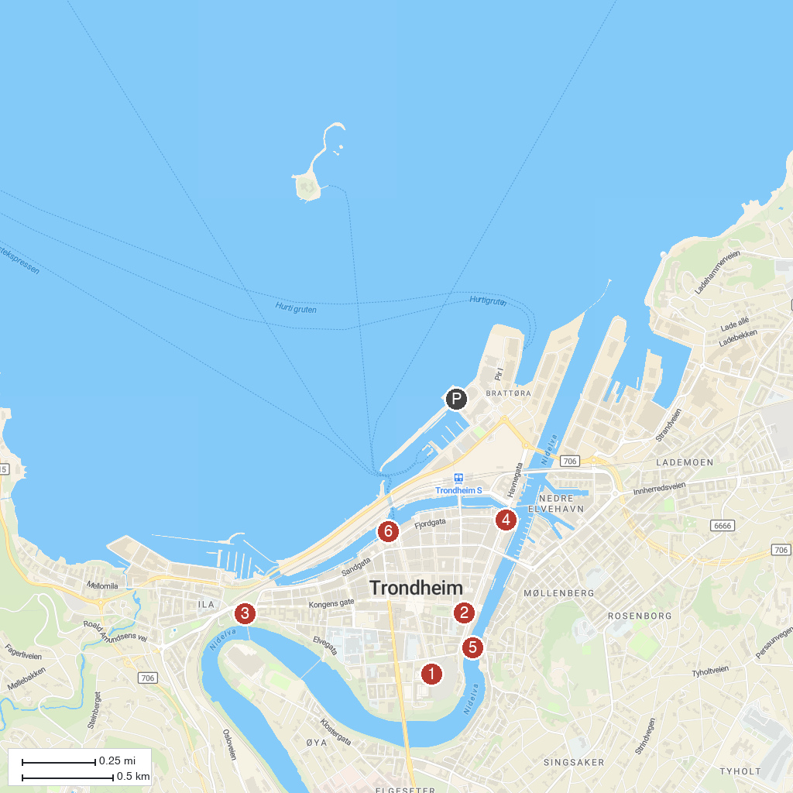
MAP KEY
1. Nidaros Cathedral | 4. Trondheim Maritime Museum
2. Trondheim Science Center | 5. Gamle bybro
3. Ilen kirke | 6. Ravnkloa
P. Cruise port / terminal
Map © MapTiler © OpenStreetMap contributors · cruiseports.org

