Tromsø, Norway
The 'Gateway to the Arctic' — a lively island city ringed by snow-capped peaks and fjords, home of the Northern Lights in winter and the midnight sun in summer.
⚓ Docked (Prostneset or Breivika) · 🕒 Typical call: 6–10 hrs · 💵 Norwegian Krone (NOK) · cards everywhere · 🗣️ Norwegian · English widely spoken
✍️ MY DAY IN PORT (FILL IN)
Ship / Date
In port | arrive ______ · all aboard ______
Booked excursion
Notes / meeting point
GETTING ASHORE
- Docking: Prostneset / Breivika
- To center: Central quay or ~3 km north
- Best For: Arctic · Scenery
- Don't Miss: Fjellheisen cable car
GETTING AROUND
- 🚕 Taxi: ~150–180 NOK (~€16–20) — Metered taxis from Breivika to the city center take 8–10 minutes. Groups of four may find taxis comparable in cost to th
- 📱 Rideshare: ✅ Uber, Bolt
TOP THINGS TO DO
- Fjellheisen Cable Car to Storsteinen — Ride the cable car up Mount Storsteinen to a 421-metre viewing terrace for a sweeping panorama over Tromsø island, the fjord, the…
- Arctic Cathedral & City Highlights — Cross the Tromsø Bridge to the soaring, white Ishavskatedralen with its dramatic glass mosaic, then tour the city's wooden…
- Fjord & Arctic Wilderness Cruise — Sail out among the fjords and islands around Tromsø to spot sea eagles, seals, and dramatic coastal scenery — and in winter…
- Northern Lights or Midnight Sun Chase — In winter, chase the aurora into the dark countryside away from city lights; in summer, witness the surreal midnight sun that…
BEST WALKS
- Storgata & Harbour Stroll: ~2 km · 1–1.5 hrs · easy — Wander Storgata, the main pedestrian street lined with painted wooden houses, shops, and cafés…
- Polaria & Polar Museum: ~2.5 km · 1.5 hrs · easy — Stroll the waterfront to Polaria's Arctic aquarium and exhibits, then on to the Polar Museum in old…
- Tromsø Bridge to Arctic Cathedral: ~3 km · 1.5–2 hrs · moderate — Cross the iconic Tromsø Bridge on foot for fjord and city views, ending at the striking white…
WEATHER · DAYLIGHT · MONEY
Month | High °F | Low °F | Rainy days
May | 45 | 35 | 17
Jul | 63 | 51 | 14
Sep | 52 | 43 | 18
Daylight: Sep 5:58AM–7:17PM
cruiseports.org/tromso · Confirm terminal & all-aboard time with your ship

Tromsø, Norway — Port Map
Red = walkable sights · Amber = excursions farther out · P = cruise terminal
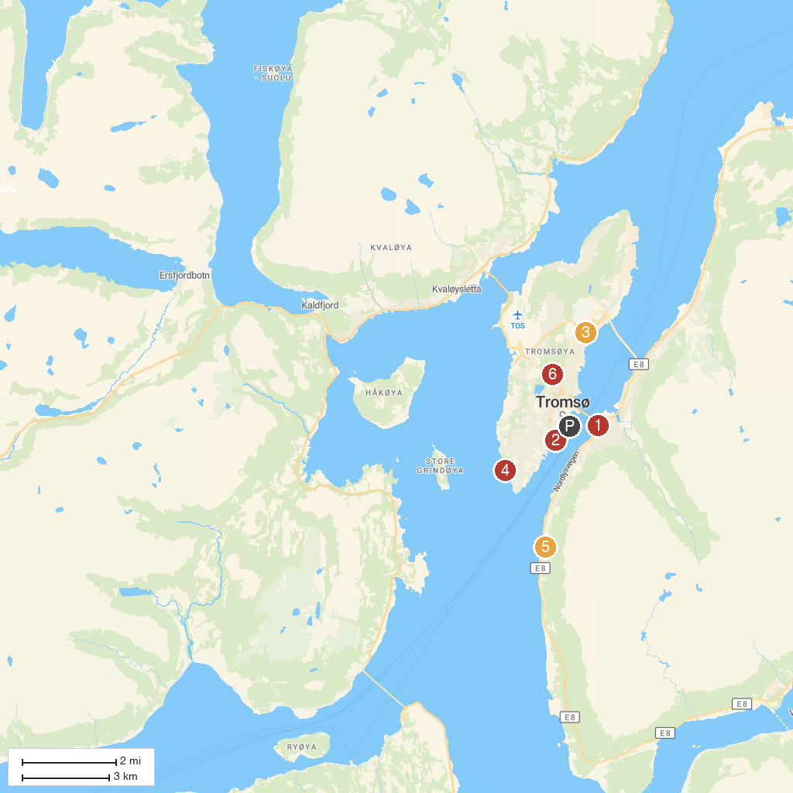
MAP KEY
1. Arctic Cathedral | 5. Tromsø Forsvarsmuseum
2. Polaria | 6. Charlottenlund Recreational Park
3. Arctic–Alpine Botanic Garden | 7. Olavsvern
4. Folkeparken
P. Cruise port / terminal
Map © MapTiler © OpenStreetMap contributors · cruiseports.org

