Trogir, Dalmatia, Croatia
One of Europe's best-preserved medieval island-towns, Trogir packs a UNESCO World Heritage cathedral, Venetian fortress, and marble labyrinth alleys into a space you can cross in 750 steps.
⚓ Small ships dock; large ships tender or call Split · 🕒 Typical call: 6–8 hrs · 💶 Currency: Euro (€) · 🗣️ Language: Croatian · 🏰 UNESCO World Heritage Site
✍️ MY DAY IN PORT (FILL IN)
Ship / Date
In port | arrive ______ · all aboard ______
Booked excursion
Notes / meeting point
GETTING ASHORE
- Docking: Small ships berth on the Riva (0-min walk); larger ships tender to same dock or call Split
- Walk to Center: Instant — gangway puts you on the Riva promenade
- Best For: Medieval architecture, Game of Thrones fans, leisurely Old Town wandering
- Don't Miss: Climbing St. Lawrence Cathedral's bell tower for 360° views of the islands
GETTING AROUND
- 🚕 Taxi: €6–€10 — Short taxi rides within Trogir are inexpensive at roughly €6–€10. Official taxis are metered; agree on a fare in advance
- 📱 Rideshare: ✅ Uber, Bolt
- 🚌 Hop-on hop-off: ✅
TOP THINGS TO DO
- St. Lawrence Cathedral & Bell Tower Climb — Trogir's UNESCO centerpiece features Radovan's Portal — one of the finest Romanesque stone carvings in the Adriatic — and a…
- Old Town Walking Tour — Alleyways & Squares — Wander the maze of shiny limestone lanes past Gothic balconies, hidden courtyards, the City Loggia, the Land Gate with its…
- Kamerlengo Castle — A 15th-century Venetian fortress at the tip of the island, with walkable ramparts and sweeping views over the sea.
- Okrug Gornji Beach, Čiovo Island — A 2 km pebble stretch across the bridge on Čiovo island, lined with beach bars and water-sports rentals.
- Day Trip to Split — Trogir sits 30 km from Split, making a combined visit easy.
BEST WALKS
- Old Town Complete Loop: 1.5 km · 45–60 min · Easy — From the Riva promenade, enter through the Land Gate, cross the main square past the Cathedral and…
WEATHER · DAYLIGHT · MONEY
Month | High °F | Low °F | Rainy days
May | 74 | 58 | 1
Jul | 89 | 71 | 0
Sep | 80 | 65 | 1
Daylight: May 5:30AM–8:12PM · Jul 5:28AM–8:33PM · Sep 6:34AM–7:04PM
cruiseports.org/trogir · Confirm terminal & all-aboard time with your ship

Trogir, Dalmatia, Croatia — Port Map
Red = walkable sights · Amber = excursions farther out · P = cruise terminal
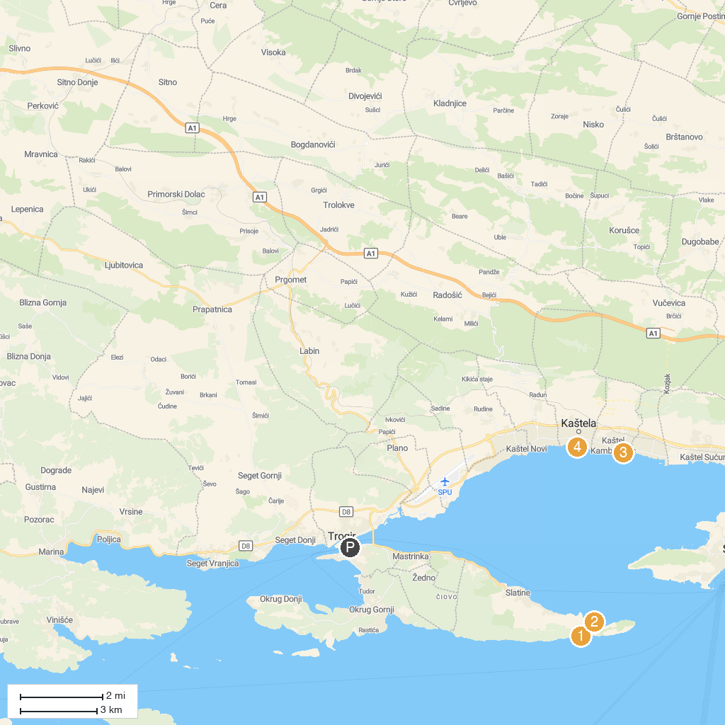
MAP KEY
1. Church of Our Lady of Prizidnice | 5. Tvrdic Honey
2. Kava Beach | 6. Forest Park Marjan
3. Kula Cambi | 7. Svjetionik Split
4. Meštrovićeve Crikvine - Kaštilac | 8. MUZEJ GRADA KAŠTELA (Dvorac Vitturi)
P. Cruise port / terminal
Map © MapTiler © OpenStreetMap contributors · cruiseports.org

