Trivandrum (Vizhinjam), Kerala, India
India's newest deepwater port puts you minutes from Kovalam's crescent beaches and the world's wealthiest temple — where ancient Kerala and a gleaming 21st-century port coexist on the same shoreline.
⚓ Pier (deep-water berth) · 🕒 Typical call: 8-10 hrs · 💵 Indian Rupee (INR) · 🗣️ Malayalam / English widely spoken · 🛂 e-Visa required before boarding
✍️ MY DAY IN PORT (FILL IN)
Ship / Date
In port | arrive ______ · all aboard ______
Booked excursion
Notes / meeting point
GETTING ASHORE
- Docking: Direct pier at Vizhinjam International Seaport — no tender
- Walk to center: Industrial port; shuttle to gate, then taxi/tuk-tuk required
- Best For: Beach day at Kovalam, temple culture, Kerala cuisine
- Don't Miss: Azhimala Shiva statue, Kovalam Lighthouse Beach, Padmanabhaswamy Temple exterior
GETTING AROUND
- 🚕 Taxi: ₹370–450 (~$4–6 USD) — Pre-paid taxis are available from Vizhinjam port to Trivandrum city center (~14 km, ~15 min). Operators include Trivandr
- 📱 Rideshare: ✅ Uber
TOP THINGS TO DO
- Kovalam Lighthouse Beach — Three crescent beaches 3 km from the port.
- Azhimala Shiva Temple & Statue — A 58-foot Shiva statue stands dramatically on a cliff above the Arabian Sea, 7 km south of the port.
- Sree Padmanabhaswamy Temple Precinct — Exterior of the world's wealthiest temple — gold-plated gopuram towering over a scenic temple tank.
- Kuthira Malika (Horse Palace) — A 19th-century royal palace beside the Padmanabhaswamy Temple, with 122 carved wooden horses supporting its roofline.
- Napier Museum & Chala Bazaar — The 1880 Napier Museum blends Kerala, Mughal, and Gothic architecture and houses bronze idols and ivory carvings.
BEST WALKS
- Kovalam Lighthouse Beach Stroll: 1.5 km • Easy • Beachside — From the Kovalam Beach entrance, walk south past seafood shacks, souvenir stalls, and surf schools…
- Vizhinjam Rock-Cut Cave Temple: Short walk • Easy • Ancient — An 8th-century rock-cut temple near the harbor dedicated to Dakshinamurti — one of Kerala's oldest.
WEATHER · DAYLIGHT · MONEY
Month | High °F | Low °F | Rainy days
May | 91 | 78 | 4
Jul | 88 | 76 | 2
Sep | 89 | 76 | 3
Daylight: May 6:03AM–6:33PM · Jul 6:11AM–6:45PM · Sep 6:12AM–6:22PM
cruiseports.org/trivandrum-vizhinjam · Confirm terminal & all-aboard time with your ship

Trivandrum (Vizhinjam), Kerala, India — Port Map
Red = walkable sights · Amber = excursions farther out · P = cruise terminal
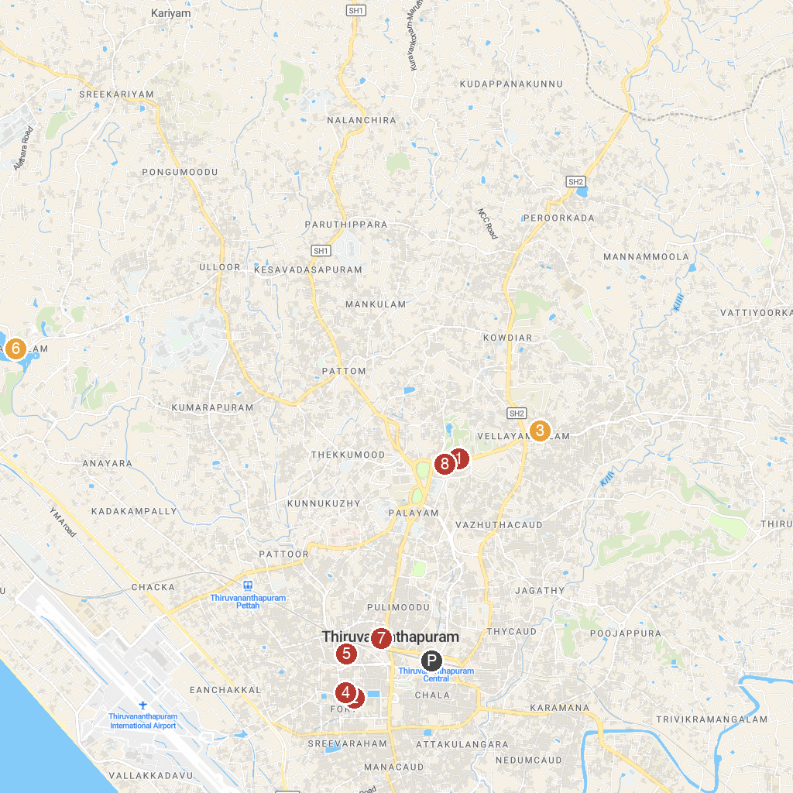
MAP KEY
1. Napier Museum | 5. Sreekanteswaram Temple
2. Sree Padmanabhaswamy Temple | 6. Akkulam Tourist Village
3. Akbar Travels of India Pvt Ltd - Trivandrum | 7. Pazhaya Sreekanteswaram Shree Mahadeva Temple
4. Ananthankadu Sree Nagaraja Temple Trust | 8. Keralam - Museum of History and Heritage
P. Cruise port / terminal
Map © MapTiler © OpenStreetMap contributors · cruiseports.org

