Trincomalee, Eastern Province, Sri Lanka
One of the world's great natural harbors, Trincomalee pairs a clifftop Hindu temple and deer-roaming colonial fort with luminous turquoise beaches and the occasional blue whale offshore.
⚓ Pier (Ashraff Jetty) · 🕒 Typical call: 7-9 hrs · 💵 Sri Lankan Rupee (LKR) · 🗣️ Sinhala / Tamil / English
✍️ MY DAY IN PORT (FILL IN)
Ship / Date
In port | arrive ______ · all aboard ______
Booked excursion
Notes / meeting point
GETTING ASHORE
- Docking: Pier — Ashraff Jetty inside Trincomalee Harbour; shuttle to port gate
- Walk to Center: ~1.5 km to Fort Frederick from port gate; tuk-tuk recommended in heat
- Best For: Temple & fort history, beach day, snorkeling Pigeon Island, whale watching
- Don't Miss: Koneswaram Temple on Swami Rock and the free-roaming spotted deer in Fort Frederick
GETTING AROUND
- 🚕 Taxi: $3–8 — Metered taxis are available near the port area. Rates start around 60 LKR base plus ~50 LKR per km; agree on a price or
- 📱 Rideshare: ❌ not available
TOP THINGS TO DO
- Fort Frederick & Koneswaram Temple — Walk through an active military fort built by the Portuguese in 1624, past free-roaming spotted deer, to the clifftop Koneswaram…
- Pigeon Island Snorkeling — A marine national park just 1 km off Nilaveli Beach, famous for blacktip reef sharks, sea turtles, and vivid coral.
- Blue Whale Watching — Trincomalee's deep offshore canyon is one of the world's best blue whale spots.
- Uppuveli Beach Day — Golden sand lined with laid-back cafes and dive shops, just 6 km north of port.
- Kanniya Hot Springs — Seven ancient stone-walled wells, each at a slightly different warm temperature, believed by locals to have therapeutic properties.
BEST WALKS
- Fort Frederick & Swami Rock Loop: 1.5 km | Easy | ~1.5 hrs | Free — From the port gate, tuk-tuk or walk to Fort Frederick's main entrance.
- Dutch Bay Waterfront Stroll: 1 km | Flat | ~30 min | Free — A short waterfront walk along Dutch Bay, the crescent beach in central Trincomalee.
WEATHER · DAYLIGHT · MONEY
Month | High °F | Low °F | Rainy days
May | 94 | 79 | 1
Jul | 95 | 79 | 1
Sep | 94 | 77 | 1
Daylight: May 5:46AM–6:16PM · Jul 5:54AM–6:28PM · Sep 5:55AM–6:05PM
cruiseports.org/trincomalee · Confirm terminal & all-aboard time with your ship

Trincomalee, Eastern Province, Sri Lanka — Port Map
Red = walkable sights · Amber = excursions farther out · P = cruise terminal
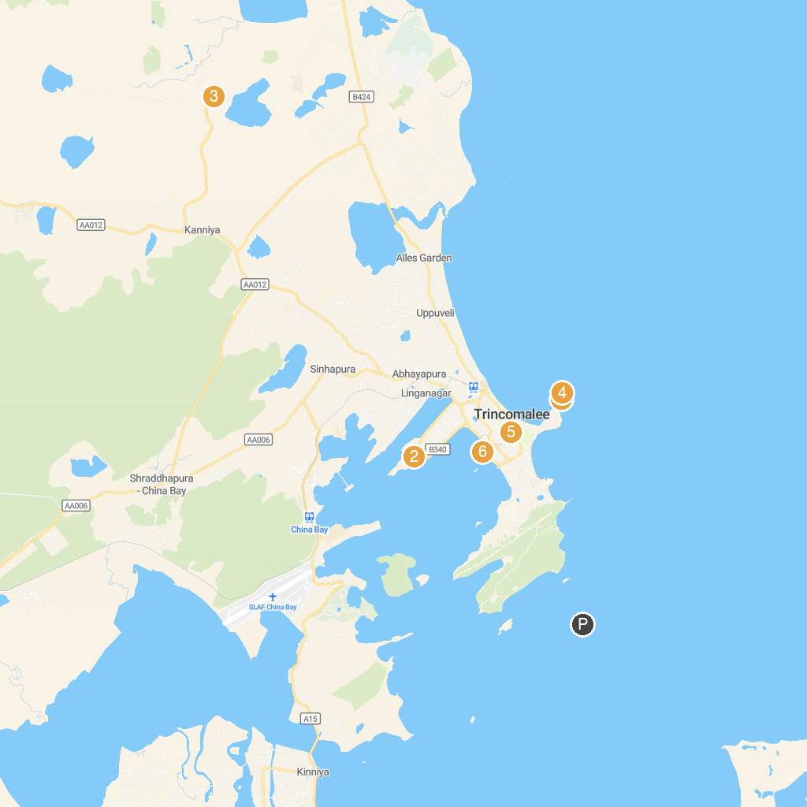
MAP KEY
1. இராவணன் வெட்டு | Rawana Abyss | රාවණා කපොල්ල | 4. Lovers Leap
2. Orr's Hill Army Museum | 5. Shri Badrakali Amman Hindu Kovil
3. Velgam Vehera Buddhist Temple | වෙල්ගම් වෙහෙර | 6. View Point
P. Cruise port / terminal
Map © MapTiler © OpenStreetMap contributors · cruiseports.org

