Trieste, Friuli-Venezia Giulia, Italy
Where the Austro-Hungarian empire meets the Adriatic — Trieste's grand neoclassical squares, historic coffeehouses, and cliff-top castle make it one of the Adriatic's most atmospheric ports. Ships dock right in the heart of the action.
⚓ Docked (Stazione Marittima) · 🕒 Typical call: 8-10 hrs · 💶 Euro (EUR) · 🗣️ Italian
✍️ MY DAY IN PORT (FILL IN)
Ship / Date
In port | arrive ______ · all aboard ______
Booked excursion
Notes / meeting point
GETTING ASHORE
- Docking: Berths 29–30 at Stazione Marittima, walkable to city center
- Walk to center: 2 min to Piazza Unità d'Italia
- Best For: Seafront squares, castle gardens, cave day trips, coffee culture
- Don't Miss: Miramare Castle perched above the Adriatic, 8 km from port
GETTING AROUND
- 🚕 Taxi: €11–€15 — Taxis are available outside the terminal and reach the city center in about 4 minutes. Metered fares start around €3.50–
- 📱 Rideshare: ✅ Uber (via itTaxi)
- 🚌 Hop-on hop-off: ✅ HopTour (Yestour / Trieste Trasporti)
TOP THINGS TO DO
- Miramare Castle & Gardens — Built for Archduke Maximilian of Austria in the 1850s, this white castle perches on a rocky promontory 8 km north of the port.
- Grotta Gigante — Giant Show Cave — A vast single-chamber show cave (former Guinness record-holder for largest tourist cave, 1995–2010), about 15 km from the port on…
- Ljubljana & Lake Bled (Slovenia) — Cross into Slovenia for Slovenia's fairy-tale capital Ljubljana with its castle and café-lined river, then continue to Lake Bled…
- Postojna Cave & Predjama Castle (Slovenia) — Explore Postojna's 24 km of caverns by electric train, then visit Predjama Castle — a medieval fortress built into a cave cliff…
- Trieste City Highlights Walk — Piazza Unità d'Italia, the Roman Theatre, Canal Grande with its Joyce statue, Castle and Cathedral of San Giusto, and a stop at…
BEST WALKS
- Waterfront to San Giusto Hill: 2.5 km · 45–60 min · Easy–Moderate (hill climb at end) — From the Stazione Marittima, stroll along the waterfront past Molo Audace to Piazza Unità d'Italia…
- Canal Grande & Coffee House Circuit: 1.5 km · 30 min · Easy — Head inland from the pier to Canal Grande, spot the James Joyce statue, explore the colonnaded…
WEATHER · DAYLIGHT · MONEY
Month | High °F | Low °F | Rainy days
May | 69 | 56 | 15
Jul | 84 | 68 | 9
Sep | 75 | 61 | 11
Daylight: May 5:34AM–8:29PM · Jul 5:30AM–8:50PM · Sep 6:43AM–7:15PM
cruiseports.org/trieste · Confirm terminal & all-aboard time with your ship

Trieste, Friuli-Venezia Giulia, Italy — Port Map
Red = walkable sights · Amber = excursions farther out · P = cruise terminal
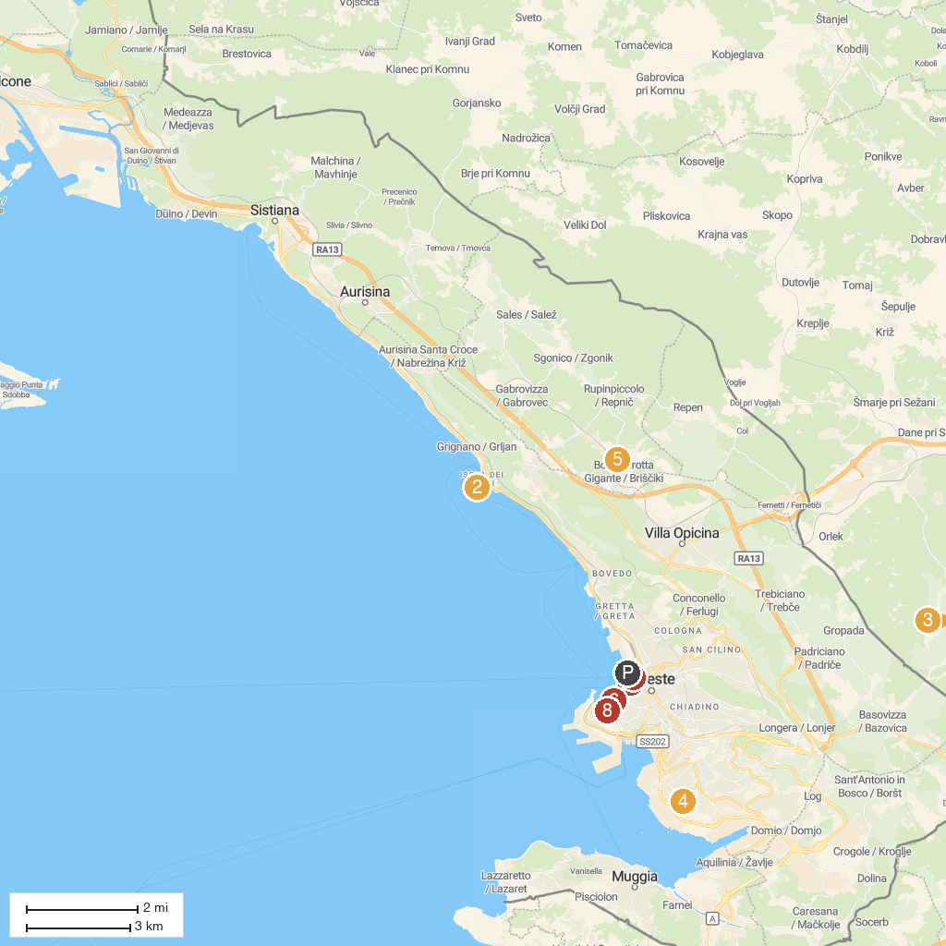
MAP KEY
1. Greek Orthodox Church of Saint Nicholas | 5. Grotta Gigante
2. Miramare Castle | 6. Revoltella Museum
3. Lipica Stud Farm | 7. Museo Teatrale Carlo Schmidl
4. San Sabba Rice Mill National Monument & Museum | 8. Bora Museum
P. Cruise port / terminal
Map © MapTiler © OpenStreetMap contributors · cruiseports.org

