Tresco Island, Isles of Scilly, England
A car-free sub-tropical island 28 miles off Cornwall, Tresco packs world-famous botanical gardens, Caribbean-quality beaches, and 17th-century castles into two walkable miles. Weather-dependent tendering is part of the adventure.
⚓ Tender port (no pier) · 🕒 Typical call: 6-8 hrs · 💷 Currency: British Pound (GBP) · 🗣️ Language: English · 🌿 Sub-tropical island, car-free
✍️ MY DAY IN PORT (FILL IN)
Ship / Date
In port | arrive ______ · all aboard ______
Booked excursion
Notes / meeting point
GETTING ASHORE
- Docking: Tender — ships anchor offshore; tenders land at Carn Near Quay (south) or New Grimsby Quay (west) depending on tide and wind
- Walk to Abbey Gardens: 10-15 min from Carn Near; 20-25 min from New Grimsby
- Best For: Botanical gardens, white-sand beaches, historic castles, cycling, wildlife
- Don't Miss: Tresco Abbey Garden and Valhalla Museum — 20,000 exotic plant species and salvaged shipwreck figureheads
GETTING AROUND
- 📱 Rideshare: ❌ not available
TOP THINGS TO DO
- Tresco Abbey Garden & Valhalla Museum — The island's crown jewel: 17 acres of sub-tropical gardens established in the 1830s, growing 20,000 species from 80 countries…
- Cromwell's Castle & King Charles' Castle — Walk the north of the island to two free historic fortifications.
- Pentle Bay Beach Day — Rated one of the most beautiful beaches in the world, Pentle Bay on the east coast offers a vast crescent of white sand…
- Red Squirrel & Seabird Spotting — Tresco has a reintroduced red squirrel population — look up in the pine trees around the Abbey Gardens.
- Cycling the Island Loop — Hire a bike from Tresco Bike Hire near New Grimsby and cycle the island's gravel and paved paths.
BEST WALKS
- Carn Near to Abbey Garden & Valhalla: 1.5 km | Easy | 10-15 min — From the south tender quay at Carn Near, follow the flat gravel path north toward the Abbey Garden…
- New Grimsby to Cromwell's Castle: 2.5 km one way | Moderate | 30-35 min — From New Grimsby Quay head north along the west coast path past Castle Porth Beach to Cromwell's…
- Old Grimsby & Pentle Bay Loop: 3 km | Easy-Moderate | 45 min — From the Abbey Garden exit, drop east to Old Grimsby harbour and the Ruin Beach Cafe, then walk…
WEATHER · DAYLIGHT · MONEY
Month | High °F | Low °F | Rainy days
May | 58 | 51 | 1
Jul | 67 | 59 | 1
Sep | 64 | 58 | 1
Daylight: May 5:39AM–9:04PM · Jul 5:33AM–9:28PM · Sep 7:01AM–7:38PM
cruiseports.org/tresco-island-england · Confirm terminal & all-aboard time with your ship

Tresco Island, Isles of Scilly, England — Port Map
Red = walkable sights · Amber = excursions farther out · P = cruise terminal
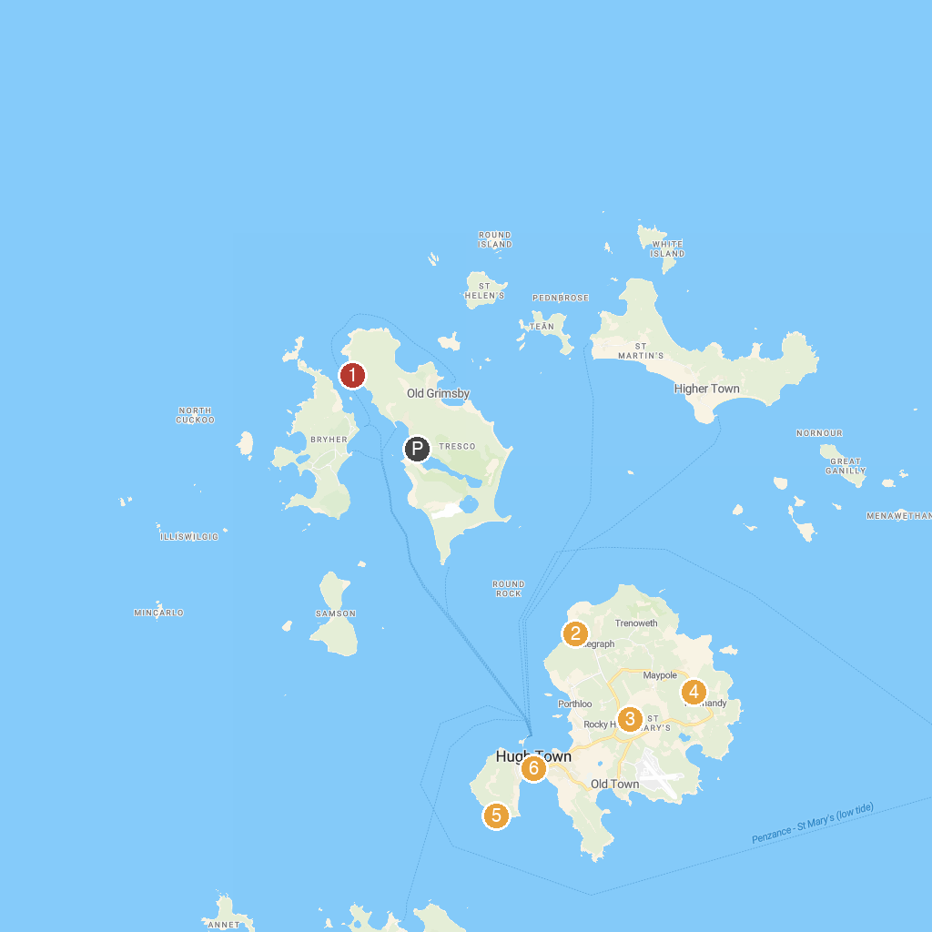
MAP KEY
1. Cromwell's Castle | 4. Isles of Scilly Heritage Coast
2. Bant's Carn Burial Chamber and Halangy Down Ancient Village | 5. Garrison Walls
3. Carreg Dhu Gardens | 6. Isles Of Scilly Museum
P. Cruise port / terminal
Map © MapTiler © OpenStreetMap contributors · cruiseports.org

