Trelleborg, Skåne, Sweden
Sweden's City of Palms hides a 10th-century Viking fortress right in its center — and the continent is barely an hour away by train. A compact, walkable port with easy access to Malmö and Copenhagen.
⚓ Pier (docked) · 🕒 Typical call: 6-8 hrs · 💳 Cashless (card/contactless only) · 🗣️ Swedish (English widely spoken)
✍️ MY DAY IN PORT (FILL IN)
Ship / Date
In port | arrive ______ · all aboard ______
Booked excursion
Notes / meeting point
GETTING ASHORE
- Docking: Pier — ships dock at Ferry Berth 10 or 14, adjacent to city center
- Walk to center: 5-10 min on foot to Rådhustorget (Town Hall Square)
- Best For: Viking history, day trips to Malmö & Copenhagen, relaxed Swedish towns
- Don't Miss: Trelleborgen Viking fortress reconstruction and the summer palm promenade on Strandgatan
GETTING AROUND
- 🚕 Taxi: 44-100 SEK (~$4-10 USD) — Taxis are available outside the terminal. The short distance to the center means fares rarely exceed 100 SEK; the base f
- 📱 Rideshare: ✅ Uber, Bolt
- 🚌 Hop-on hop-off: ✅
TOP THINGS TO DO
- Trelleborgen Viking Ring Fortress — A reconstructed quarter of the original 980 AD ring fortress built by King Harald Bluetooth, complete with a wooden palisade and…
- Day Trip to Malmö — Board a direct train for 30 minutes to Sweden's third-largest city: the futuristic Turning Torso, historic Malmöhus Castle, and…
- Day Trip to Copenhagen — Take the train to Malmö and continue over the iconic Öresund Bridge into Copenhagen — Nyhavn, Tivoli Gardens, and the Little…
- Smygehuk — Sweden's Southernmost Point — A scenic rocky peninsula with a classic lighthouse, a small fishing harbour, and the fish smokery Smyge Rökeri — the perfect spot…
- Dalabadet Beach — A sandy beach 3 km east of port with a bathing jetty, volleyball court, and café.
BEST WALKS
- Port to Viking Fortress Loop: 1.5 km · 25 min · Flat — Walk from the cruise berth through the palm-lined Strandgatan promenade, past Rådhustorget (Town…
- Coastal Walk to Dalabadet Beach: 3 km · 35 min one-way · Flat coastal path — Head east along the seafront from the port following the coastal path to Dalabadet beach.
WEATHER · DAYLIGHT · MONEY
Month | High °F | Low °F | Rainy days
May | 59 | 48 | 0
Jul | 70 | 59 | 1
Sep | 64 | 55 | 0
Daylight: May 4:57AM–9:10PM · Jul 4:46AM–9:38PM · Sep 6:40AM–7:23PM
cruiseports.org/trelleborg · Confirm terminal & all-aboard time with your ship

Trelleborg, Skåne, Sweden — Port Map
Red = walkable sights · Amber = excursions farther out · P = cruise terminal
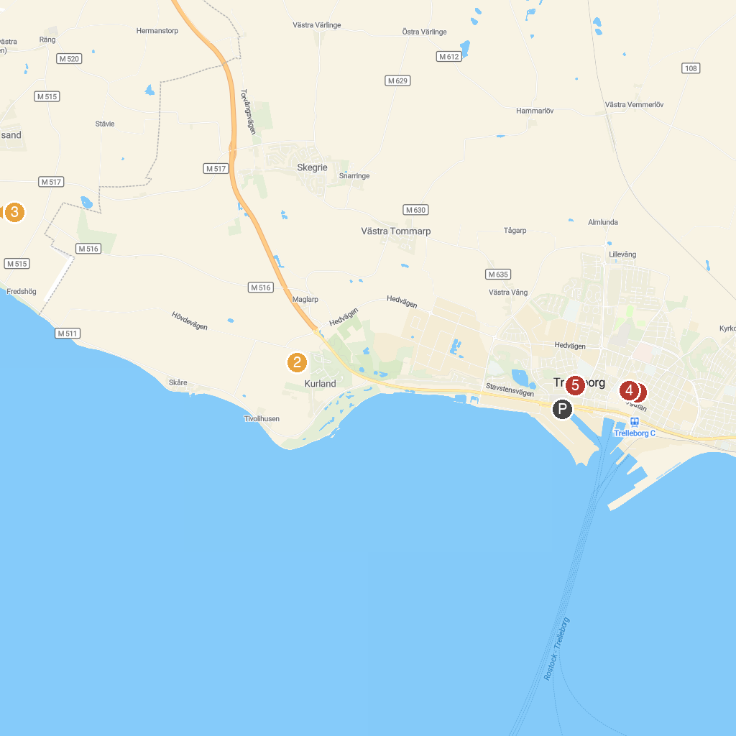
MAP KEY
1. Trelleborg City Park | 5. Trelleborgs Museum
2. Nature reserve Maglarps sandpit | 6. Foteviken Museum
3. amber Museum | 7. Trelleborgen Viking Fort
4. Kopmansmagasinet
P. Cruise port / terminal
Map © MapTiler © OpenStreetMap contributors · cruiseports.org

