Třebenice (Slapy), Bohemia, Czech Republic
A quiet river landing on the Vltava just below the Slapy Dam where historic Prague steamboats tie up long enough for passengers to hike wooded river bluffs, visit a century-old tramp pub, and watch herons work the shallows.
⚓ River dock (small boat landing) · 🕒 Typical call: 2–3 hrs · 💵 Czech Koruna (CZK) · 🗣️ Czech
✍️ MY DAY IN PORT (FILL IN)
Ship / Date
In port | arrive ______ · all aboard ______
Booked excursion
Notes / meeting point
GETTING ASHORE
- Docking: River pier at Slapy–Třebenice landing
- Walk to pub: ~10 min from the pier
- Best For: Hiking · Czech tramp culture
- Don't Miss: Hospoda U Taterů & Vyhlídka Máj
GETTING AROUND
- 🚕 Taxi: CZK 1,200–1,700 (~$55–80 USD) — The most practical option. Book through AAA Radiotaxi or similar Prague taxi apps before your cruise day; the ~40 km dri
TOP THINGS TO DO
- Hospoda U Taterů — Legendary Tramp Pub — A century-old pub in Staré Třebenice that has been the beating heart of Czech tramp culture — the tradition of weekend hiking…
- Vyhlídka Máj — Panoramic Vltava Viewpoint — A demanding but rewarding hike from Třebenice along the Třeblová valley to the Máj viewpoint, which looks down on the Vltava's…
- Slapy Dam & Reservoir Walk — The Slapy Dam (1949–1955) is a major hydroelectric structure forming one of the Vltava Cascade's key reservoirs.
- Riverside Relaxation & Swimming — The Slapy Reservoir is a popular summer swimming destination for Czechs.
BEST WALKS
- Pier to Hospoda U Taterů: ~0.8 km · 10 min · easy — A short walk uphill from the river landing into Třebenice village, following the road to the tramp…
- Towards Vyhlídka Máj (partial): ~4–5 km one-way · 1.5–2.5 hrs · moderate — From the landing, follow the Třeblová stream valley southeast into the forest toward the Máj…
WEATHER · DAYLIGHT · MONEY
Month | High °F | Low °F | Rainy days
May | 66 | 47 | 11
Jul | 78 | 59 | 11
Sep | 69 | 52 | 8
Daylight: May 5:16AM–8:45PM · Jul 5:09AM–9:09PM · Sep 6:40AM–7:17PM
cruiseports.org/trebenice · Confirm terminal & all-aboard time with your ship

Třebenice (Slapy), Bohemia, Czech Republic — Port Map
Red = walkable sights · Amber = excursions farther out · P = cruise terminal
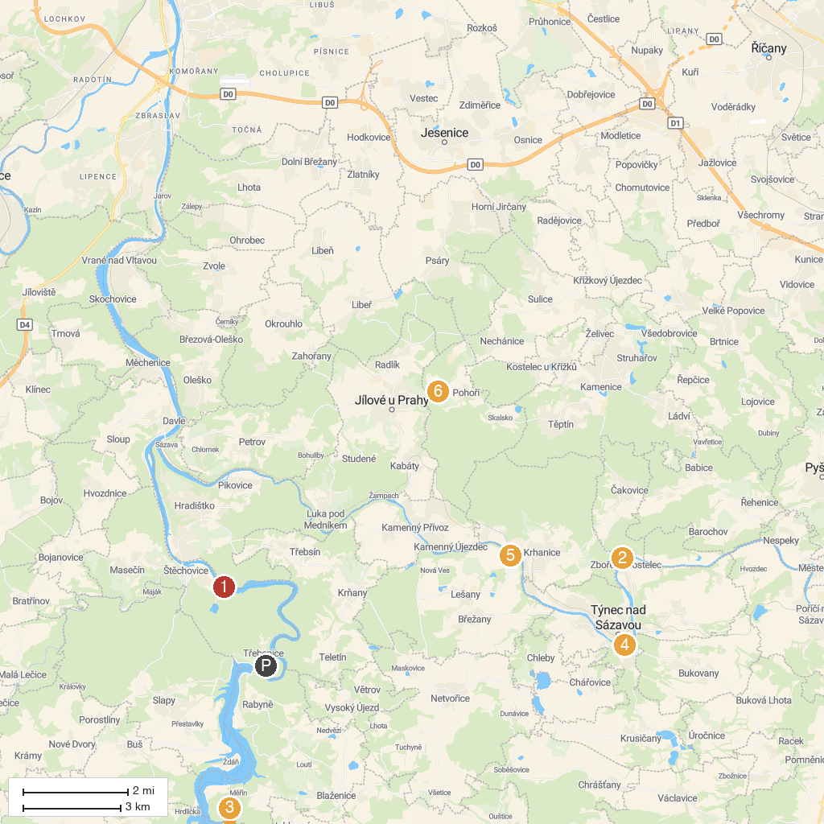
MAP KEY
1. Přehrada Štěchovice | 5. Military History Institute in Prague
2. Castle Zbořený Kostelec | 6. Mníšek pod Brdy Chateau
3. Trapistický Klášter Naší Paní nad Vltavou | 7. Ski Resort Chotouň
4. Castle Týnec nad Sázavou
P. Cruise port / terminal
Map © MapTiler © OpenStreetMap contributors · cruiseports.org

