Traverse City, Michigan, USA
The cherry capital of the world, Traverse City blends crystal-clear bay waters with rolling vineyards, sandy beaches, and a walkable downtown packed with farm-to-table dining. Expect a relaxed, genuinely beautiful Great Lakes day.
⚓ Tender (no dedicated cruise pier) · 🕒 Typical call: 7-9 hrs · 💵 USD · 🗣️ English · 🍒 Cherry & wine country
✍️ MY DAY IN PORT (FILL IN)
Ship / Date
In port | arrive ______ · all aboard ______
Booked excursion
Notes / meeting point
GETTING ASHORE
- Docking: Tender to shore via small boat; ships anchor in Grand Traverse Bay
- Walk to center: ~10 min from tender dock to downtown Front Street
- Best For: Scenic drives, wineries, beaches, local food
- Don't Miss: Sleeping Bear Dunes National Lakeshore (45 min drive)
GETTING AROUND
- 🚕 Taxi: $10–20 — Local taxis (e.g., Traverse City Taxi) provide 24/7 service. Fares within the city typically run $10–20 depending on dis
- 📱 Rideshare: ✅ Uber, Lyft
TOP THINGS TO DO
- Sleeping Bear Dunes National Lakeshore — One of the most dramatic landscapes in the Midwest — massive sand dunes rising 450 feet above Lake Michigan.
- Leelanau Peninsula Wine Trail — Michigan's premier wine region wraps around the Leelanau Peninsula northwest of the city.
- Traverse City Beaches — The eastern arm of Grand Traverse Bay has clear, sandy beaches.
- Downtown Front Street & Local Food — Traverse City's walkable main street is lined with independent shops, galleries, craft breweries, and farm-to-table restaurants.
- TART Trail Bike Ride — The TART (Traverse Area Recreation and Transportation) Trail is a paved multi-use path connecting the waterfront to Suttons Bay…
BEST WALKS
- Waterfront to Downtown Loop: 1.5 miles · ~30 min · Easy · Flat — From the tender landing at the Open Space park, walk along the waterfront promenade south to Front…
- Clinch Park & West End Beach: 1 mile · ~20 min · Easy — Head west from the tender dock along the shoreline to Clinch Park and the West End Beach.
WEATHER · DAYLIGHT · MONEY
Month | High °F | Low °F | Rainy days
May | 67 | 45 | None
Jul | 81 | 61 | None
Sep | 73 | 55 | None
Daylight: May 6:14AM–9:04PM · Jul 6:11AM–9:24PM · Sep 7:21AM–7:52PM
cruiseports.org/traverse-city-mi · Confirm terminal & all-aboard time with your ship

Traverse City, Michigan, USA — Port Map
Red = walkable sights · Amber = excursions farther out · P = cruise terminal
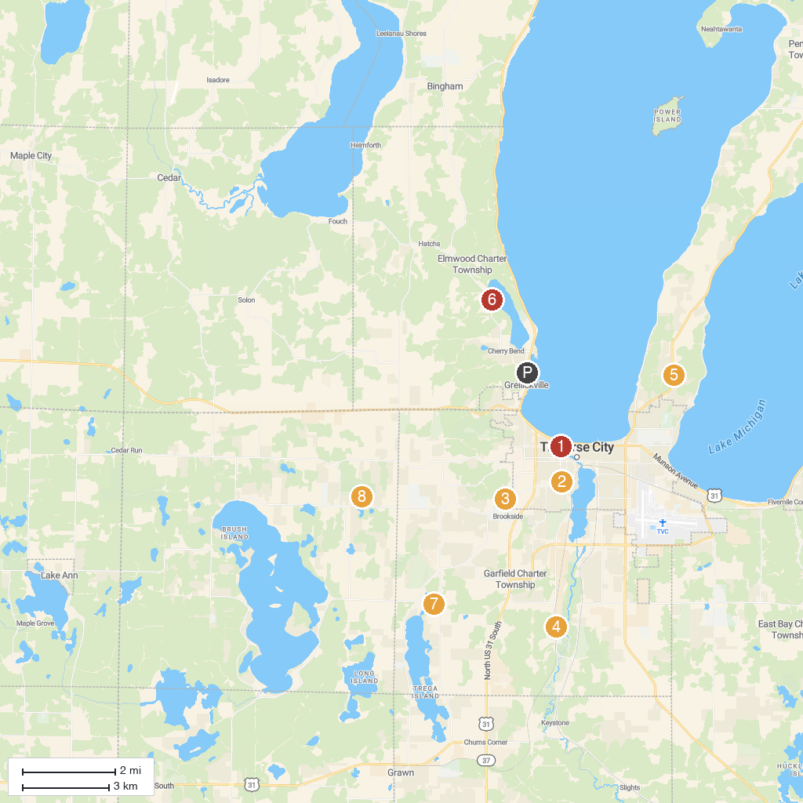
MAP KEY
1. City Opera House | 5. Pelizzari Natural Area
2. St. Francis Catholic Church | 6. DeYoung Natural Area
3. The Cathedral Barn at Historic Barns Park | 7. Silver Lake Recreation Area
4. Grand Traverse Natural Education Reserve | 8. Twin Lakes Park
P. Cruise port / terminal
Map © MapTiler © OpenStreetMap contributors · cruiseports.org

