Travemünde/Lübeck, Schleswig-Holstein, Germany
The gateway to Lübeck's UNESCO-listed Hanseatic old town, Travemünde combines a lively Baltic resort promenade with quick rail access to one of Germany's most intact medieval cities — famed for brick-Gothic churches, hidden courtyards, and the world's best marzipan.
⚓ Pier (Ostpreußenkai — most ships) · 🕒 Typical call: 8-10 hrs · 💶 Euro (€) · 🗣️ German (English widely spoken)
✍️ MY DAY IN PORT (FILL IN)
Ship / Date
In port | arrive ______ · all aboard ______
Booked excursion
Notes / meeting point
GETTING ASHORE
- Docking: Pier — Ostpreußenkai (central Travemünde) for small-mid ships; Skandinavienkai (industrial, shuttle needed) for large vessels
- Walk to center: 0 min from Ostpreußenkai — promenade is right at the gangway; ~20 km to Lübeck (20 min by train)
- Best For: History buffs, beach lovers, foodies, architecture fans
- Don't Miss: Café Niederegger marzipan in Lübeck; Holstentor Gate; fresh Fischbrötchen at the fish harbor
GETTING AROUND
- 🚕 Taxi: €35–€55 — Taxis available at the port; ride to Lübeck city center takes ~19–22 minutes (~16–21 km). Pre-booked private transfers c
- 📱 Rideshare: ✅ Uber, Bolt
TOP THINGS TO DO
- Lübeck Old Town Walking Tour — Explore the UNESCO World Heritage city — the Holstentor gate, St.
- European Hansemuseum — The world's largest museum on the Hanseatic League — immersive, modern, and genuinely fascinating.
- Travemünde Beach Day — Wide, fine-sand Baltic beach just a 15-minute walk from the cruise pier.
- Museum Ship Passat — The legendary 1911 four-masted steel barque moored on the Priwall peninsula — one of the last Flying P-Liners.
- Fish Harbor & Fischbrötchen Lunch — Travemünde's Fischereihafen (fishermen's harbor) is steps from the pier.
BEST WALKS
- Travemünde Harbor Promenade & Beach Walk: 2.5 km · 30-40 min · Easy · Flat — From the cruise pier, stroll the Vorderreihe promenade past cafes and historic buildings, stop at…
- Lübeck Old Town Loop: 3 km · 1.5-2 hrs · Easy · Cobblestones — From Lübeck Hauptbahnhof walk over the Puppenbrücke to the Holstentor, along Holstenstraße to the…
WEATHER · DAYLIGHT · MONEY
Month | High °F | Low °F | Rainy days
May | 62 | 45 | 1
Jul | 73 | 56 | 1
Sep | 67 | 52 | 0
Daylight: May 5:14AM–9:12PM · Jul 5:04AM–9:39PM · Sep 6:50AM–7:31PM
cruiseports.org/travemunde-lubeck · Confirm terminal & all-aboard time with your ship

Travemünde/Lübeck, Schleswig-Holstein, Germany — Port Map
Red = walkable sights · Amber = excursions farther out · P = cruise terminal
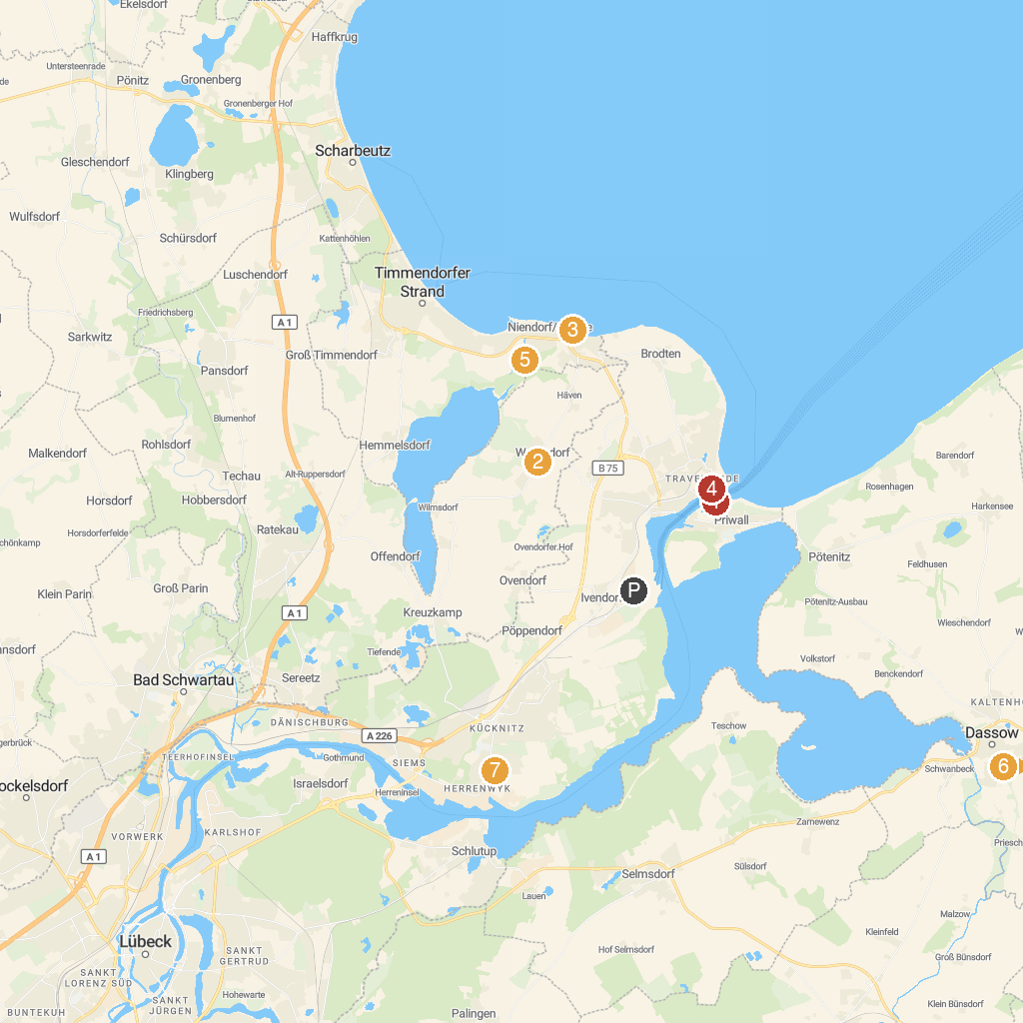
MAP KEY
1. Passat | 5. Old Lighthouse Travemünde
2. Hansa-Park | 6. Bird Park Niendorf
3. Karls Erlebnis-Dorf - Warnsdorf | 7. Tigerpark Dassow
4. Seebrücke Niendorf | 8. Industriemuseum Herrenwyk
P. Cruise port / terminal
Map © MapTiler © OpenStreetMap contributors · cruiseports.org

