Trabzon, Black Sea, Turkey
Once capital of a Byzantine empire and gateway to the Silk Road, Trabzon trades turquoise Aegean clichés for misty Pontic mountains, centuries-old cliff monasteries, and some of Turkey's most distinct regional food.
⚓ Pier (direct dock) · 🕒 Typical call: 8-10 hrs · 💵 Turkish Lira (TRY) — cards widely accepted · 🗣️ Turkish — limited English outside tourist sites
✍️ MY DAY IN PORT (FILL IN)
Ship / Date
In port | arrive ______ · all aboard ______
Booked excursion
Notes / meeting point
GETTING ASHORE
- Docking: Pier — ships berth directly at Trabzon Port, no tender required
- Walk to center: ~1.5 km (20-25 min) uphill to Atatürk Square; taxis ≈ $3-5 USD
- Best For: Byzantine history, dramatic mountain scenery, authentic Turkish culture
- Don't Miss: Sümela Monastery — a 4th-century Greek Orthodox monastery clinging to a sheer cliff face
GETTING AROUND
- 🚕 Taxi: ₺15–25 (~$0.50–$0.75 USD) — Yellow taxis are plentiful at the port. The short ride to the city center costs little more than the base fare; agree on
- 📱 Rideshare: ✅ Uber, BiTaksi
TOP THINGS TO DO
- Sümela Monastery — Founded in 386 AD, this Greek Orthodox monastery is carved into a sheer 300-meter cliff face in Altındere National Park.
- Trabzon Hagia Sophia — A 13th-century Byzantine church famous for its remarkably preserved Christian frescoes.
- Atatürk Villa & City Highlights — Visit the elegant 19th-century hillside mansion gifted to Mustafa Kemal Atatürk — now a museum with period furniture, gardens…
- Boztepe Hill & Tea Gardens — Take a taxi or dolmuş to this hilltop overlooking the city and Black Sea.
- Trabzon Food & Bazaar Walk — Trabzon has one of Turkey's most distinctive regional cuisines.
BEST WALKS
- Atatürk Square to Ortahisar Old Town: 1.5 km · 30-40 min · Easy-moderate — From Meydan Park walk through the Kemeraltı Bazaar to the walled Ortahisar quarter.
- Port to Trabzon Hagia Sophia: 4 km · or quick taxi · Easy — If you prefer to walk west from the port along the coastal road, you'll reach the Hagia Sophia in…
WEATHER · DAYLIGHT · MONEY
Month | High °F | Low °F | Rainy days
May | 66 | 58 | 1
Jul | 80 | 72 | 1
Sep | 77 | 69 | 1
Daylight: May 5:03AM–7:31PM · Jul 5:02AM–7:51PM · Sep 6:01AM–6:29PM
cruiseports.org/trabzon · Confirm terminal & all-aboard time with your ship

Trabzon, Black Sea, Turkey — Port Map
Red = walkable sights · Amber = excursions farther out · P = cruise terminal
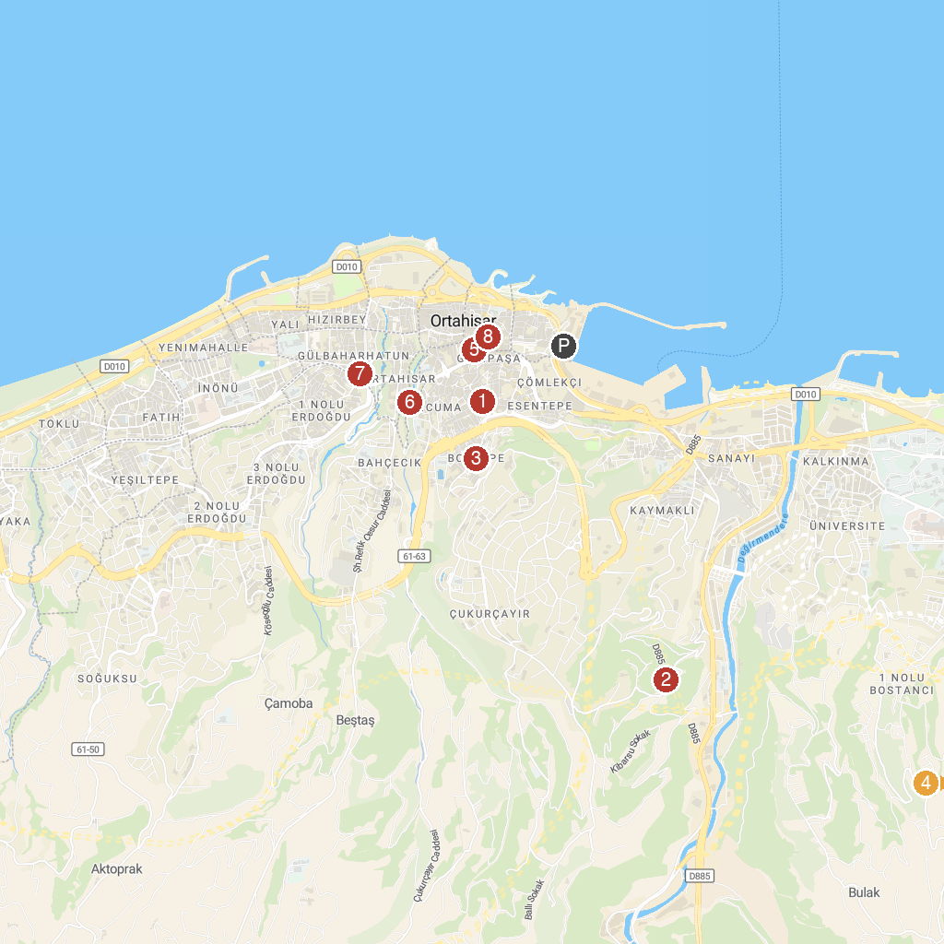
MAP KEY
1. Tavanli Mosque | 5. Trabzon Museum (Kostaki Mansion)
2. Kaymaklı Manastırı | 6. Trabzon Castle
3. Ahi Evren Dede Parkı | 7. Gulbahar Hatun Mosque
4. Yalıncak Mahallesi | 8. Trabzon City Museum
P. Cruise port / terminal
Map © MapTiler © OpenStreetMap contributors · cruiseports.org

