Traben-Trarbach, Moselle Valley, Germany
Once Europe's second-largest wine-trading city after Bordeaux, this twin town flaunts Art Nouveau mansions and 100km of underground cellars — all steps from the river.
⚓ River docked (direct gangway) · 🕒 Typical call: 6–9 hrs · 💶 Euro (€) — carry cash for small wineries · 🗣️ German · 🍷 Wine-forward destination
✍️ MY DAY IN PORT (FILL IN)
Ship / Date
In port | arrive ______ · all aboard ______
Booked excursion
Notes / meeting point
GETTING ASHORE
- Docking: River-docked alongside the Moselle promenade; max vessel 135 m, single berth
- Walk to Center: 0–5 min from dock to either town center; bridge crossing to opposite side ~10 min
- Best For: Riesling tastings, Art Nouveau architecture, underground cellar tours, castle hike
- Don't Miss: The underground wine cellar tour (Unterwelt) and the Brückentor gate on the Trarbach side
GETTING AROUND
- 🚕 Taxi: €6–11 (short town trips) — Local taxis serve Traben-Trarbach with metered fares. A short in-town ride runs €6–11; airport transfers to Frankfurt-Ha
- 📱 Rideshare: ✅ Uber
TOP THINGS TO DO
- Underground Wine Cellar Tour (Unterwelt) — Descend into the network of 19th-century vaulted cellars beneath the town, once holding millions of liters of Moselle wine.
- Art Nouveau Architecture Walk — Bruno Möhring's Belle Époque legacy is everywhere — the Brückentor gate, Romantik Hotel Bellevue, and Villa Huesgen are all…
- Hike to Grevenburg Castle Ruins — A steep 20–30 minute zig-zag climb through the vineyards above the Trarbach side rewards you with spectacular panoramic views of…
- Buddha Museum — One of the world's largest collections of Buddha figures, housed inside a restored Art Nouveau winery designed by Bruno Möhring.
- Riesling Tasting at a Local Weingut — The steep slate-soil vineyards of the Moselle produce world-class Riesling.
BEST WALKS
- Twin Town Stroll: 2.5 km · 45–60 min · Flat — Walk the Traben promenade, cross the Möhring-designed bridge (Brückentor gate on the Trarbach…
- Vineyard Climb to Grevenburg Ruins: 3 km · 1.5–2 hrs · Strenuous — From the Trarbach waterfront, follow the vineyard trail steeply uphill to the ruined Grevenburg…
WEATHER · DAYLIGHT · MONEY
Month | High °F | Low °F | Rainy days
May | 62 | 46 | 1
Jul | 74 | 56 | 1
Sep | 66 | 50 | 1
Daylight: May 5:45AM–9:10PM · Jul 5:39AM–9:34PM · Sep 7:07AM–7:44PM
cruiseports.org/traben-trarbach · Confirm terminal & all-aboard time with your ship

Traben-Trarbach, Moselle Valley, Germany — Port Map
Red = walkable sights · Amber = excursions farther out · P = cruise terminal
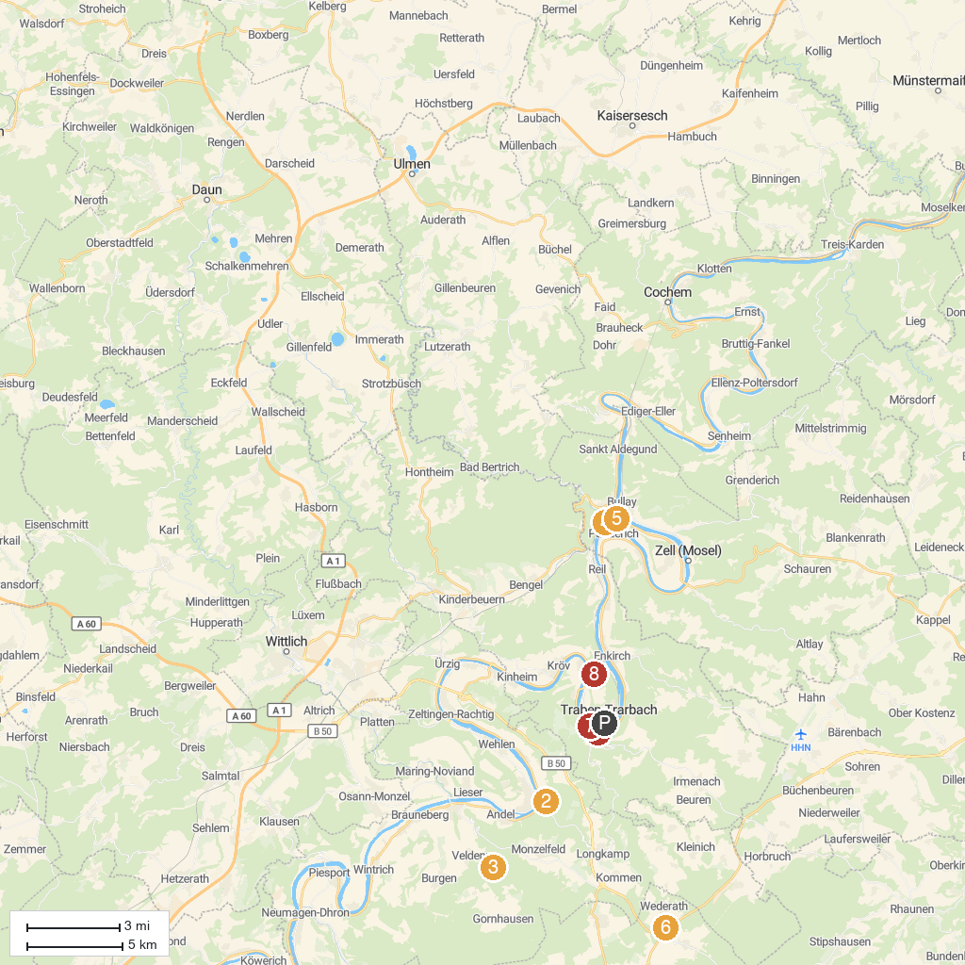
MAP KEY
1. Grevenburg Castle Ruins | 5. Prinzenkopf observation tower
2. Historische Bonbonmacherei | 6. Kulturzentrum Archäologiepark BELGINUM
3. Schloss Veldenz | 7. Buddha-Museum
4. Pündericher Hangviadukt | 8. Mont Royal
P. Cruise port / terminal
Map © MapTiler © OpenStreetMap contributors · cruiseports.org

