Townsville, Queensland, Australia
Tropical North Queensland's gateway city — a sun-drenched waterfront promenade, a granite hill with panoramic views, and the Great Barrier Reef and Magnetic Island beckoning just offshore.
⚓ Docked (Port of Townsville) · 🕒 Typical call: 8–10 hrs · 💵 Australian Dollar (AUD) · 🗣️ English
✍️ MY DAY IN PORT (FILL IN)
Ship / Date
In port | arrive ______ · all aboard ______
Booked excursion
Notes / meeting point
GETTING ASHORE
- Docking: Port of Townsville (~3 km from centre)
- Walk to center: Shuttle or taxi needed
- Best For: Magnetic Island · Reef trips
- Don't Miss: Magnetic Island ferry day
GETTING AROUND
- 🚕 Taxi: A$19–24 — 13cabs and other local taxis serve the port. The city center is about 5 km away — roughly a 7-minute ride.
- 📱 Rideshare: ✅ Uber, DiDi
TOP THINGS TO DO
- Magnetic Island Day Trip — Catch the Sealink ferry to Magnetic Island for koalas in the wild, the Forts Walk through WWII ruins with sweeping sea views…
- Great Barrier Reef Dive & Snorkel — Day-boat trips from Breakwater Marina reach the outer reef in under two hours — world-class coral, sea turtles, reef fish, and…
- Billabong Sanctuary — A wildlife park about 17 km south of the city with crocodile shows, koala holds, wombats, cassowaries, and freshwater crocs in a…
- Reef HQ Aquarium & Museum of Underwater Art — The world's largest living coral reef aquarium, right in the city centre, with a predator exhibit (sharks, rays) and the striking…
- Castle Hill Lookout — A distinctive pink granite monolith rising 286 m over the city — drive or walk a track to the summit for sweeping views of…
BEST WALKS
- The Strand Waterfront Walk: ~3 km one-way · 1.5 hrs · easy — Townsville's signature promenade stretches along the beach from the Strand rock pool at the…
- Castle Hill Summit Walk: ~3 km return · 1 hr · moderate — A winding trail climbs through granite boulders to the Castle Hill summit for the best views in…
WEATHER · DAYLIGHT · MONEY
Month | High °F | Low °F | Rainy days
May | 80 | 66 | 5
Jul | 76 | 60 | 4
Sep | 81 | 65 | 3
Daylight: May 6:32AM–5:45PM · Jul 6:46AM–5:50PM · Sep 6:09AM–6:07PM
cruiseports.org/townsville · Confirm terminal & all-aboard time with your ship

Townsville, Queensland, Australia — Port Map
Red = walkable sights · Amber = excursions farther out · P = cruise terminal
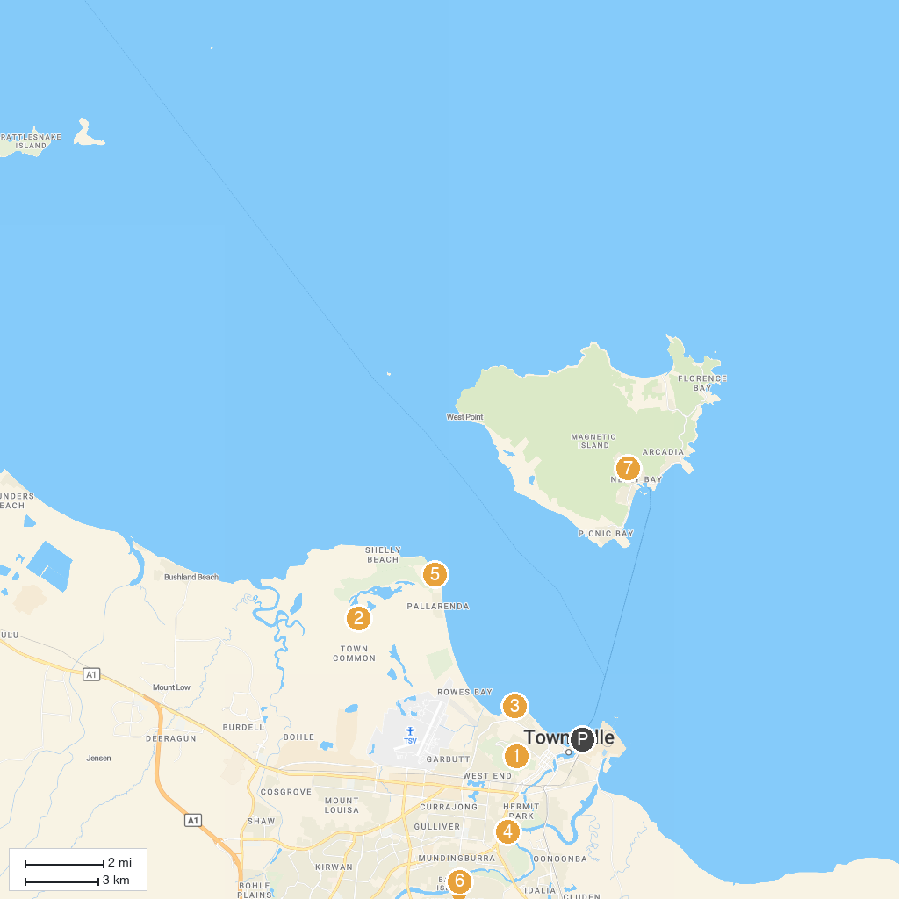
MAP KEY
1. Castle Hill Lookout | 5. Cape Pallarenda Conservation Park
2. Townsville Town Common Conservation Park | 6. Mt Stuart Lookout
3. Army Museum North Queensland | 7. Aquasearch Aquarium
4. Corcoran Park | 8. Discovery Park
P. Cruise port / terminal
Map © MapTiler © OpenStreetMap contributors · cruiseports.org

