Tournus, Burgundy, France
A small Burgundian river town with an outsized culinary reputation and one of the oldest Romanesque abbeys in France — and your ship docks virtually at its doorstep.
⚓ Docked (river quay) · 🕒 Typical call: 6-8 hrs · 💶 Euro (€) · 🗣️ French · 🍷 Burgundy wine country
✍️ MY DAY IN PORT (FILL IN)
Ship / Date
In port | arrive ______ · all aboard ______
Booked excursion
Notes / meeting point
GETTING ASHORE
- Docking: River ships moor at Quai du Midi or Quai de la Marine — steps from the old town
- Walk to Center: 2 min to the old town; 8-10 min to Abbaye Saint-Philibert
- Best For: Romanesque architecture, Burgundy wine, slow French lunches, cycling the Voie Bleue
- Don't Miss: The crypt and 12th-century zodiac mosaics in the Abbey — free to enter
GETTING AROUND
- 🚕 Taxi: €8–€15 — Local taxis are available in Tournus for transfers to the train station or nearby villages. Short in-town rides start ar
- 📱 Rideshare: ✅ Uber
TOP THINGS TO DO
- Abbaye Saint-Philibert — One of the oldest and most complete Romanesque abbeys in France, built in the 10th–11th centuries from warm pink sandstone.
- Hôtel-Dieu & Musée Greuze — A beautifully preserved 17th-century hospital with curtained box beds and a stunning original apothecary — 300-year-old…
- Bicycle Museum (Musée du Vélo) — A surprisingly rich collection of nearly 200 historic bicycles from 1818 to the present day, including Tour de France memorabilia.
- Burgundian Lunch or Wine Tasting — Tournus punches well above its weight gastronomically — it hosts multiple Michelin-recognized restaurants for a town of 6,000…
- Cycling the Voie Bleue — The Voie Bleue is a flat, paved cycling path running right along the Saône past your moored ship and into the Burgundian…
BEST WALKS
- Old Town & Abbey Loop: ~1.5 km · 30-40 min · Easy (some cobblestones) — From the quay walk inland to Place de l'Abbaye, explore the abbey and its cloisters, then wind back…
- Voie Bleue Riverside Stroll: ~2 km out-and-back · 30 min · Flat & paved — Head south along the Voie Bleue cycling/walking path from the mooring quay.
WEATHER · DAYLIGHT · MONEY
Month | High °F | Low °F | Rainy days
May | 69 | 51 | 1
Jul | 83 | 62 | 0
Sep | 75 | 54 | 1
Daylight: May 6:06AM–9:07PM · Jul 6:02AM–9:29PM · Sep 7:18AM–7:51PM
cruiseports.org/tournus · Confirm terminal & all-aboard time with your ship

Tournus, Burgundy, France — Port Map
Red = walkable sights · Amber = excursions farther out · P = cruise terminal
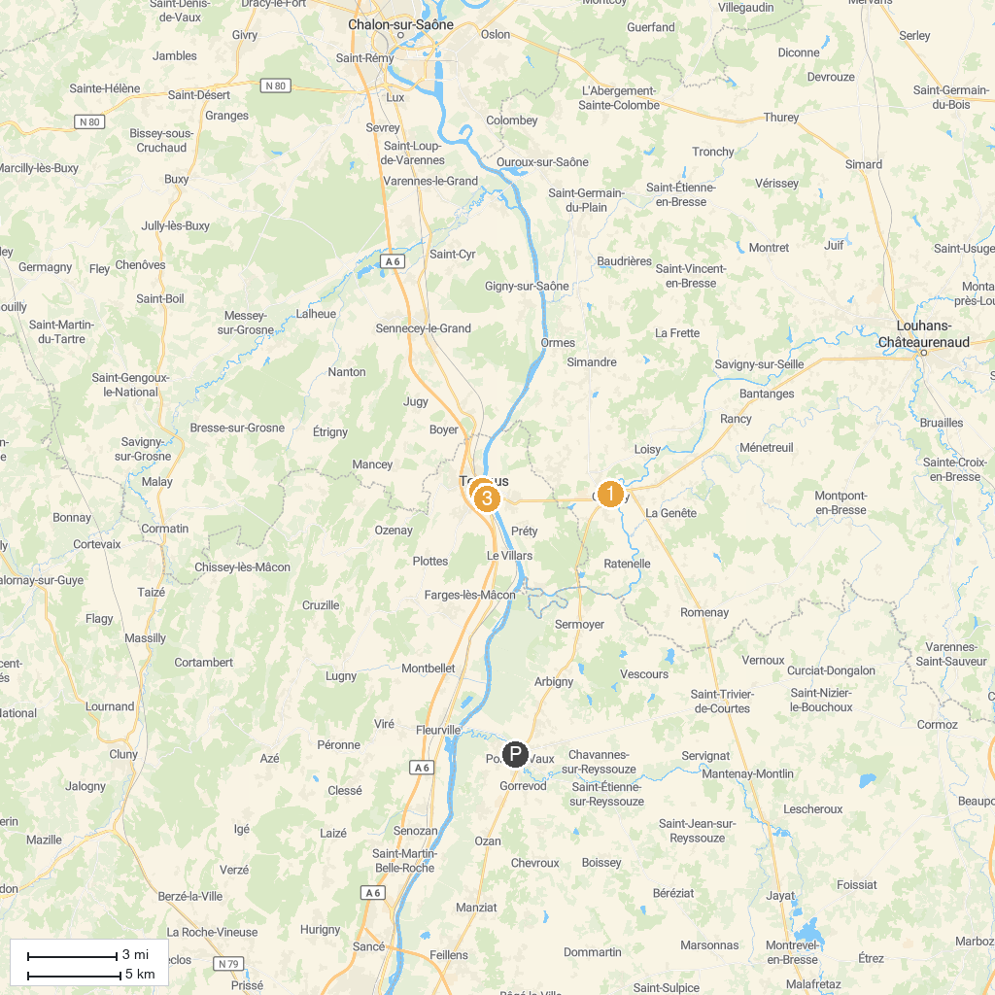
MAP KEY
1. Ferme du Champ bressan-Musée du Terroir, Romenay | 3. Hotel Dieu - Museum Greuze
2. Centre Eden | 4. Musée du Vélo Michel Grezaud
P. Cruise port / terminal
Map © MapTiler © OpenStreetMap contributors · cruiseports.org

