Tournon-sur-Rhône, Ardèche, France
A medieval river town paired with one of France's most prestigious wine appellations, Tournon-sur-Rhône rewards cruise passengers with a château, historic footbridge, and a walk across the Rhône to Tain-l'Hermitage's legendary vineyards and Valrhona chocolate.
⚓ Docked (riverside quay) · 🕒 Typical call: 8-10 hrs · 💶 Euro · 🗣️ French
✍️ MY DAY IN PORT (FILL IN)
Ship / Date
In port | arrive ______ · all aboard ______
Booked excursion
Notes / meeting point
GETTING ASHORE
- Docking: Docked at riverside quay near town center
- Walk to center: 2 min to old town; 10 min to Château
- Best For: Wine lovers, history, foodies, easy walkers
- Don't Miss: Hermitage vineyards & Valrhona Cité du Chocolat
GETTING AROUND
- 🚕 Taxi: €5–€15 — Local taxis are available for short hops around Tournon and to Tain-l'Hermitage. The base fare in Ardèche department is
TOP THINGS TO DO
- Château-Musée de Tournon — A 10th-century feudal fortress classified as a Historic Monument, housing fine arts, Rhône navigation history, and sweeping…
- Cité du Chocolat Valrhona — Valrhona's interactive chocolate museum and boutique in Tain-l'Hermitage — tastings, bean-to-bar exhibits, and a shop stocked…
- Hermitage & Crozes-Hermitage Wine Tasting — Visit renowned cellars M.
- Hermitage Hill Vineyard Walk — Hike the steep granite slopes of the Hermitage hill for panoramic views over the Rhône, Tournon, and the patchwork of famous vine…
- Ardèche Steam Train (Chemin de Fer du Vivarais) — A vintage narrow-gauge steam railway winds through the Doux river gorge from Tournon to Lamastre — a scenic 2-hour journey into…
BEST WALKS
- Tournon Old Town & Château Loop: 2 km · 45 min · Easy — From the quay, walk north along the riverfront to the medieval Château-Musée, through the old town…
- Footbridge to Tain-l'Hermitage Wine & Chocolate: 3 km round-trip · 1-2 hrs · Easy — Cross the 1825 Passerelle Marc Seguin pedestrian bridge into Tain-l'Hermitage.
WEATHER · DAYLIGHT · MONEY
Month | High °F | Low °F | Rainy days
May | 72 | 51 | None
Jul | 87 | 62 | None
Sep | 79 | 55 | None
Daylight: May 6:11AM–9:03PM · Jul 6:08AM–9:24PM · Sep 7:19AM–7:51PM
cruiseports.org/tournon-sur-rhone · Confirm terminal & all-aboard time with your ship

Tournon-sur-Rhône, Ardèche, France — Port Map
Red = walkable sights · Amber = excursions farther out · P = cruise terminal
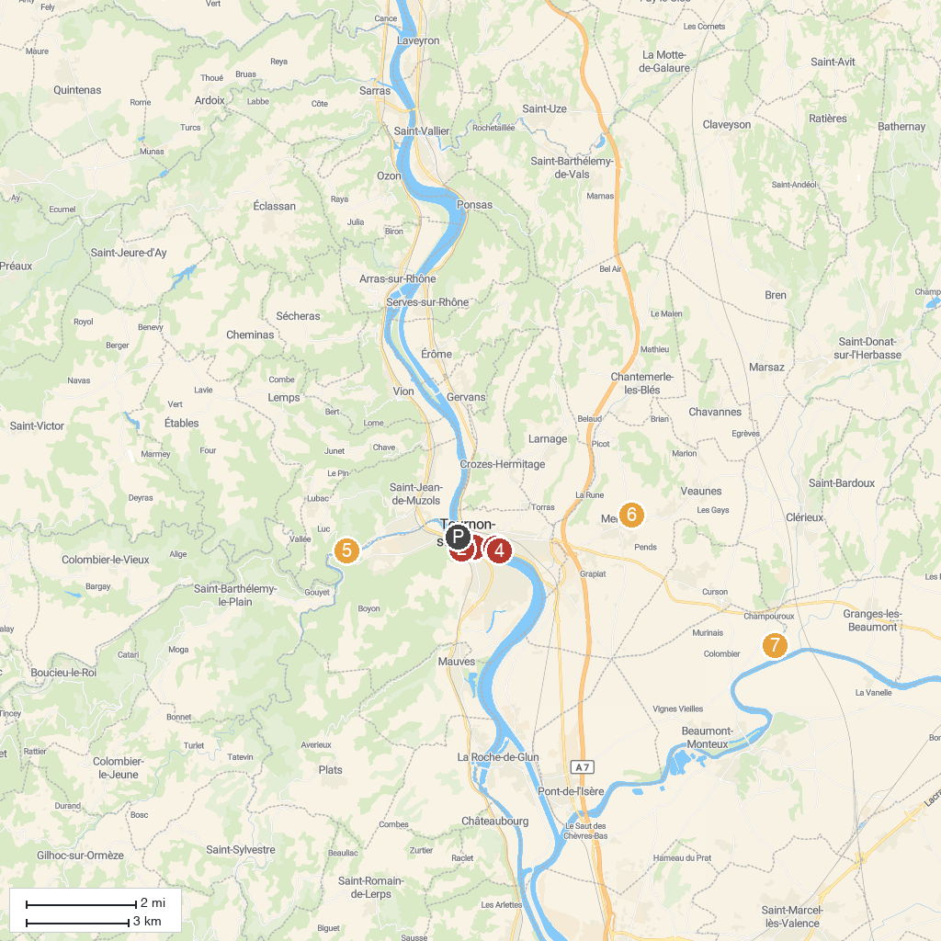
MAP KEY
1. Passerelle Marc Seguin | 5. Train de l'Ardèche
2. Église Saint-Julien de Tournon-sur-Rhône | 6. La Tour de Mercurol
3. Cite du Chocolat Valrhona | 7. Château de Crussol
4. Le petit train des vignes de l'Hermitage | 8. Zen d'Erik Borja Garden
P. Cruise port / terminal
Map © MapTiler © OpenStreetMap contributors · cruiseports.org

