Toulon, Provence, France
France's storied naval capital opens onto sun-drenched Provence — with a lively fish market, panoramic cable car, and the entire Côte d'Azur within easy reach.
⚓ Pier (city center or La Seyne-sur-Mer) · 🕒 Typical call: 8-10 hrs · 💶 Euro · 🗣️ French
✍️ MY DAY IN PORT (FILL IN)
Ship / Date
In port | arrive ______ · all aboard ______
Booked excursion
Notes / meeting point
GETTING ASHORE
- Docking: Small ships: Quai Fournel (city center). Larger ships: La Seyne-sur-Mer (10-min ferry or shuttle to Toulon).
- Walk to center: 5 min from Quai Fournel; 10-min ferry + walk from La Seyne-sur-Mer
- Best For: Provençal culture, day trips to Cassis or Aix-en-Provence, naval history
- Don't Miss: Cours Lafayette morning market, Mont Faron cable car views, Mourillon beaches
GETTING AROUND
- 🚕 Taxi: €10–15 — Metered taxis wait outside the terminal for a quick ride to the city center (~10 min). From the La Seyne-sur-Mer dock (l
- 📱 Rideshare: ✅ Uber, Bolt
TOP THINGS TO DO
- Mont Faron Cable Car — Ride the téléphérique to the summit of Mont Faron for sweeping panoramas over Toulon's harbor, bay, and the surrounding Provençal…
- Cours Lafayette Market & Old Town — The daily morning market on Cours Lafayette is one of Provence's best — fish, produce, olives, and spices.
- National Naval Museum (Musée National de la Marine) — Located on the waterfront, this museum traces French naval history from the age of sail to modern submarines with ship models…
- Calanques & Cassis Day Trip — Head 45 minutes west to the picture-perfect fishing port of Cassis, gateway to the dramatic limestone calanques.
- Aix-en-Provence Full Day — Elegant Aix — fountains, Cours Mirabeau, Cézanne's studio, and excellent Provençal restaurants — is an hour from Toulon and one…
BEST WALKS
- Waterfront to Old Town Loop: 1.5 km · 30–45 min · Easy — From the pier, walk along Quai Cronstadt past the naval museum, then turn inland through the Cours…
- Mourillon Beach Walk: 2 km beach promenade · Easy · Swimwear useful — From Mourillon, a pleasant promenade links four sheltered coves with cafés and clear water…
WEATHER · DAYLIGHT · MONEY
Month | High °F | Low °F | Rainy days
May | 71 | 56 | 0
Jul | 85 | 69 | 0
Sep | 79 | 64 | 0
Daylight: May 6:12AM–8:53PM · Jul 6:10AM–9:13PM · Sep 7:16AM–7:45PM
cruiseports.org/toulon · Confirm terminal & all-aboard time with your ship

Toulon, Provence, France — Port Map
Red = walkable sights · Amber = excursions farther out · P = cruise terminal
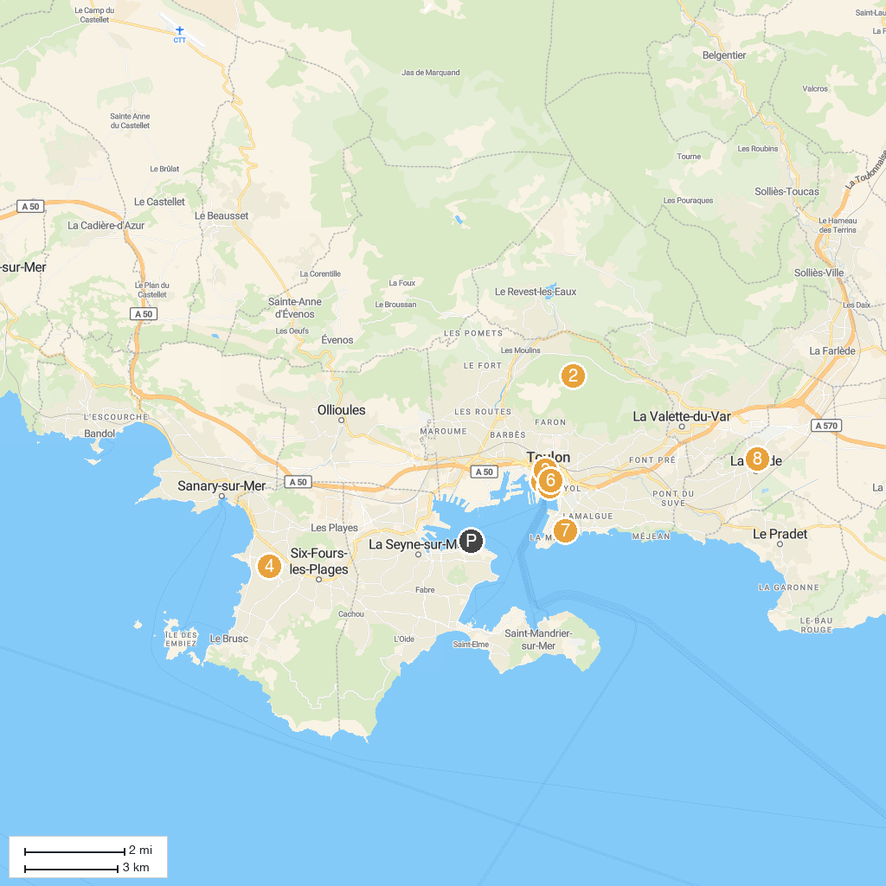
MAP KEY
1. Musée National de la Marine | 5. The Little Trains of Toulon
2. Zoo Fauverie Du Mont Faron | 6. Maison de la photographie
3. Hotel des Arts (Mediterranean Center of Art) | 7. Musée des Arts Asiatiques
4. Coudou Parc | 8. Veyret Garden
P. Cruise port / terminal
Map © MapTiler © OpenStreetMap contributors · cruiseports.org

