Tortola, British Virgin Islands
The largest of the British Virgin Islands, Tortola pairs a lively pier-side scene with easy escapes to powder-sand beaches, lush national park trails, and the boulder-strewn Baths of Virgin Gorda just a short ferry away.
⚓ Docked (most ships) — tender if 3+ ships in port · 🕒 Typical call: 7–9 hrs · 💵 Currency: US Dollar · 🗣️ Language: English
✍️ MY DAY IN PORT (FILL IN)
Ship / Date
In port | arrive ______ · all aboard ______
Booked excursion
Notes / meeting point
GETTING ASHORE
- Docking: Cyril B. Romney Pier Park, Road Town — 2 berths, up to 180,000 GT; overflow ships anchor & tender
- Walk to Center: 5 min to Road Town Main Street from the pier
- Best For: Beach days, island hopping to Virgin Gorda & Jost Van Dyke, snorkeling
- Don't Miss: The Baths on Virgin Gorda — book the ferry excursion early
GETTING AROUND
- 🚕 Taxi: $8–$12 per person — Regulated shared taxis (open-air safari-style vans) wait at the pier. Fares are set per person by destination — Cane Gar
- 📱 Rideshare: ❌ not available
TOP THINGS TO DO
- The Baths, Virgin Gorda — Massive granite boulders tumbled along the shore form sea-lit grottoes, tidal pools, and a hidden beach at Devil's Bay.
- Cane Garden Bay Beach — Tortola's most popular beach — calm turquoise water, soft sand, beach bars, and watersports rentals.
- Jost Van Dyke Day Trip — Hop a boat to this tiny island for White Bay beach and the famous Bubbly Pool — a natural jacuzzi formed by waves crashing over…
- Sage Mountain National Park Hike — A short trail through mahogany forest leads to the highest point in the Virgin Islands (1,716 ft) with sweeping views over both…
- Snorkeling & Catamaran Sail — Catamaran tours circle Tortola stopping at Smuggler's Cove and other clear-water reef sites.
BEST WALKS
- Road Town Waterfront & Main Street: ~1 hr | Flat | Easy — Exit the pier into Pier Park, then walk north along the waterfront toward the Ferry Terminal and…
WEATHER · DAYLIGHT · MONEY
Month | High °F | Low °F | Rainy days
May | 80 | 78 | 10
Jul | 82 | 80 | 15
Sep | 83 | 80 | 16
Daylight: May 5:44AM–6:44PM · Jul 5:50AM–6:58PM · Sep 6:06AM–6:20PM
cruiseports.org/tortola-island-bvi · Confirm terminal & all-aboard time with your ship

Tortola, British Virgin Islands — Port Map
Red = walkable sights · Amber = excursions farther out · P = cruise terminal
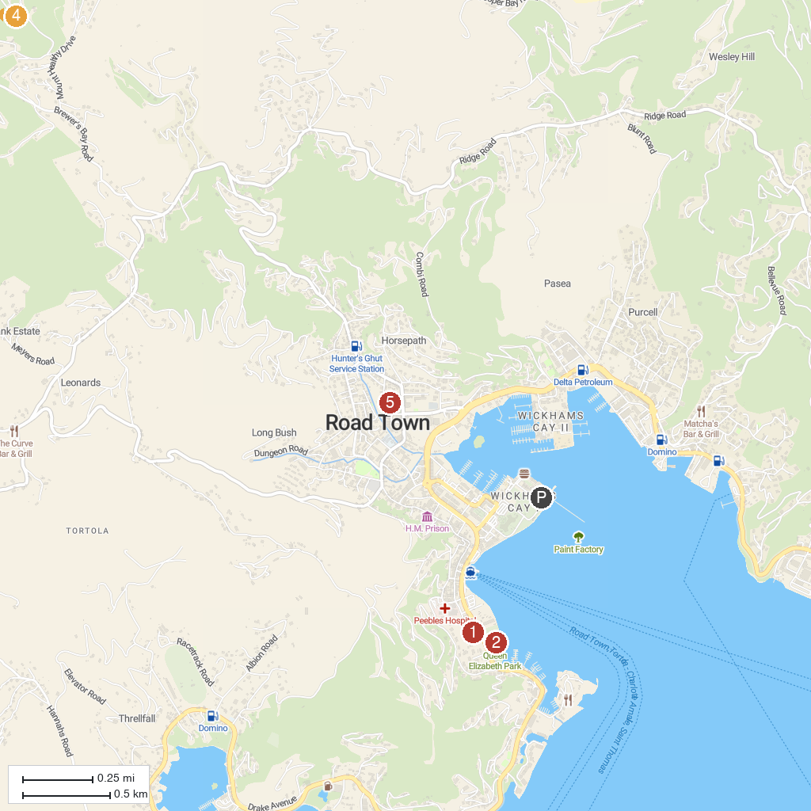
MAP KEY
1. Old Government House Museum | 5. Carolina Corral
2. Queen Elizabeth II National Park | 6. Annaberg Sugar Plantation
3. Cyril B. Romney Tortola Pier Park | 7. J.R. O'Neal Botanical Gardens
4. Bubbly Pool
P. Cruise port / terminal
Map © MapTiler © OpenStreetMap contributors · cruiseports.org

