Torretta-Legnago, Veneto, Italy
A tiny rural hamlet on the Canalbianco canal, Torretta-Legnago is one of Italy's most authentic river cruise stops — no tourist crowds, just flat farmland, lock systems, and a short ride to Verona or Mantua.
⚓ Docked (river pier) · 🕒 Typical call: 8-10 hrs · 💶 Euro (EUR) · 🗣️ Italian · 🚴 Great cycling
✍️ MY DAY IN PORT (FILL IN)
Ship / Date
In port | arrive ______ · all aboard ______
Booked excursion
Notes / meeting point
GETTING ASHORE
- Docking: River mooring on Canalbianco canal; walk-off gangway, no tender
- Walk to center: Legnago town is ~5.5 km north — taxi, ship shuttle, or bike needed
- Best For: Verona day trips, cycling canal levees, quiet Italian countryside
- Don't Miss: Teatro Salieri and the Torrione fortress tower in Legnago
GETTING AROUND
- 🚕 Taxi: €20–30 — Taxis can be arranged from the pier to Legnago city center (~13 km). Expect roughly €20–30 each way based on standard It
- 📱 Rideshare: ✅ Uber
TOP THINGS TO DO
- Verona — Arena, Juliet's Balcony & Piazzas — Italy's most romantic city is 45 minutes away.
- Mantua — Gonzaga Renaissance Palaces — Mantua (Mantova) is a UNESCO-listed Renaissance gem surrounded by lakes.
- Legnago — Salieri's Birthplace & Torrione — The town of Legnago honors its most famous son, composer Antonio Salieri, with a named theater and square.
- Canal & River Cycling — Canalbianco Levees — The Veneto is pancake-flat and perfect for cycling.
- Ferrara — Moated Renaissance City — Ferrara's fairy-tale Estense Castle with its moat and towers, plus the massive medieval city walls (still intact and walkable)…
BEST WALKS
- Legnago Town Center Walk: 2-3 km loop • Easy • ~1 hr — From Piazza Libertà, see the Torrione tower and the remnants of the old fortifications, then head…
- Canalbianco Levee Stroll: Easy • Flat • As long as you like — From the ship mooring, walk along the raised levee path beside the Canalbianco canal.
cruiseports.org/torretta-legnago · Confirm terminal & all-aboard time with your ship

Torretta-Legnago, Veneto, Italy — Port Map
Red = walkable sights · Amber = excursions farther out · P = cruise terminal
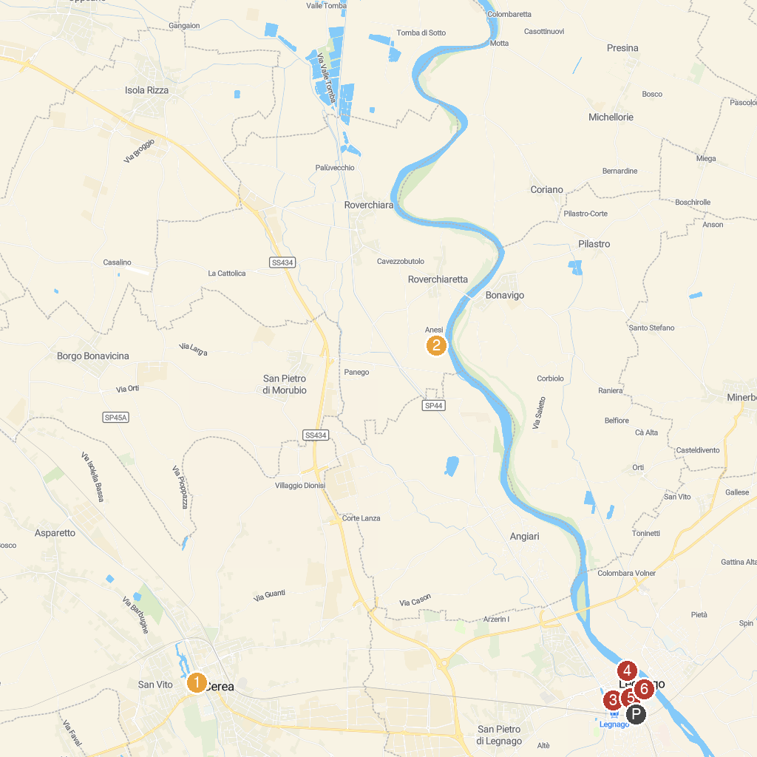
MAP KEY
1. "Le Vallette" Park | 5. Parco Comunale di Legnago
2. Associazione Radici in Movimento | 6. Oasi La Verbena Adige
3. City of Montagnana | 7. Fioroni Museum Foundation
4. Villa Correr | 8. Torrione di Legnago
P. Cruise port / terminal
Map © MapTiler © OpenStreetMap contributors · cruiseports.org

