Torgau, Saxony, Germany
Where the Reformation met the Renaissance, live bears roam a castle moat, and Allied soldiers shook hands to end World War II — Torgau packs extraordinary history into a compact, walkable Elbe river town.
⚓ Docked (riverside quay) · 🕒 Typical call: 6–8 hrs · 💶 Currency: Euro (€) · 🗣️ Language: German
✍️ MY DAY IN PORT (FILL IN)
Ship / Date
In port | arrive ______ · all aboard ______
Booked excursion
Notes / meeting point
GETTING ASHORE
- Docking: Direct alongside Elbe riverbank quay — no tender
- Walk to center: Castle: 3–5 min (200 m); Marktplatz: 10 min (800 m)
- Best For: Reformation history, WWII Elbe Day, Renaissance architecture
- Don't Miss: The live bears in Schloss Hartenfels moat (since 1425)
GETTING AROUND
- 🚕 Taxi: €5–€10 — Local taxis are available in Torgau with a base fare of ~€3.90 plus per-km charges. A ride to any point in the small cit
- 📱 Rideshare: ❌ not available
TOP THINGS TO DO
- Schloss Hartenfels & the Castle Bears — Explore the magnificent Renaissance courtyard, marvel at the Großer Wendelstein — a freestanding spiral staircase from the 1540s…
- Elbe Day Monument & WWII Walk — On April 25, 1945, US and Soviet troops met here at the destroyed Elbe bridge — one of history's most symbolic handshakes.
- Luther & Katharina von Bora — Visit the Schlosskirche — the first newly built Protestant church in the world, dedicated by Martin Luther in 1544 — and the…
- Stadtkirche St. Marien — A Late Gothic hall church where Luther himself preached.
- Elbe Cycle Route (Elberadweg) — One of Europe's most celebrated long-distance bike paths passes directly through Torgau.
BEST WALKS
- Castle to Marktplatz Loop: ~2 km | 45–60 min | Easy — From the quay, walk up to Schloss Hartenfels, cross into the courtyard, visit the bears and…
- Elbe Day Riverbank Walk: ~1 km | 20 min | Easy — Follow the Elbe embankment north from the dock toward the Elbe Day Monument (Denkmal der Begegnung).
WEATHER · DAYLIGHT · MONEY
Month | High °F | Low °F | Rainy days
May | 68 | 44 | 0
Jul | 80 | 56 | 1
Sep | 71 | 49 | 0
Daylight: May 5:16AM–8:53PM · Jul 5:08AM–9:18PM · Sep 6:43AM–7:21PM
cruiseports.org/torgau · Confirm terminal & all-aboard time with your ship

Torgau, Saxony, Germany — Port Map
Red = walkable sights · Amber = excursions farther out · P = cruise terminal
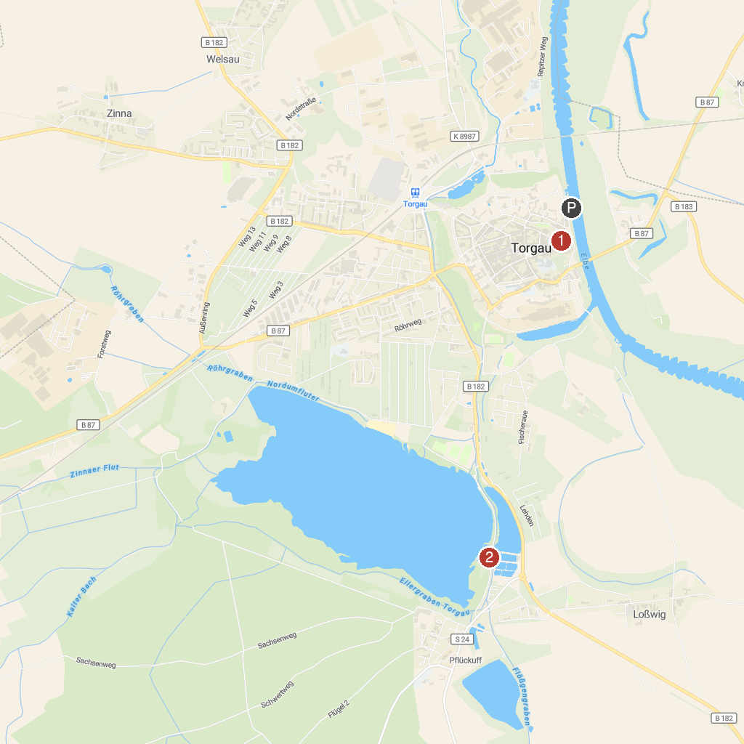
MAP KEY
1. Bärengraben | 3. Landschaftspark Treblitzsch
2. NABU-Biberhof Torgau
P. Cruise port / terminal
Map © MapTiler © OpenStreetMap contributors · cruiseports.org

