Torbay, Devon, England
Palm-lined promenades, prehistoric caves, and the birthplace of Agatha Christie — Torbay's three seaside towns pack an entire holiday into a single shore day.
⚓ Tender port · 🕒 Typical call: 8–10 hrs · 💷 British Pound (GBP) · 🗣️ English
✍️ MY DAY IN PORT (FILL IN)
Ship / Date
In port | arrive ______ · all aboard ______
Booked excursion
Notes / meeting point
GETTING ASHORE
- Docking: Tender — ships anchor in Tor Bay; tenders land at Haldon Pier, Torquay
- Walk to centre: 2 min to marina, 10 min to Torquay town centre
- Best For: Agatha Christie fans, seafood, beaches, Brixham fishing village
- Don't Miss: Brixham harbour & Golden Hind replica, Cockington Village, Kents Cavern
GETTING AROUND
- 🚕 Taxi: £7–£12 — Licensed hackney carriages are metered with council-set fares. Local companies include Torbay Taxis and Bay Taxis; short
- 📱 Rideshare: ✅ Uber
- 🚌 Hop-on hop-off: ✅
TOP THINGS TO DO
- Kents Cavern Prehistoric Caves — One of Europe's most important Stone Age cave systems, with stalactites and the oldest human remains found in Britain.
- Agatha Christie Mile & Torquay Museum — Follow the self-guided walking trail through 12 Christie landmarks, then visit Britain's only dedicated Agatha Christie gallery…
- Torre Abbey Historic House & Gardens — Torbay's oldest monument — a 12th-century monastery turned art gallery set in 18 acres of award-winning gardens.
- Brixham Harbour & Golden Hind — Take the ferry across the bay to Brixham — a pastel-coloured fishing village where you can board a full-scale replica of Sir…
- Cockington Village & Country Park — A perfectly preserved medieval village with thatched-roof cottages, a working forge, and craft studios, set within a 450-acre…
BEST WALKS
- Torquay Harbour Promenade to Torre Abbey Sands: 2 km · 25 min · Flat · Scenic — Stroll from Haldon Pier along the palm-fringed promenade past Princess Gardens to the main Torre…
- Agatha Christie Mile Self-Guided Walk: 1.6 km · 40 min · Flat · Cultural — Follow the heritage trail plaques from the harbour past the Grand Hotel, Princess Pier, Agatha…
WEATHER · DAYLIGHT · MONEY
Month | High °F | Low °F | Rainy days
May | 62 | 46 | 1
Jul | 72 | 55 | 1
Sep | 68 | 50 | 1
Daylight: May 5:26AM–8:55PM · Jul 5:20AM–9:19PM · Sep 6:50AM–7:27PM
cruiseports.org/torbay-uk · Confirm terminal & all-aboard time with your ship

Torbay, Devon, England — Port Map
Red = walkable sights · Amber = excursions farther out · P = cruise terminal
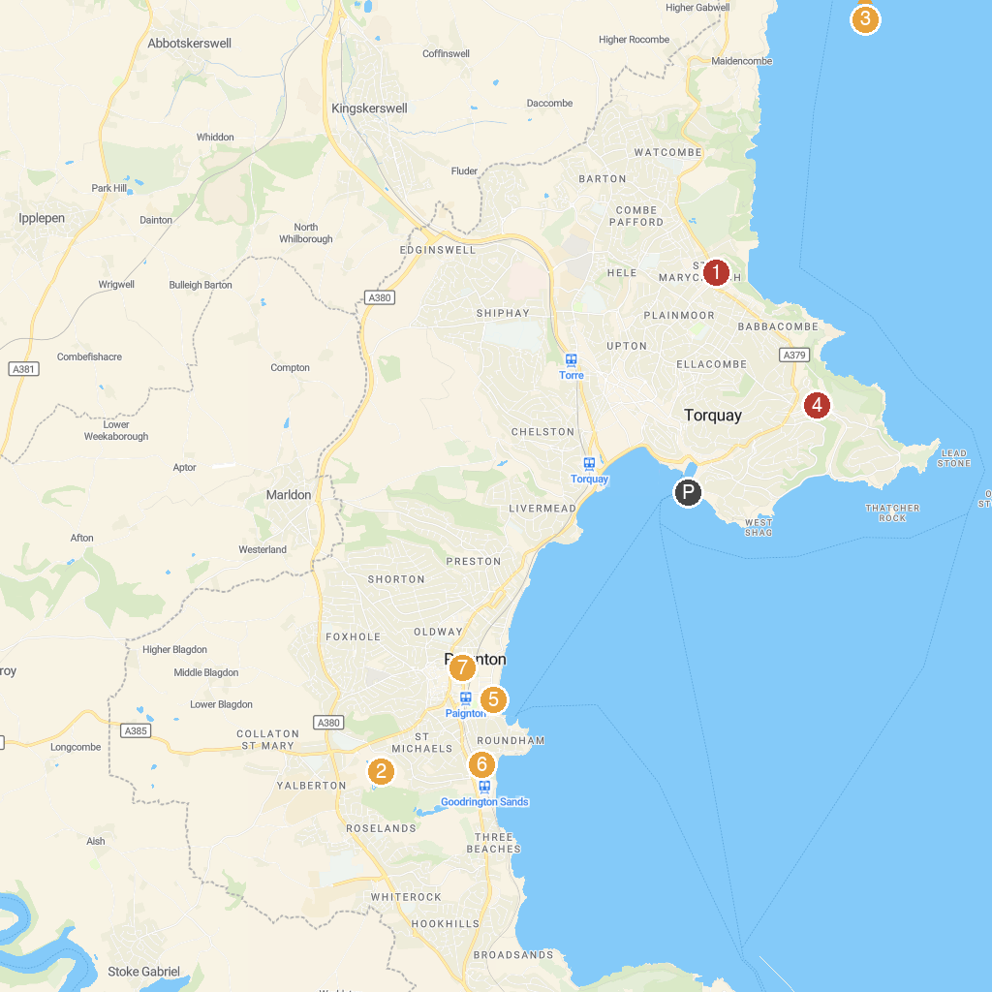
MAP KEY
1. Leechwell Garden | 5. Kents Cavern Prehistoric Caves
2. Babbacombe Model Village & Gardens | 6. Pirates Bay Adventure Golf
3. Paignton Zoo Environmental Park | 7. Young's Park
4. Teignmouth Pier | 8. Victoria Park
P. Cruise port / terminal
Map © MapTiler © OpenStreetMap contributors · cruiseports.org

